Register for COVID-19 Principal Support Opportunities
- Create your Profile
Recruitment Online (ROL) is the government schools’ recruitment job board.
Open the Recruitment Online portal (Jobs in a Victorian Government Schools) via the ROL link on HRWeb at: http://www.education.vic.gov.au/hrweb/careers/Pages/advacsSCH.aspx
Click Add your resume to ROL Job Opportunities to login and create a profile to register your interest in COVID-19 Principal Support positions/s.
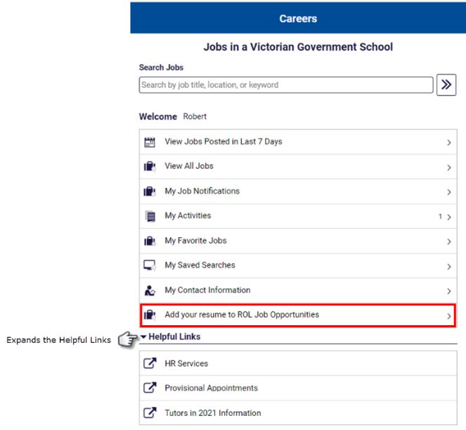
- Create a Recruitment Online account
You will be prompted to sign into Recruitment Online. As a new user, click Register Now and follow the prompts to set up a profile. Principals will search profiles for applicants to fill their COVID-19 Principal Support positions.
Note: You will need access to a personal email account to set up a profile.
If you have been a previous user of ROL and you use the same email account, the system will not allow you to create another profile with this email account – see the ROL COVID-19 Principal Support – Current User guide to set up a COVID-19 Principal Support profile with your email account.
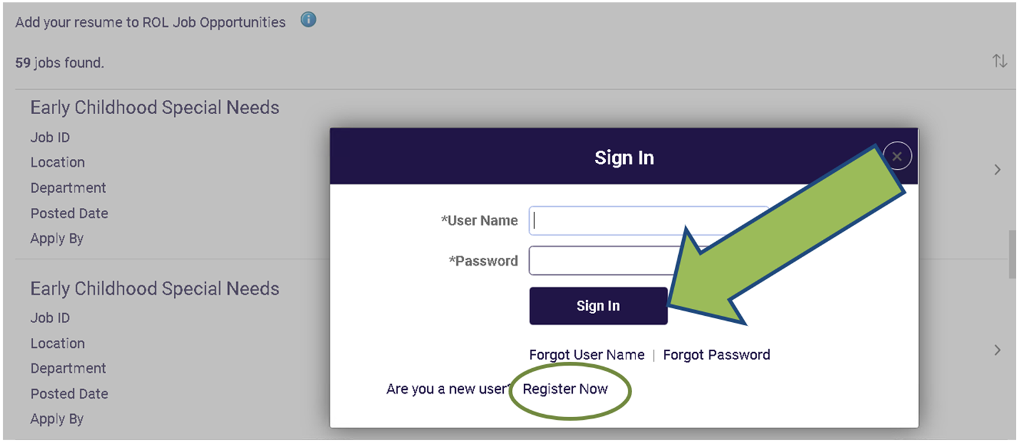

- Recruitment Online application process
After you have signed into Recruitment Online, the Job Opportunities profile screen will appear. The bar at the side of the screen shows your progress.
3.1 Step 1 of 8 - Terms and Conditions
Tick the box in the terms and conditions bar to progress to step 2. Click Next to move to step 2. This is the only step that you must complete before you can progress through the system.
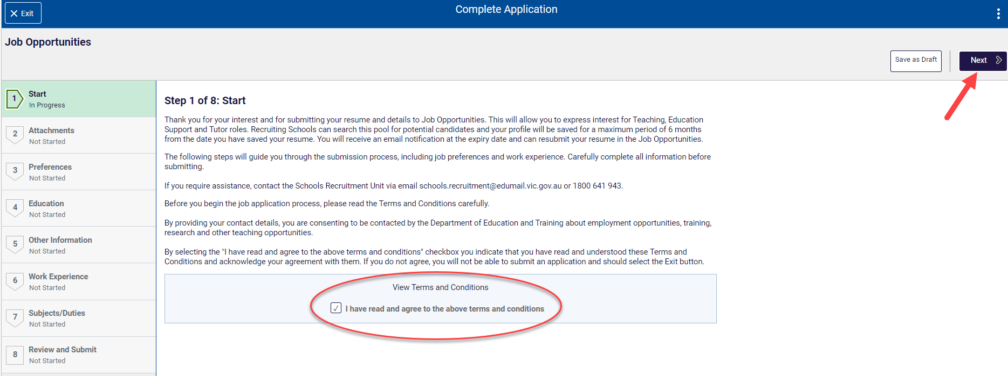
3.2 Step 2 of 8 – Attachments
You can choose to add 1 attachment to support your application. Click the “Add Attachment” button to upload a document. Your attachment should be less than 5MB in size.
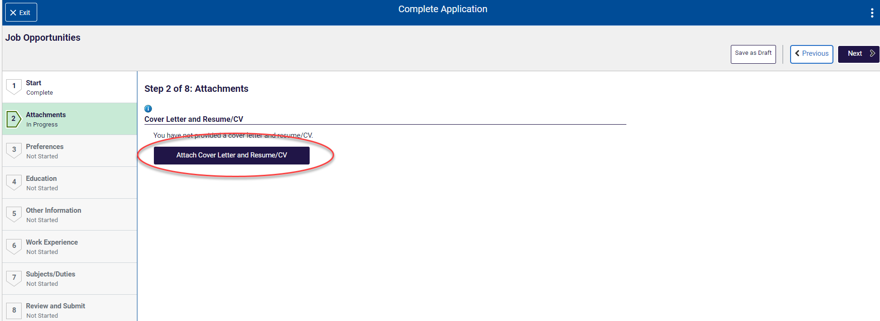
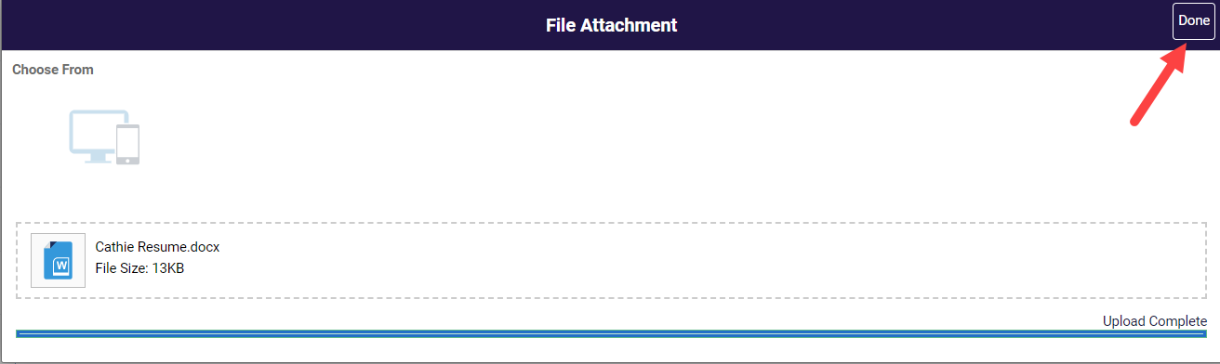

Once your upload is complete click the Done button.
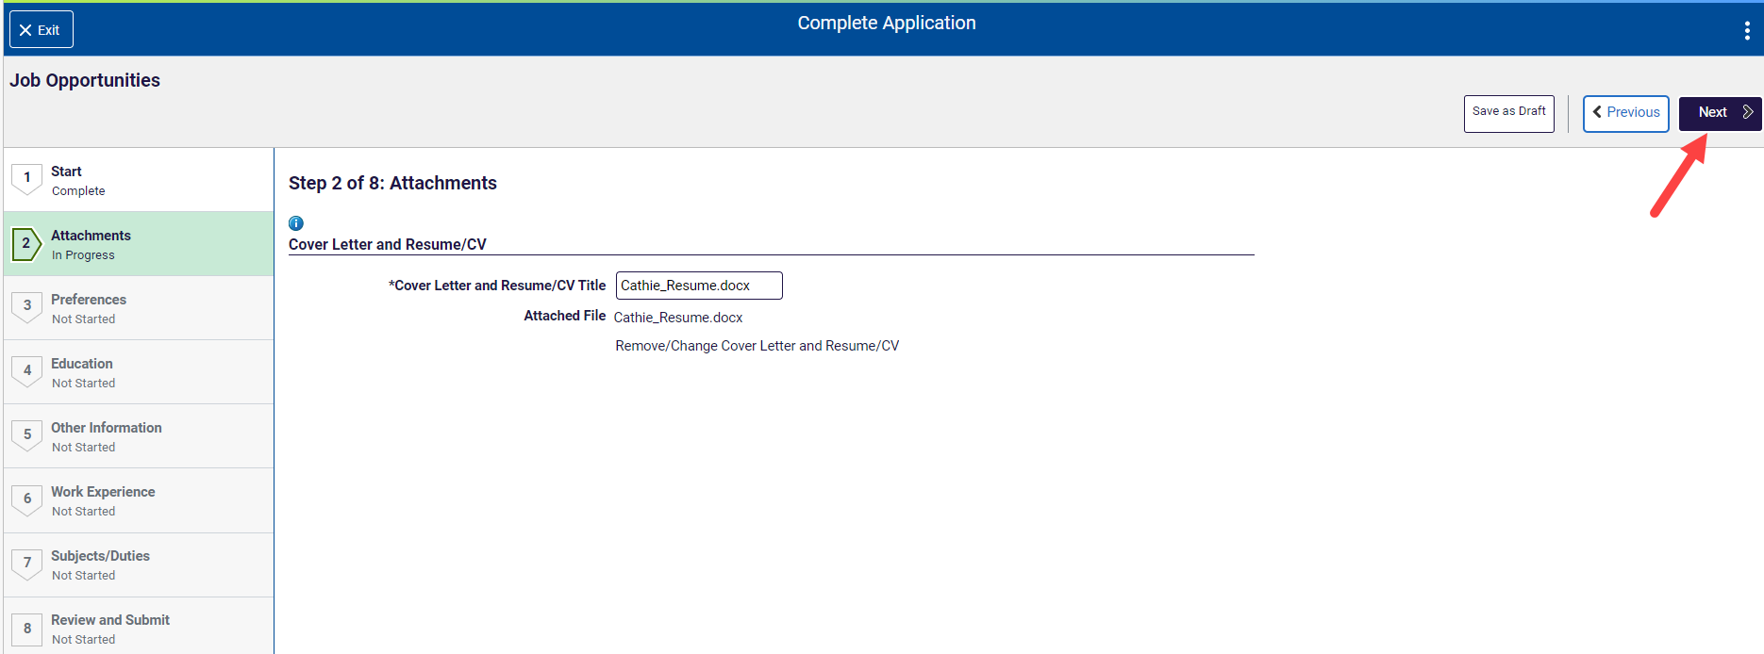
Click Next to move to step 3.
3.3 Step 3 of 8 – Preference
Choose options that are relevant to you.
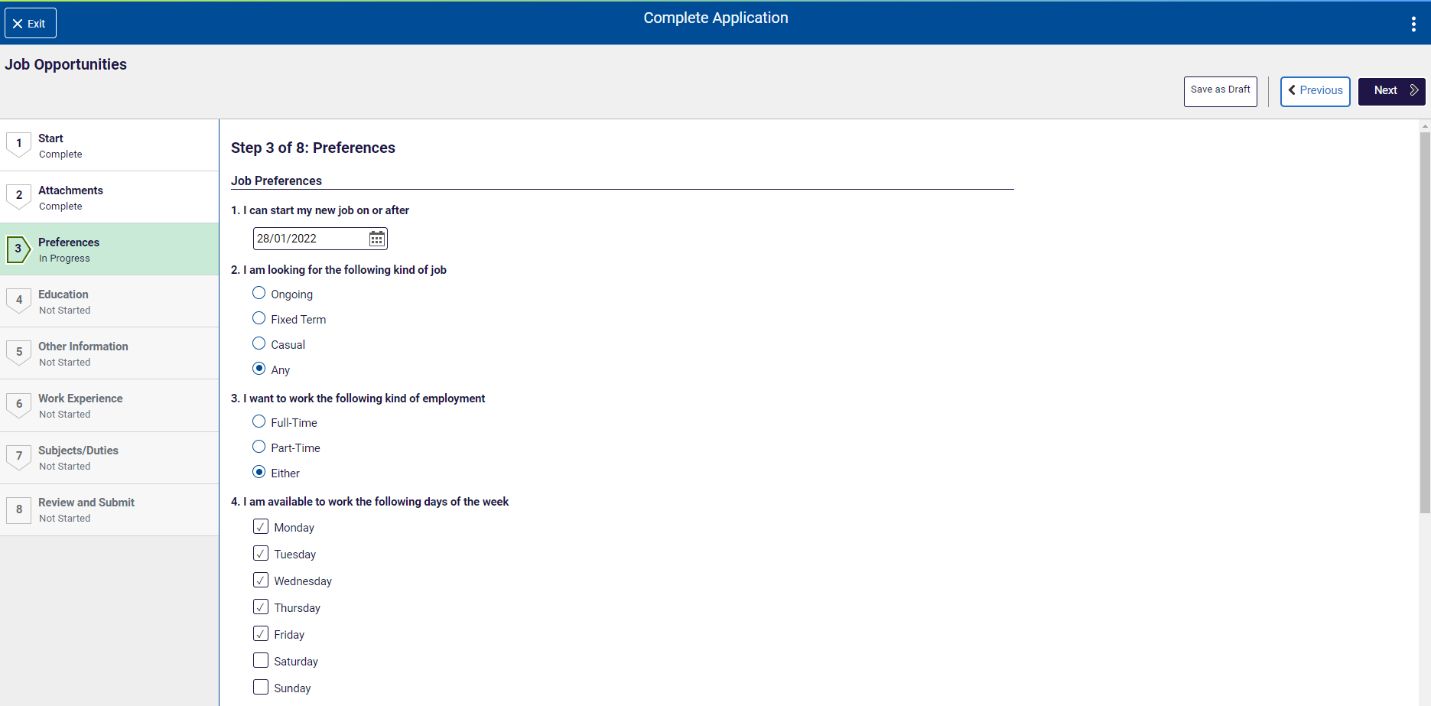

Scrolling down will allow you to also enter the number of hours per week you are able to work, Add Location Preferences and Role Types. The Role Type is important for the COVID-19 Principal Support – do not skip this step.

Enter the hours you can work per week.
You can select a Location Preference by Region, Locality or School when you click the Add Location Preference button.
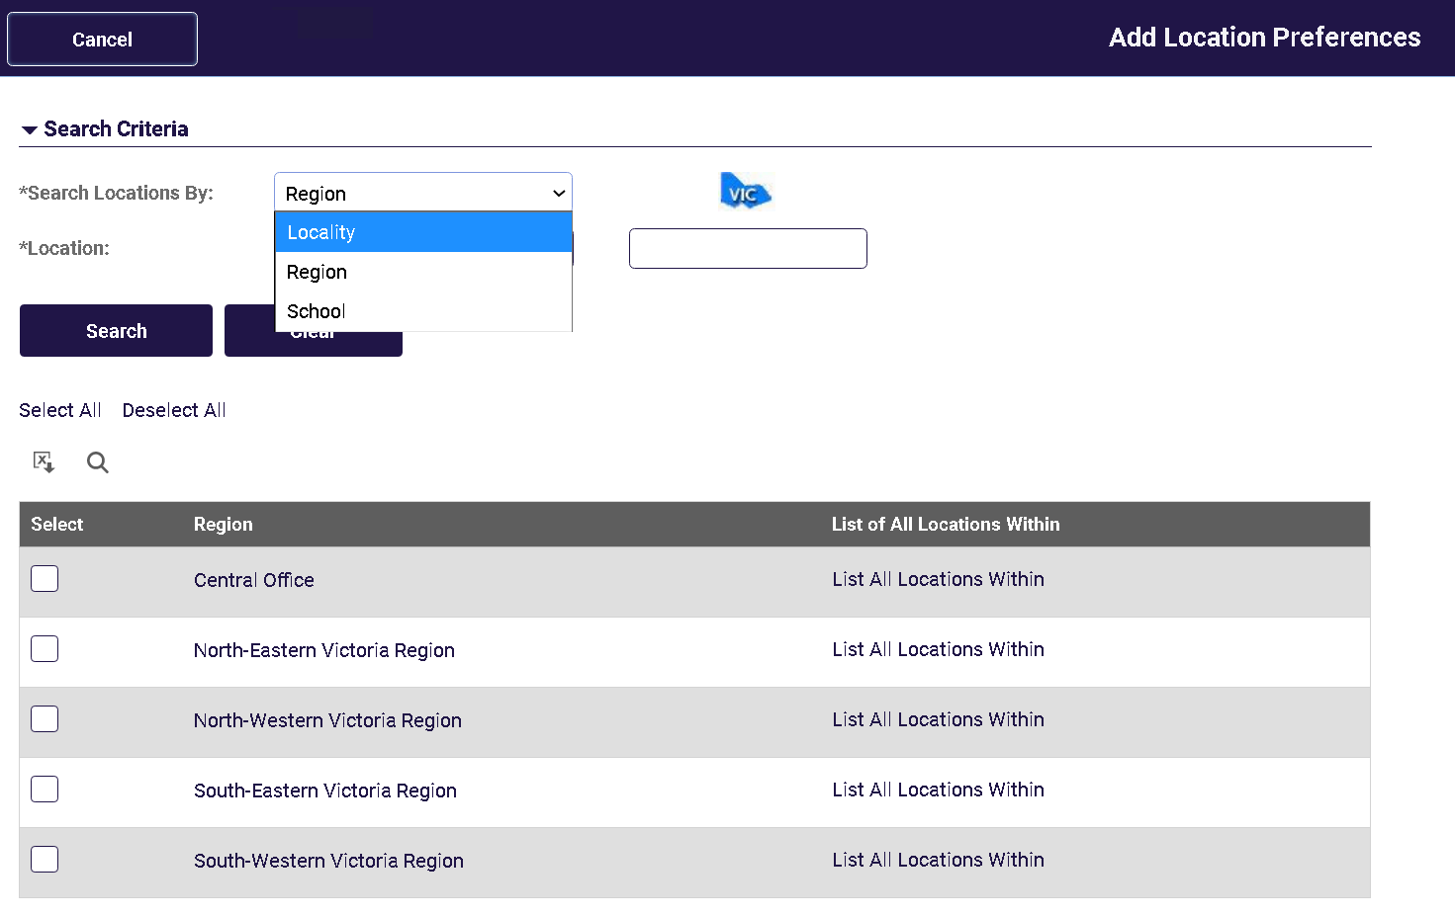
Click Add Role Types.
Click the Role Type ID lookup, select R00605 - COVID-19 Principal Support from the resulting list. The date does not need to be changed.
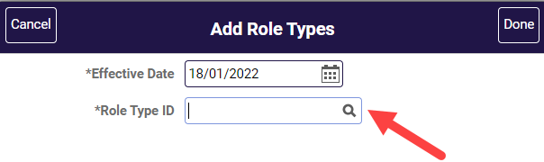
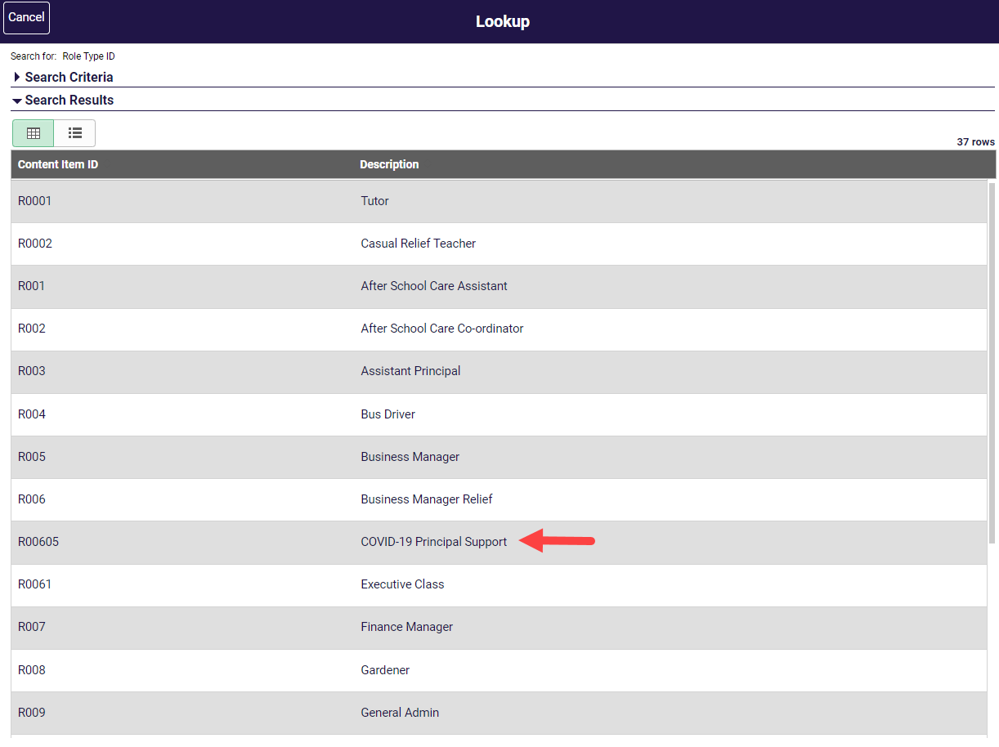
Click the Done button once you have selected Role Type COVID-19 Principal Support.
The Preferences page returns displaying the COVID-19 Principal Support role that you have added.
Click Next to move to step 4.

3.4 Step 4 of 8 – Education
You can add information about your education history to your profile. Click the buttons in this section to add information. Once you have finished click Done. Note that you can progress to step 5 without entering information in this step.
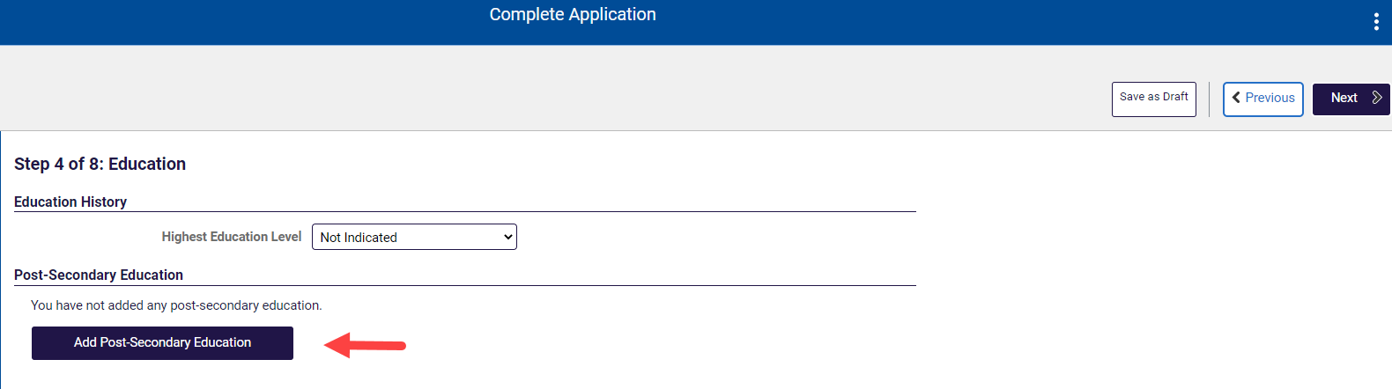
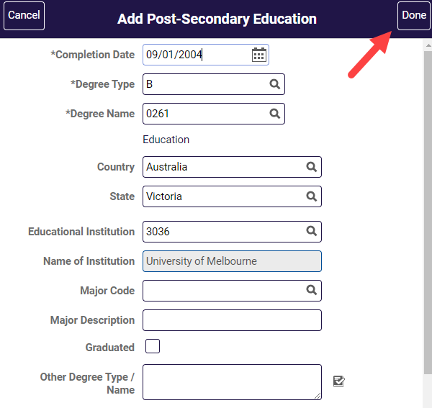
Click Next to move to step 5.
3.5 Step 5 of 8 – Other Information
Add any relevant Licenses & Certifications and Language Skills that you may have.
You may progress to step 6 without completing this section, however entry of this information may assist in the selection process.
It is recommended you record your Victorian Institute of Teaching (VIT) or Working With Children Check (WWC Check) card details in the relevant section on this page.

Click the Add VIT Registration / WWC Check button.
The following page appears when Add VIT Registration / WWC Check is selected.
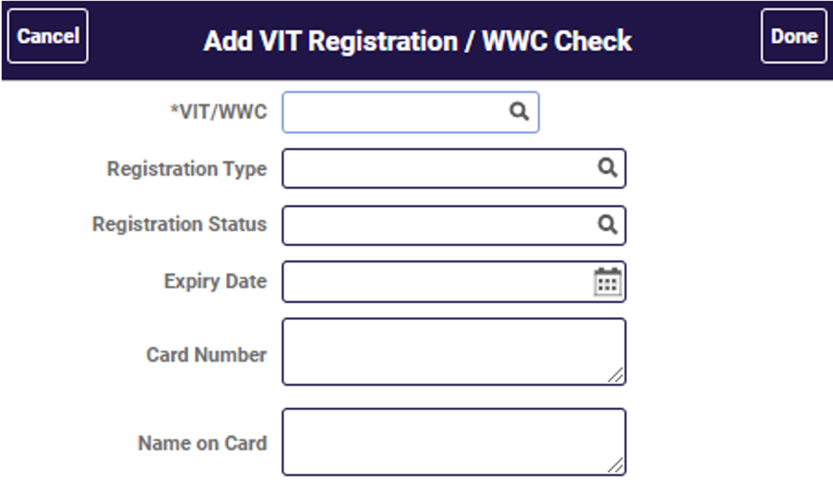
Click the VIT/WWC lookup icon and select from the options displayed for VIT or WWC Check
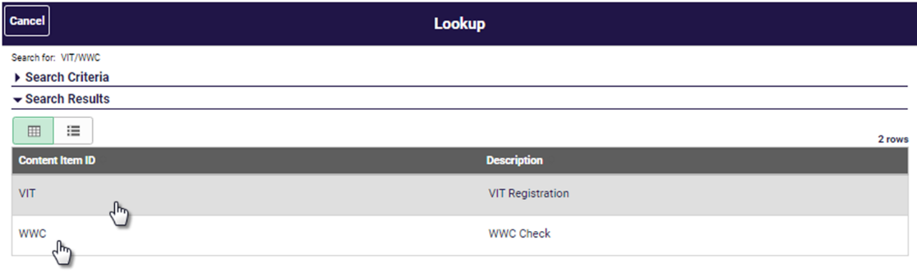
Select the appropriate registration type for VIT or WWC Check for your card.
Note: If you don’t currently hold VIT registration and you are a qualified teacher visit the vit.vic.edu.au website for more information.
You can register your interest for COVID-19 Principal Support position without current VIT registration or WWC Check, however, if you are selected for a COVID-19 Principal Support position, you will be required to provide evidence of VIT registration or an employee type WWC Check as appropriate for the position offered.

Click on the Add VIT Registration / WWC Check button. Click VIT/WWC lookup icon and select the appropriate registration for you.
Click the Registration Type look up icon and select the appropriate registration for you.
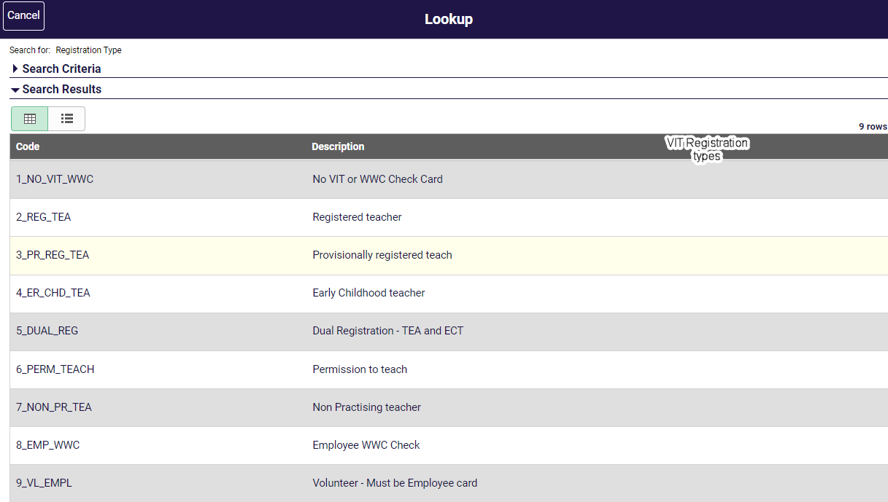
The Add VIT Registration / WWC Check page returns. Record the:
- Expiry date of your Card,
- Card number and
- Name on the card.
VIT registration must be valid for 2022.
A Working With Children Check card must be an employee type card and have an expiry date in the future. A Volunteer card cannot be used for employment purposes.
Click Done when complete. The Step 5 Other Information page returns which shows the results of your entry.
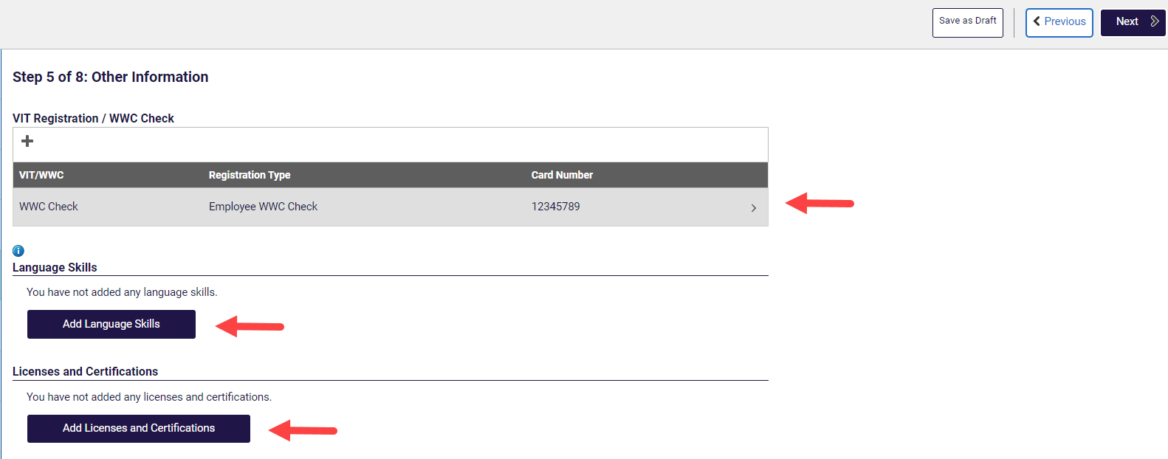
Click the Add License and Certifications button to add License/Certifications. Complete the relevant fields and click Done.
Click Add Language Skills button to add any Language skills you may have. Complete the relevant fields and click Done.
Click Next to move to step 6.
3.6 Step 6 of 8 – Employment History
You can add information about your employment history to your online application. Click the buttons in this section to add information.
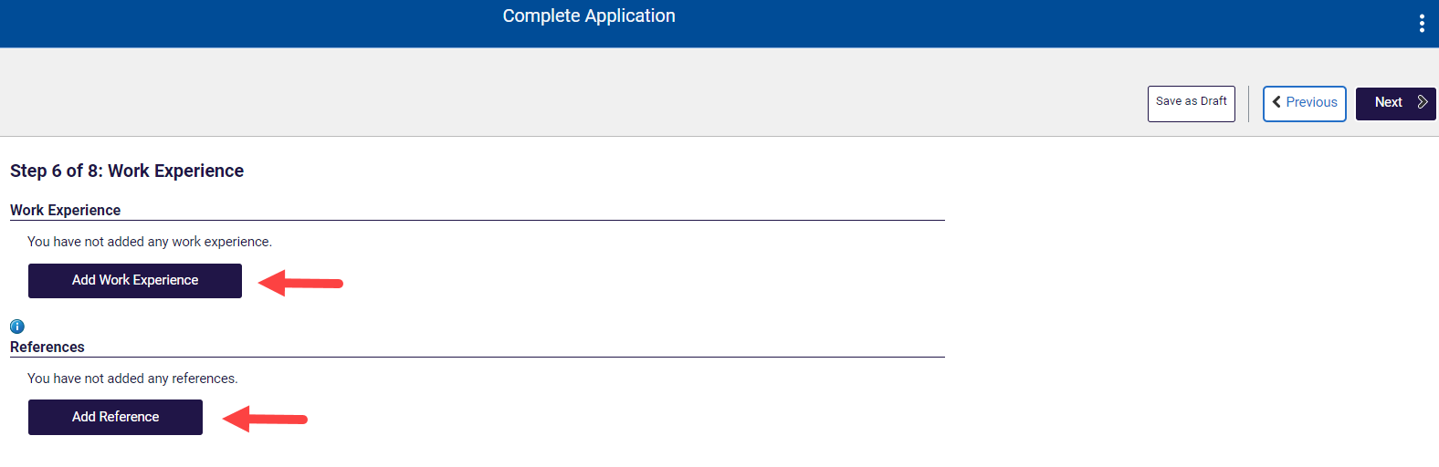
Work Experience
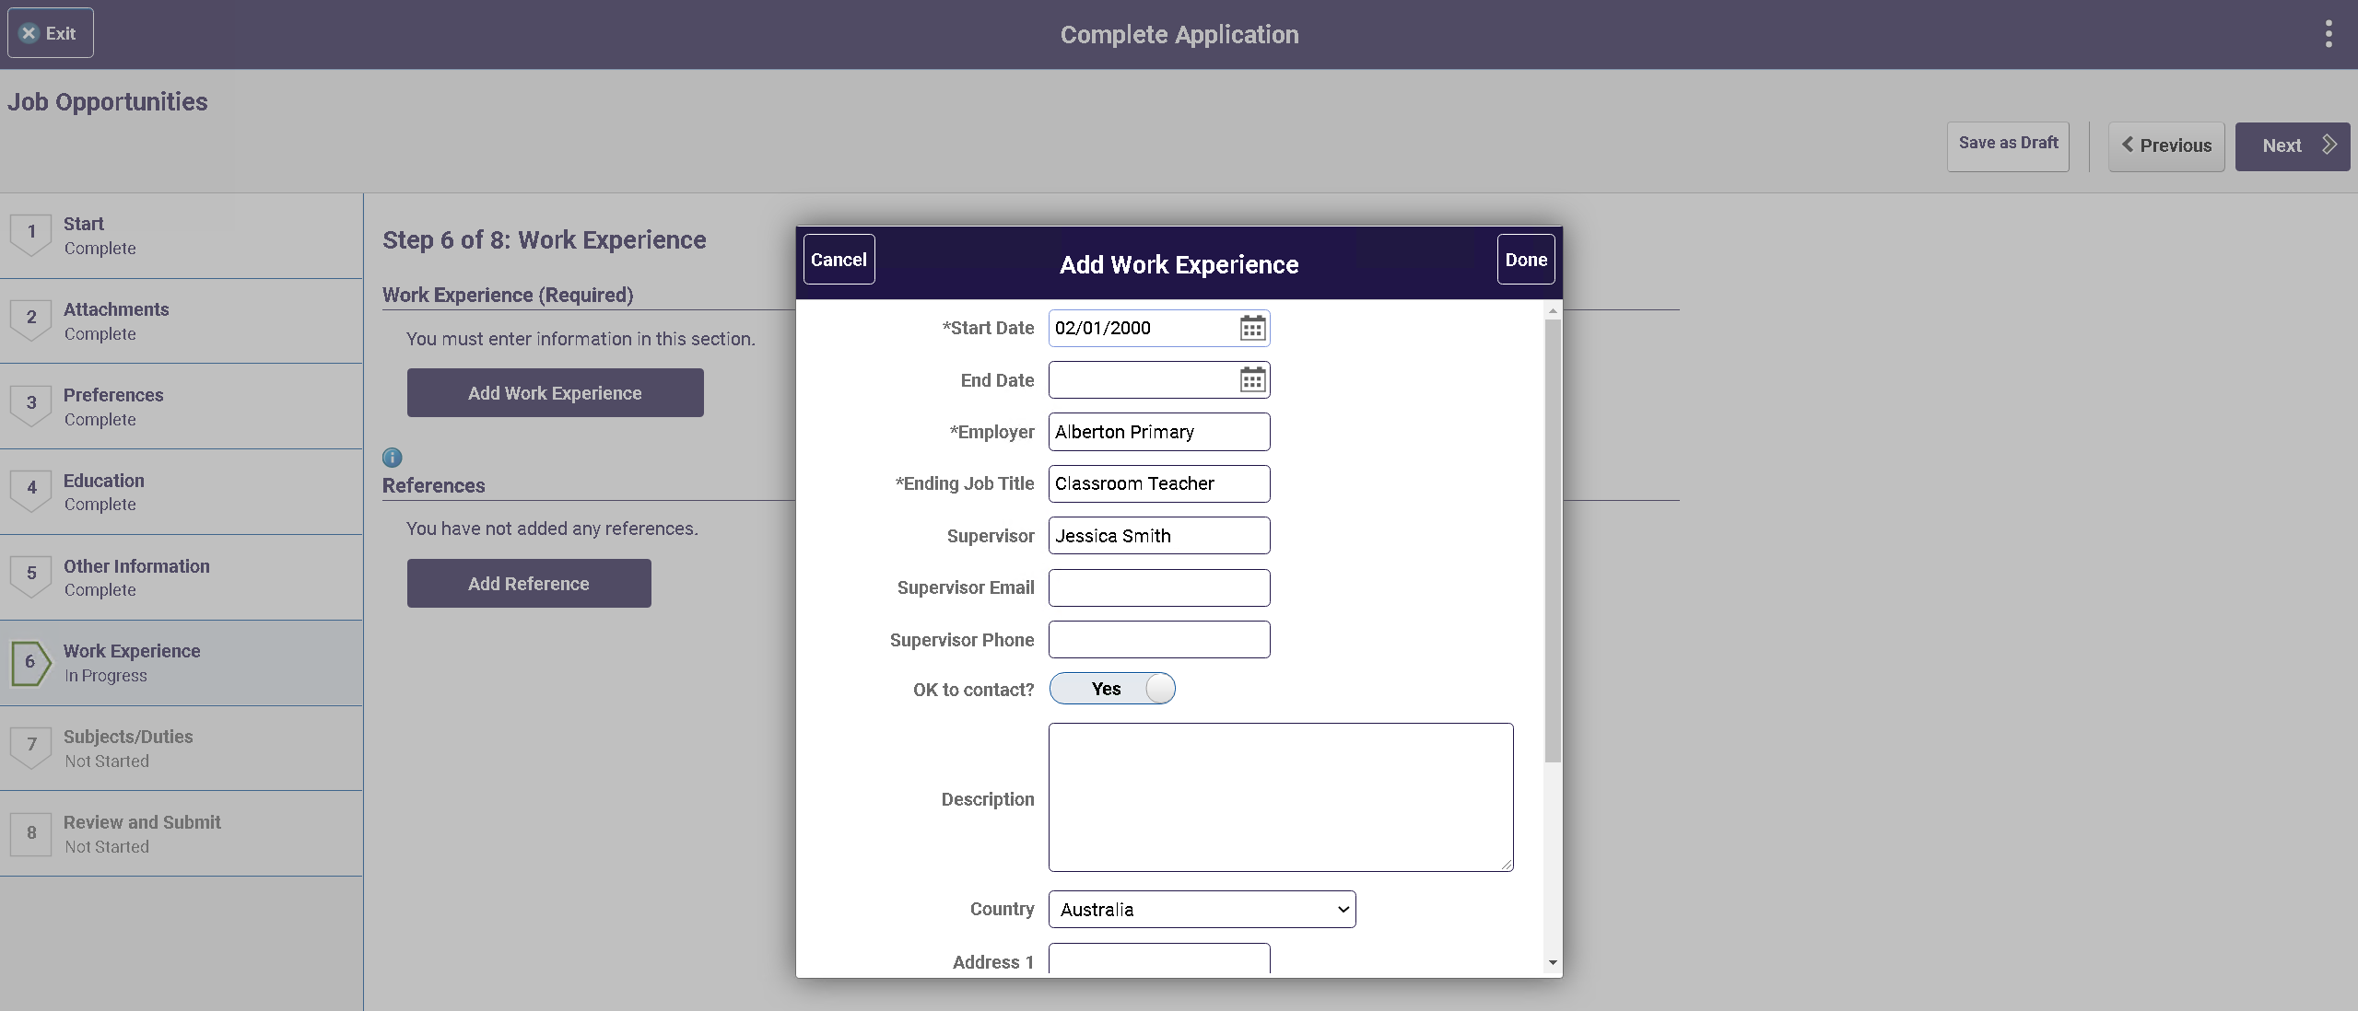
Reference
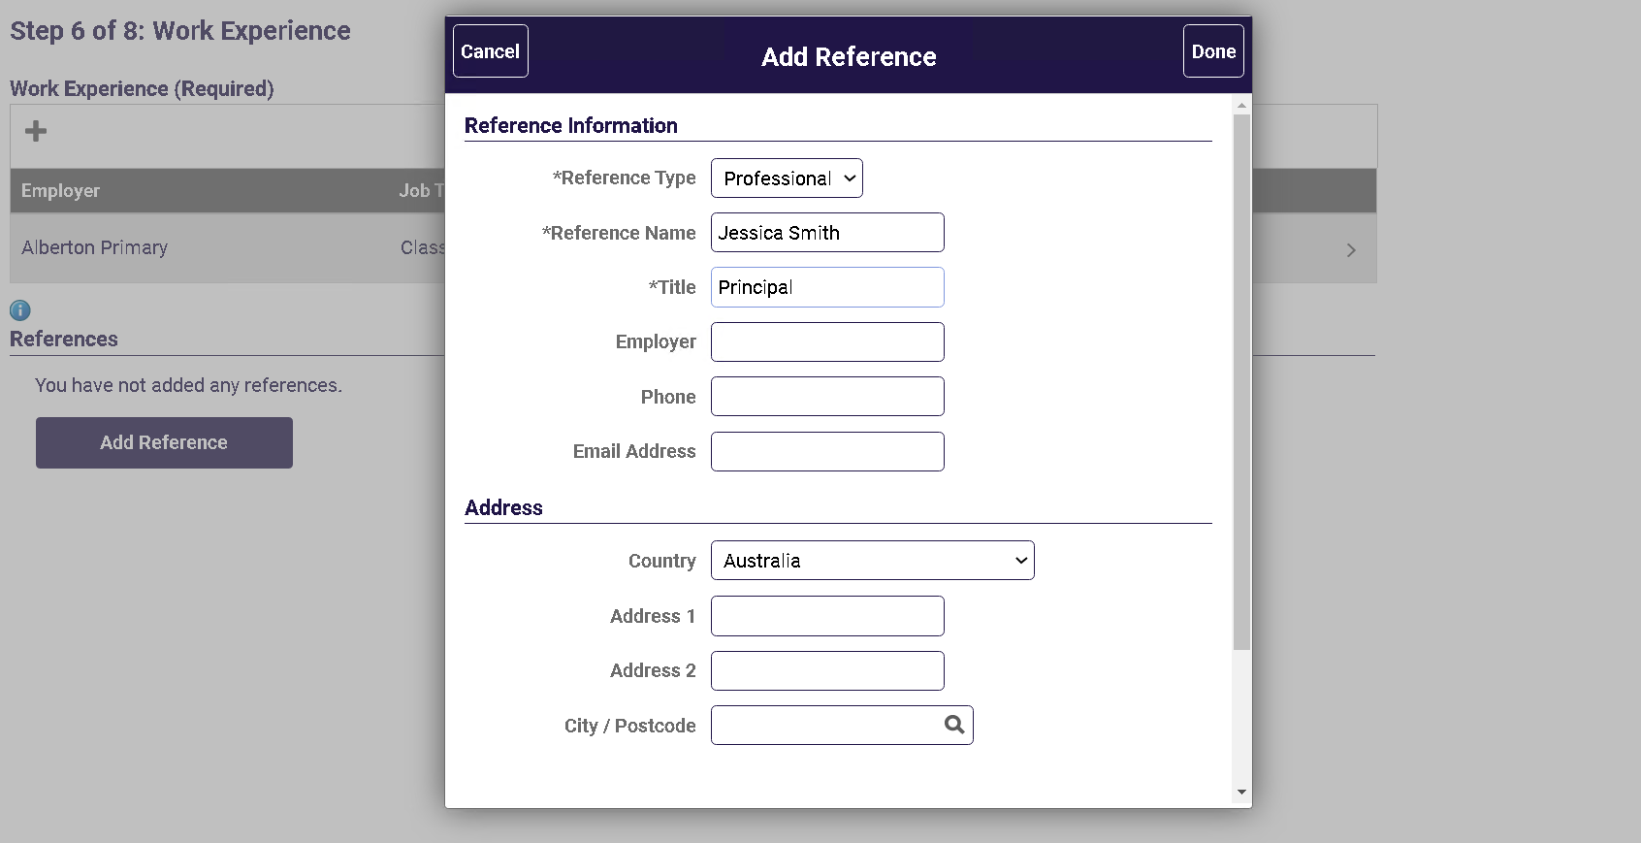
Click Next to move to step 7.

3.7 Step 7 of 8 – Subjects/Duties
For COVID-19 Principal Support vacancies it is not necessary to enter information about the Subjects/Duties you are able to teach or perform.
3.8 Step 8 of 8 – Review/Submit
At step 8, you can preview the information that you have added to your profile. To change any of the details you have entered, click the Modify link in each section.
Make sure you have indicated COVID-19 Principal Support at Step 3 Preferences under the Role Types option. This is important for principals to identify people interested in these positions.
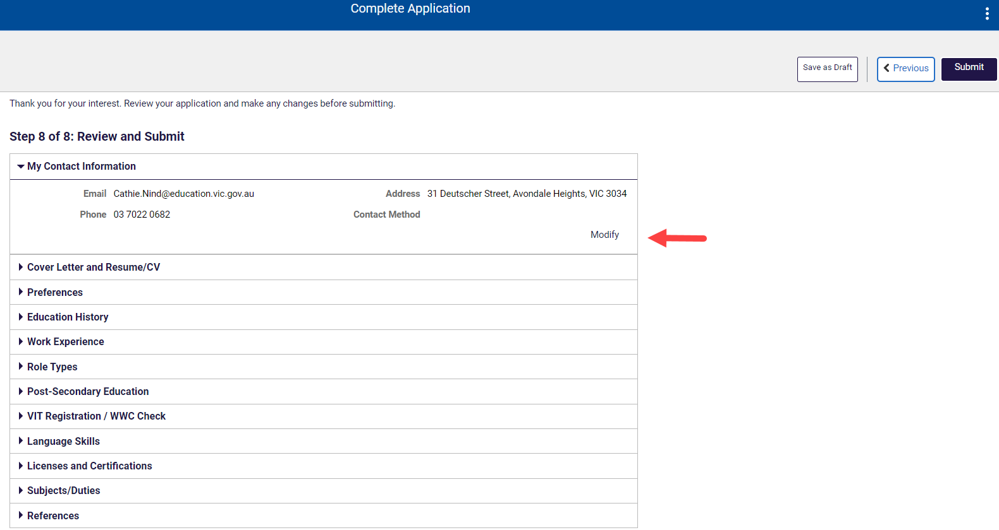
Once you are satisfied with your profile Click the Submit button.
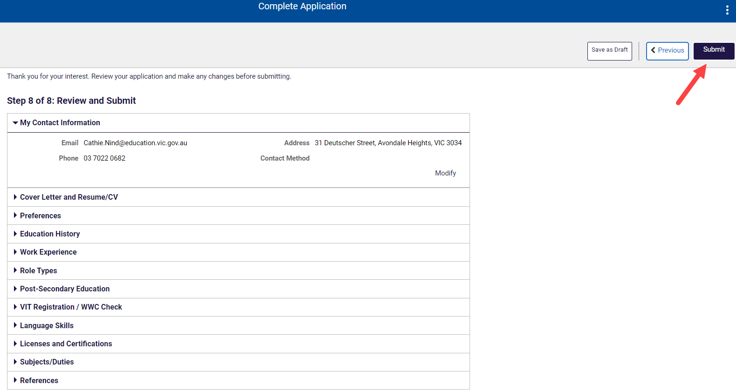

3.9 Application submitted confirmation
After you have completed and successfully submitted your Job Opportunities profile, a confirmation message will appear on screen. If you don’t see this message, you can confirm the status of your profile in My Activities.
Click the View Submitted Application to see the Application Summary.
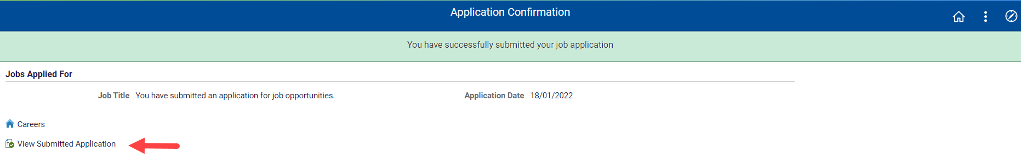
Your profile is now complete.

Additional Information
How to access your profile and withdraw from job opportunities.
Remember to use your login details when applying for other jobs advertised on Recruitment Online. Your profile will be automatically populated into your application.
Click the Careers link to return to the Careers Home screen. The Helpful Links section contains links to HR Services, Provisional Appointments and COVID-19 Principal Support information.
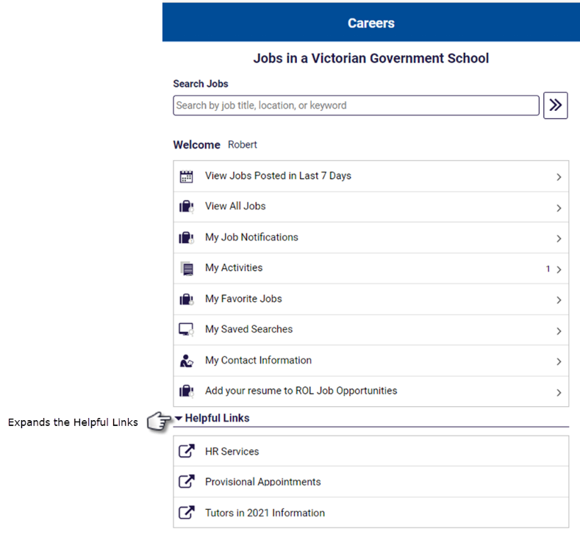
- My Activities view
In the Careers Home screen, click the My Activities link at the top of the page.
The COVID-19 Principal Support vacancies are not advertised, from the profile you have just created a principal or recruiting officer can search for your record based on their requirements against the information you have included and contact you directly.
- Withdraw from Job Opportunities
In My Activities, click the withdraw button next to the Application you wish to withdraw.
A pop-up message will appear asking you to confirm the Withdrawal.
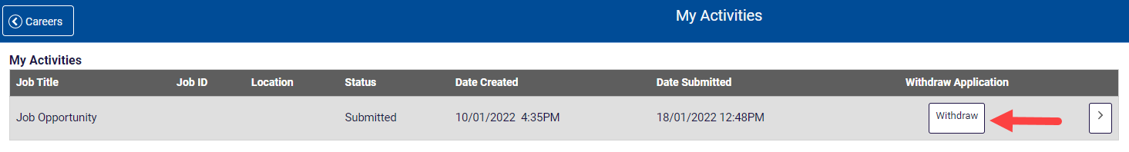
When the Application has been withdrawn, the Application cannot be edited and will be greyed out.

Contact:
Schools Recruitment Unit
Phone: 1800 641 943 (selection options for Schools Recruitment)
Email: schools.recruitment@education.vic.gov.au

