PRINCIPAL HEALTH AND WELLBEING

STRATEGY 2018-2021

Published by the Department of Education and Training April 2018
© State of Victoria (Department of Education and Training) 2018

This work is licensed under a Creative Commons Attribution 4.0 licence. You are
free to reuse the work under that licence, on the condition that you credit the State
of Victoria (Department of Education and Training), indicate if changes were made
and comply with the other licence terms available at creativecommons.org/licenses/
by/4.0/deed.en.

The licence does not apply to:
- any trademarks or branding, including the Victorian Government logo and the
Department of Education and Training logo
- images or photographs or other content supplied by third parties.

Copyright queries may be directed to copyright@edumail.vic.gov.au.

Authorised by the Department of Education and Training

2 Treasury Place, East Melbourne, Victoria, 3002

If you would like to receive this document in an accessible format such as large print
or audio, please telephone 1800 809 834 or email edline@vic.gov.au.

This document is available in PDF and accessible Microsoft Word format at
www.education.vic.gov.au

CONTENTS

OUR COLLECTIVE COMMITMENT 4
PRINCIPAL HEALTH AND WELLBEING STRATEGY 2018 – 2021 5
TEAM AROUND THE PRINCIPAL: AN INTEGRATED FRAMEWORK 7
FROM IDEAS TO ACTIONS: SEVEN NEW KEY INITIATIVES 13
FUTURE DIRECTIONS 19
EVALUATION 20
APPENDIX A: UNDERSTANDING PRINCIPAL HEALTH AND WELLBEING NEEDS 22
APPENDIX B: BUILDING ON LEADING PRACTICE 24
APPENDIX C: CURRENT SUPPORTS AVAILABLE TO PRINCIPALS 29

OUR COLLECTIVE COMMITMENT

Dear School Principals

We are thrilled to announce the Principal Health and Wellbeing Strategy 2018 – 2021 (the Strategy).

Schools thrive when principals thrive. A great education starts with confident, committed and passionate leaders. The wellbeing of our school leaders is central to creating a positive school culture for teaching and learning. We are all committed to supporting our principals to be their best, so that they can bring out the best in our teachers, support staff and young people.

The Victorian Government has invested over $5 million in the key initiatives that form part of this Strategy. It has been co-designed with the profession, for the profession. We have all worked together to create a team around the principal – central and regional employees, principals and your peak associations and unions – to develop this Strategy and its key initiatives. It represents our collective commitment to strengthening the health and wellbeing of school principals in a systematic and sustainable way.

The Strategy was developed following a comprehensive needs analysis of the health and wellbeing challenges faced by principals and a review of leading practice research. We have listened to your valuable feedback and designed an integrated framework of initiatives and practical resources that reflect contemporary research and respond to the specific needs of the profession. The Strategy places principals at the centre of these practical initiatives and aims to provide more direct support for them.

This Strategy recognises the technical and leadership skills of principals. It acknowledges that leading and managing a school is complex and comes with many challenges and multiple demands that can, and sometimes do, impact on your health and wellbeing. This Strategy includes actions aimed at reducing the stigma around mental health.

Leading a school of committed educators to help young people learn and thrive is a great privilege, with the opportunity to fundamentally change lives for the better every day. Roles with these rewards carry large responsibility, many challenges and can be stressful. The Strategy recognises these challenges and provides supports to help principals flourish in the role. This includes providing you with a choice of specialist supports and services that can be tailored to your individual needs and different school contexts. It builds on your individual skills and capabilities to proactively promote and lead positive wellbeing within yourself and your school communities. It is designed to embed a responsive service culture to ensure that principals have confidence in our services and increasingly utilise these services in a proactive way.

The Strategy builds upon the work commenced by the new School Delivery Unit. The establishment of the unit acknowledges the workload pressures experienced by principals and represents a significant cultural shift. The Unit aims to streamline and better coordinate communications and requests to schools to ensure that schools are provided with the right information, at the right time, and with the right support.

Our collective vision is to have safe, healthy and resilient school leaders leading positive school climates, supported by strong collaborative partnerships with peers, regional and central colleagues and management.

We have included in this Strategy key information about each of the new initiatives.

Your health and wellbeing matters.

Let’s continue to work together to improve the health and wellbeing of Victorian Government school principals.

Signed by the Secretary

PRINCIPAL HEALTH AND WELLBEING STRATEGY 2018 – 2021

VISION
The Principal Health and Wellbeing Strategy (the Strategy) aims to protect, promote and address mental and physical health and wellbeing outcomes for principals across Victoria. Our vision is to have safe, healthy, resilient and connected school leaders who are supported by strong collaborative partnerships with peers, areas, regions and central colleagues. Principals are pivotal to schools achieving excellence in teaching and learning. Their health and wellbeing is vital to them being effective wellbeing leaders within their school.

SCHOOLS THRIVE WHEN PRINCIPALS THRIVE
The Principal Health and Wellbeing Strategy aligns with the Whole of Victorian Government (WoVG) Mental Health and Wellbeing Charter (the Charter) that was launched by the Department in March 2017. The Charter demonstrates a strong commitment across government to improve health and wellbeing of the public sector at all levels.

The WoVG Mental Health and Wellbeing Charter approach:

- PROTECTING health and wellbeing by identifying potential risks and implementing practical strategies to mitigate these risks.
- PROMOTING health and wellbeing by building awareness, capability and confidence amongst employees to empower and assist them to manage their own wellbeing as well as promote the wellbeing of others.
- ADDRESSING potential health and wellbeing challenges through the provision of timely and professional support services.

The Principal Health and Wellbeing Strategy translates this Charter to meet the wellbeing needs and priorities of our school principals. The Strategy seeks to take into account the realities of a principal’s role and ensures support mechanisms to suit their unique circumstances.

The purpose of this Strategy is to provide a clear roadmap to help the Department achieve this vision. The Department, made up of principals, regional and central office colleagues, commits to this roadmap to achieve our vision. It represents our shared commitment to improving principal health and wellbeing. The Department has committed over $5 million in funding to help implement this Strategy.

Co-designed with the Profession for the Profession
This Strategy has been co-designed with the profession, for the profession. It is the result of consultations with over 3000 school leaders across the principal class and each of the peak associations and unions. The Department has listened to the lived experience of principals, and learned from conversations about what can improve their health and wellbeing (Appendix A). We have also incorporated inputs from experts and research into leading practice to ensure a strong evidence-base for this Strategy (Appendix B). The key initiatives that make up this Strategy reflect a balance between building on contemporary thinking and standards around health and wellbeing and responding to the specific needs of the profession.

WHY FOCUS ON PRINCIPAL HEALTH AND WELLBEING?

Growing Focus on Wellbeing at Work
The World Health Organisation defines mental health or wellbeing as ‘a state in which every individual realises his/her potential, can cope with normal stressors of life, can work productively and fruitfully and is able to make a contribution to his/her community’. The growing incidence of mental health issues within the population affects individuals, organisations and communities alike and poses a significant financial and social burden. Promotion of health and wellbeing requires a collaborative approach and there is a growing recognition of the role that workplaces can play in elevating wellbeing within the community. Building heathy workplaces not only helps protect individuals from health and wellbeing risks, but also helps them to flourish and operate at their best.

The Department is committed to creating a healthy and thriving culture that helps support the wellbeing of our school principals in a potentially volatile and ever-changing work environment.

School Leadership: A Rewarding and Demanding Role
As school leaders, principals have complex and demanding leadership roles. They are not only educational leaders; they also play the role of being workplace managers, looking after the day-to-day operational aspects of running a safe and effective school environment. In many instances, principals are also regarded as leaders within the local community. Principals often have a unique blend of technical and leadership skills, resilience and resourcefulness that help them navigate this complex environment. Most principals find their roles extremely rewarding and as a profession register higher levels of job satisfaction than the general population.

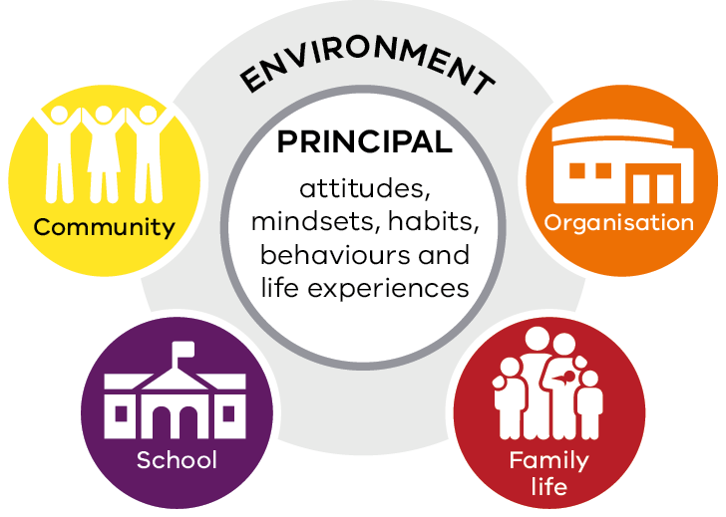
Figure 1: Key Stressors in a Principal’s Role (adapted from the ‘Transactional Model of Stress’)

Principals must manage multiple demands from within the school, the broader community and the central and regional offices, often spanning multiple legal requirements, as well as government policy and program commitments. Principals also have to attend to the pressures of life outside of work such as family commitments, financial obligations, personal matters and health issues. These ongoing challenges can have a cumulative impact on the health and wellbeing of principals.

The Strategy will help ensure that we are embedding a combination of proactive and responsive initiatives to help principals thrive in their roles. It builds on the inherent strengths that principals bring to their role and supports them with targeted initiatives that are available when they need it the most.

The Australian Principal Occupational Health, Safety and Wellbeing Survey found that nationally, when compared to the general population, principals experienced higher levels of:

- Job demands (1.5 times higher)
- Emotional demands (1.7 times higher)
- Emotional labour demands (1.7 times higher)
- Burnout (1.6 times higher)
- Stress symptoms (1.7 times higher)
- Difficulty sleeping (2.2 times higher)
- Cognitive stress (1.5 times higher)
- Somatic symptoms (1.3 times higher)
- Depressive symptoms (1.3 times higher)
- 2.9% reported thoughts of self-harm, often or all of the time.

Achieving Excellence in Teaching and Learning Outcomes
School excellence relies on our principals being healthy and safe. Their wellbeing contributes to a positive school culture that maximises teaching and learning outcomes.

The Principal Health and Wellbeing Strategy will assist with the achievement of two key elements of the Framework for Improving Student Outcomes (FISO) — a positive climate for learning and professional leadership.

The Strategy also aligns with the Developing self and others professional practice requirements outlined in the Australian Professional Standard for Principals and recognises principal health and wellbeing as a fundamental enabler for success.
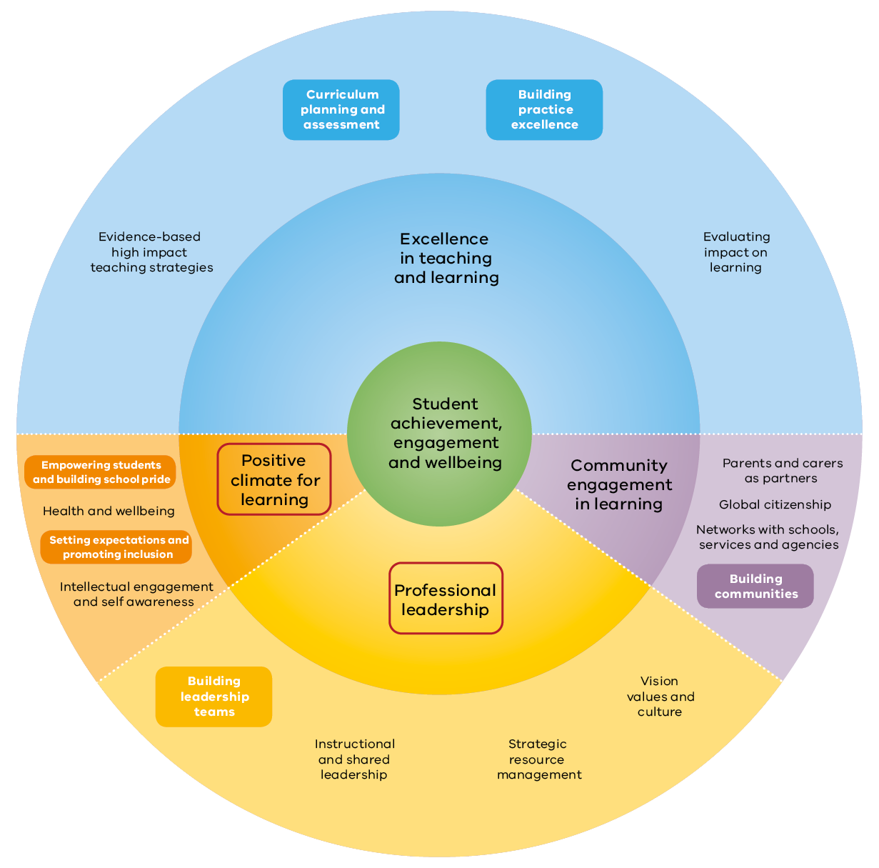
Figure 2: Alignment with FISO Outcomes

TEAM AROUND THE PRINCIPAL: AN INTEGRATED FRAMEWORK

The Strategy defines for the first time an integrated framework of supports that can work cohesively to promote and sustain the health and wellbeing of our school leaders. It maps the existing system, fills gaps, and encourages everyone who works with principals to consider health and wellbeing in everything they do. This approach ensures an effective team around the principal to support their health and wellbeing.

WHY INTEGRATED?
The term ‘integrated’ refers to a systematic approach where different supports work cohesively together to provide a joined-up service framework. An integrated approach to workplace health and wellbeing combines the strengths of health promotion, OHS and human resources to optimise both the promotion of health and prevention and management of health problems in the workplace.

- There is a growing recognition that wellbeing and health promotion activities within organisations require a more holistic and integrated approach to have sustainable impacts
- The central and regional offices currently offer a range of services to help support the health and wellbeing of principals
- However, the consultations to date highlight the need for more improvements in how these supports work and provide more information to build awareness of these services and ways to access them
- The development of the Strategy identified potential gaps and opportunities to ensure a more integrated and holistic support framework.

Integration is no small aim for our large system, but it is critical for the delivery of better wellbeing outcomes for school principals, and helps them in turn to become better wellbeing leaders for their respective school communities. As such, it is a framework we aspire to achieve together over time.

KEY FEATURES OF THE INTEGRATED FRAMEWORK
- Demonstrates the need for shared leadership across the Department towards delivering more integrated, joined-up services to enhance principal health and wellbeing
- Provides access to multiple support options that offer a combination of practical, operational supports along with physical, psychological and social supports
- Builds on the existing organisational service structure to reinforce the range of supports available to principals
- Underpinned by key initiatives that address the gaps identified across the current suite of services
- Recognises the need to support principals in becoming effective wellbeing leaders in their own schools.

BENEFITS OF THE INTEGRATED FRAMEWORK
This Integrated Framework has been designed to create a wrap-around system of supports for principals to help them flourish in their role as school leaders. Some of benefits to principals include:

- Addressing key sources of stress (e.g. workload and managing complex matters) through practical and operational support
- Offering principals the flexibility to choose from multiple support pathways (both internal and external) depending on what best suits their present needs
- Providing access to specialist supports and services to meet individual wellbeing needs and challenges
- Embedding a culture of support across the Department
- Promoting individual skill and capability to enhance their own wellbeing
- Equipping principals with the tools and confidence to be effective wellbeing leaders for their teachers, students and the broader school community.
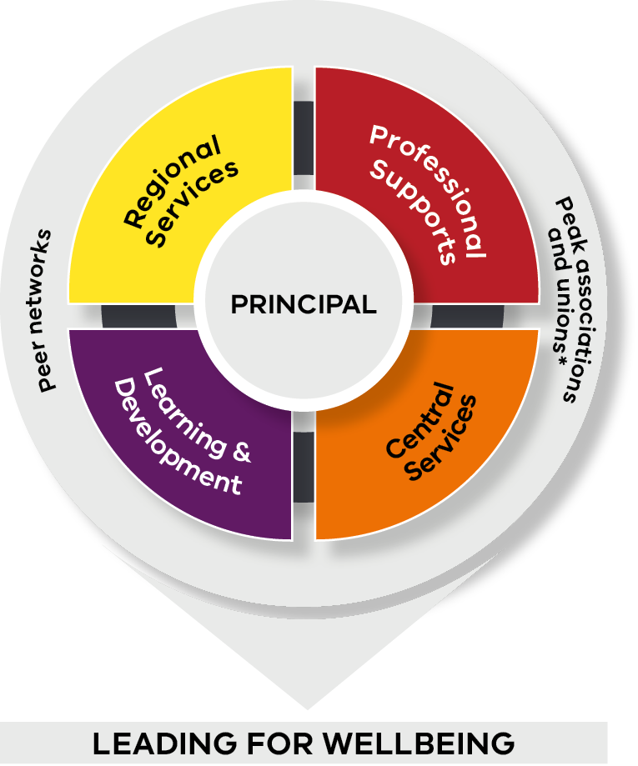
Figure 3: The Team around the Principal
*Accessing additional wellbeing supports offered through professional associations and unions are optional

WORKING TOGETHER TO DELIVER A FRAMEWORK OF INTEGRATED SUPPORTS
The Integrated Framework recognises that different functions and roles across the Department need to play a role in supporting and enhancing the health and wellbeing of our principals. It represents our collective aspiration and acknowledges gaps in the current system to deliver a well-rounded system of supports.

Regional Services
Regional Services aim to provide operational services that support schools at the local level. Local supports can have the greatest immediate impact on principal health and wellbeing. They are frequently the first point of call for many of the day-to-day challenges that principals face. Regional leaders provide critical line management support to principals through advice, guidance and coaching. Similarly, dedicated regional staff can help principals activate a range of locally available services through Learning Places and Communities of Practice, including advice on managing student behaviours, teaching and learning, occupational health and safety (OHS), and other operational challenges faced by principals. Regional services also have a team of specialists who can help support principals with emergency response, safety and security issues within schools.

“Just knowing that I had the backing of my SEIL in dealing with this complex issue made my stress levels go down. It made me feel like we were working on this together – it wasn’t all up to me. This hasn’t always been my experience in the past.”

QUESTION: When facing a difficult technical or legal issue, do you know who to contact in Regional or Central services for support?
The Department is currently developing the Principals Page + which will help clarify who you can contact for what purposes. Our aim is to ensure you can access the relevant supports simply and in a timely way.

Central Services
Central Services aim to provide principals access to in-house technical specialists who provide advice, systems and policies to guide schools in their operations. This can impact the health, safety and wellbeing of all employees (including principals).
The role of Central Services can range from providing expert technical advice and guidance, identifying systemic challenges and issues, developing and implementing effective organisational systems and policies to managing service delivery standards through contractors. Central Services include the Principal Support Unit, the Legal Division, OHS, Payroll, Recruitment, Workers’ Compensation, media and communications and Employee Conduct Branch, to name a few.

“The practical advice from the Legal Division makes me feel supported through difficult times. In my experience, they have always been highly responsive, empathetic and helpful in navigating some of the issues that I’ve had to manage.”

QUESTION: Are the number of direct reports you have adversely affecting your wellbeing?
Evidence shows that having too many direct reports can significantly increase the supervisory load for leaders and result in ineffective delegation of authority and increased workload. A study conducted on a sample of principals in 2017 shows that over 75% of them had over 12 direct reports.

The Department’s Organisation Design Guide offers practical steps to help you practice distributed leadership. It can help you identify your optimal number of direct reports to reduce the workload associated with supervising too many staff. This is particularly relevant for larger schools.

Learning and Development
Learning and Development aims to provide proactive strategies that help build skills and confidence of principals to better manage health and wellbeing – their own and that of others. Building capability amongst principals can help them be effective at leading positive school climates. Learning and development supports empower principals with the necessary skills, tools and resources through access to professional learning. They help principals better manage their own wellbeing and that of others and recognise when to seek additional support. While a majority of these are currently made available through the Bastow Institute, several other areas of the Department provide opportunities for specialist training and professional development sessions as part of maintaining professional practice standards.

“The Evolve program was just what I needed when I started out in my role as a principal. The transition can be quite daunting because of the sheer breadth of responsibilities. The Evolve program offered practical technical skills that I could draw on and having access
to an expert coach was invaluable.”

Professional Supports
Professional Supports aim to provide external, expert supports that have been engaged by the Department to help support the health, safety and wellbeing of all staff (including principals). These services can be accessed on demand. The Department recognises that on some occasions, principals may benefit from and prefer accessing advice and support from experts external to the Department to seek a different and independent perspective. A number of these services are confidential and free for principals to access. Principals can seek support on personal health and wellbeing issues, advice and coaching on managing complex staff issues, and health and safety, amongst other services.

“When it comes to my own health and wellbeing, it’s easier talking about it with someone external to the Department. There’s still a lot of stigma attached around raising health and wellbeing issues – I don’t want to be seen as ‘not coping’. Having experienced, independent experts to debrief was very helpful.”

QUESTION: Do you ever debrief with a trained professional for your mental health and wellbeing?
Principals as a profession are not required to undertake professional supervision – a good practice framework widely utilised across Allied Health professions. Yet the research suggests that the uniqueness of the principal role and their high exposure to challenging interactions makes them well suited to benefit from professional supervision with a trained professional to help maintain their health and wellbeing.

Professional Networks, Peak Associations and Unions
Peer networks provide critical social capital that is essential for sustaining wellbeing in a principal role. Social capital refers to the benefits of social networks that build solidarity and mutual goodwill and reciprocity by linking a group of individuals together. The Department actively encourages principals to participate in formal and informal peer networks to help principals feel connected and reduce potential feelings of isolation. Peer networks often help identify and escalate shared issues that require a more systemic solution. They encourage sharing of innovative strategies and help create economies of scale. In addition, these networks also provide an important source of peer support and consultation that can help complement other systemic supports. Peak associations and unions offer their members wellbeing supports through professional learning forums and one-on-one advice, should principals choose to join.

“It is always helpful to know that you are not alone in your journey as a principal. It can be an isolating one unless you build your peer networks. Your peers can sometimes be your biggest source of support. They know what you’re going through. Making a quick call or
meeting over a coffee can make a difference.”

Principals
Finally, in order for the Principal Health and Wellbeing Strategy to be effective, principals themselves are encouraged to play an active role. Health and wellbeing often requires a personal commitment on the part of the individual. Like any sustainable behaviour change, it requires the development and maintenance of personal wellbeing habits and strategies. Principals are encouraged to proactively engage with the range of strategies on offer through the Department and identify ones that work best for them. Their active involvement and feedback will help ensure that the services put in place are effective in meeting their needs and adopt a continuous improvement approach.

As principals, you often put yourself last. You’re always prioritising the wellbeing of your students and your staff over your own. You want to instil confidence in others by not letting anything get to you. But if you are not looking after yourself or getting support when you need it – you’re not going to be of much assistance to those you lead.”

QUESTION: Have you asked someone to check-in regularly with you on your health and wellbeing?
Individuals are often the last to realise that they are not feeling their best. Consider having a ‘critical friend’ who can check in with you on a regular basis. This can be a family member, a peer in another school, or someone in your leadership team. Make sure they know the referral pathways for support so they can prompt you to seek timely assistance to sustain your health and wellbeing.

BUILDING ON EXISTING INITIATIVES AND SUPPORTS FOR PRINCIPALS
The Department already has a number of existing initiatives that support principal health and wellbeing.

Principal Support Unit (PSU)

Expert advice and support on curly HR and workforce matters
The PSU consists of former principals and expert VPS staff providing principals with confidential and specialist advice and support. The PSU conducts school visits and ongoing phone/email consultations with principals (as well as with regional, professional association and union personnel seeking input to their support for principals). The PSU also runs workshops for principals and prospective principals addressing a range of topics which are drivers of many of the ‘wellbeing issues’ arising for school leaders such as people management, human resource issues, decision making, managing consultative processes, workforce planning and building leadership within their schools.

School Delivery Unit (SDU)

Starting the cultural shift on how the Department communicates with schools
The SDU was established in January 2018 in response to feedback from schools and peak bodies that principals receive too much information and too many requests, from too many central office and regional channels. This was seen as having a significant impact on principal health and wellbeing. The SDU helps coordinate information and requests sent to schools and ensures that principals are provided with the right information, at the right time, and with the right support.

Principal Health and Wellbeing: Mindsets for Effective Change

Building capability to help principals manage stress and thrive in their roles
The Bastow Institute of Educational Leadership (Bastow) offers a practical two-and-a-half-day workshop which is designed to help the principal-class better understand the impact of their role on their health and wellbeing and reduce stress by developing an individualised health and wellbeing plan. This workshop does not simply present a range of standard resilience or coping strategies, but rather seeks to engage deeply with the individual’s situation and motivating beliefs to explore immediate alternative strategies.

Learning Places

Mobilising expert support in the regions to assist schools
Learning Places embeds multi-disciplinary teams and approaches in each of the 17 Areas to provide schools, students and their families with more local access to a range of experts – from executive leaders to curriculum and assessment expertise, and a dedicated health and wellbeing workforce. These teams work together to ensure that a holistic, focused and complementary set of skills and resources are available to those most in need.

Employee Assistance Program (EAP) and Manager Assist

Confidential and free access to expert support for personal and workplace wellbeing challenges
EAP is a short-term, effective and strictly confidential counselling service that is available 24/7 for up to four sessions for the Department’s employees to discuss any personal or work-related issues. Similarly, the Manager Assist is a telephone advisory service supporting principals and managers to access management support and coaching. Both services are free to use and can be accessed by calling 1300 361 008.

Local Administrative Bureau (LAB) Model

Creating economies of scale – administrative support for smaller schools
LAB provides cost effective and high quality administration support for small Victorian schools on an opt-in, fee-for-service basis. Its aim is to reduce the impact of red tape and the day-to-day administrative burden on principals and business managers so they have more time to focus on learning and teaching outcomes, strategic planning and management of their resources. Staff at the LAB are trained and kept up to date in best-practice administration for Department policies and systems. Their services include administration support in the areas of finance, budget, payroll, administration and the Student Resource Package (SRP).

FROM IDEAS TO ACTIONS: SEVEN NEW KEY INITIATIVES

To learn more about each of these initiatives, please visit the Principals Page +

KEY INITIATIVES 2018-2019

PROACTIVE INITIATIVES

School Policy Templates Portal
What is it?
- Suite of relevant policy templates
- Meets legal, Departmental policy, and school registration requirements
- Easily adapted for each school

How will it benefit principals?
- Reduces workload by providing resources to support compliance
- Provides practical guidelines for policy implementation

Service type
Central Services

Principal Mentor Program
What is it?
- On demand access to experienced principal mentors
- Mentors trained in psychological first aid
- Up to 12 hours of mentoring on offer

How will it benefit principals?
- Reduces feelings of isolation
- Connects principals to experienced peers
- Provides operational and psychological support

Service type
Learning and Development

Regional Capability Development
What is it?
- Capability development sessions for regional leaders and staff
- Skills and resources to better support principals’ health and wellbeing

How will it benefit principals?
- Provides a culture of care and support through regular engagement on health and wellbeing
- Promotes awareness of supports available

Service type
Regional Services

Proactive Wellbeing Supervision
What is it?
- Allied health model bi-annual debriefing sessions with an experienced psychologist (being piloted in two networks)
- Proactive check-in for new and acting principals at 6-8 week mark

How will it benefit principals?
- Proactive debrief opportunities with an independent provider
- Development of a personalised wellbeing plan and strategies

Service type
Professional Supports

Principal Health Checks
What is it?
- Access to physical and mental health check services
- Detailed health assessment report
- Independent provider
- Confidential and voluntary

How will it benefit principals?
- Provides expert practical health and lifestyle advice based on assessment
- Access referrals to specialist services as needed

Service type
Professional Supports

RESPONSIVE INITIATIVES

Complex Matter Support Team
What is it?
- A Lead Professional will coordinate and connect principals with supports from a number of areas
- Assist with responding to correspondence from parents and advocates

How will it benefit principals?
- Reduces principals’ workload in managing complex cases
- Provides expert guidance and support to ensure better outcomes

Service type
Regional Services

Early Intervention Program
What is it?
- Early intervention for principals requiring support through self referrals
- Access to up to 12 mental health and 4 physical support sessions

How will it benefit principals?
- Provides support before health issues escalate
- Enables principals to choose a provider of their choice for ongoing support

Service type
Professional Supports

SEVEN NEW INITIATIVES TO SUPPORT THE PRINCIPAL HEALTH AND WELLBEING STRATEGY FRAMEWORK
The Department has committed over $5 million to help implement pilot strategies to address the potential gaps identified through the Principal Health and Wellbeing Strategy Discussion Paper. This funding builds upon existing Department initiatives and paves the way for the introduction of seven new pilot initiatives to support principal health and wellbeing in 2018.

The seven pilot initiatives aim to:
- Address the key gaps identified through our consultations with the profession to date (Appendix A)
- Draw on leading practice frameworks in promoting mental health and wellbeing (Appendix B)
- Offer principals a combination of proactive and responsive services
- Provide more services where the Department actively works with principals to support their health and wellbeing, rather than simply providing access to more self-help strategies
- Target operational, physical, psychological and social wellbeing resources to help support principal health and wellbeing
- Establish a principal-centric service delivery model where each initiative integrates seamlessly with the others, ensuring more cross-referrals.

The feedback and evaluation outcomes for these pilot initiatives will help inform longer-term strategies for enhancing principal health and wellbeing.

LISTENING, LEARNING AND RESPONDING TO PRINCIPALS’ NEEDS

School Policy Templates Portal

What we heard
- Developing school-level policies is an essential but time-consuming part of a principal’s role
- Having to balance multiple policy requirements ranging from various legislations, Departmental polices and school registration requirements made the task of drafting school level policies extremely complex and added considerably to principals’ administrative workload
- Principals told us that they would like more support from the Department to help meet their policy compliance requirements.

Our response
The Department is providing principals and schools with a suite of policy templates that are written in plain English, are all located in the same place (the portal) and meet legal, Departmental policy and school review and registration requirements. Principals can tailor the templates to meet their school’s particular needs. Research indicates that workload is a critical job demand that impacts on employee wellbeing as it requires sustained physical and psychological effort. Job demands may result in physical and mental health problems such as burnout if workload transforms into chronic overload.
The School Policy Templates Portal is a proactive operational initiative that will streamline the process of developing and implementing school-level policies and reduce principal workload.

Principal Mentor Program

What we heard
- Principalship is an exciting, unique and challenging role. It requires knowledge and know-how in an almost unprecedented range of disciplines, from pedagogy and data analysis to literacy, procurement and counselling
- The role can also be an isolating one and several principals have suggested that having access to an experienced mentor, who has been in their shoes, would enhance some aspects of their role
- Most principals are aware of the benefits of mentoring and actively mentor others, but few have mentors themselves.

Our response
The Principal Mentor Program is a proactive initiative offered through Bastow that will link principals (including acting principals) with a trained mentor who is an experienced and highly skilled recently retired principal. Mentors will partner with their mentees to share their expertise—as a sounding board and trusted advisor. Mentors will be supported to recognise emerging health and wellbeing issues and respond to them appropriately.

There are a number of well-established benefits to mentoring, including improved self-confidence, greater personal satisfaction and growth, an increased availability of advice and relevant information, encouraged reflection on practice, additional personal support, and reduced isolation. Higher levels of health and wellbeing has also been noted as an outcome of mentoring amongst school leaders. The Principal Mentor Program will offer timely support from a trusted peer who has a unique understanding of the challenges and rewards that come with this remarkable role.

Regional Capability Development

What we heard
For most principals, the culture of support stems from the perceived support they experience from the regional leadership teams and support functions they interact with on a regular basis (e.g. SEILs, AEDs, RDs, CLOs, OHS Support Officers, etc.)
Principals reported that the nature and extent of support received from regional leaders and staff varied considerably across individuals
Principals also indicated that dual responsibilities of regional leaders to support principals and monitor performance made them reluctant to raise wellbeing issues with their leaders.

Our response
The Regional Capability Development initiative aims to develop the skills, capabilities and confidence of regional leaders and staff so that they can contribute to a culture of care and support for principals. A genuine culture of care and support can significantly buffer the impact of the day-to- day challenges that principals experience. There is significant evidence to show that building a supportive culture at work can help minimise the stigma associated with raising mental health issues and encourage individuals to seek help early. A growing body of evidence shows that positive leadership approaches that help build psychological capital can help promote wellbeing amongst employees.

Through a series of capability development workshops, this pilot program will establish a shared understanding and language for discussing wellbeing at work and equip regional staff with practical tools and resources to help principals access the supports that they need.

Proactive Wellbeing Supervision

What we heard
- The principal role can be a challenging role that may place significant demands on their own wellbeing
- Principals reported that they would benefit from more proactive access to psychological support services from someone familiar with their role context
- They identified a preference to debrief with an independent expert practitioner on personal and professional aspects of their role that impact on their wellbeing
- New and acting principals reported feeling overwhelmed 6-8 weeks into their role.

Our response
The Proactive Wellbeing Supervision pilot is a proactive initiative aimed at offering principals (including acting principals) access to bi-annual wellbeing supervision sessions with an experienced psychologist. Supervision is a well-recognised good practice framework that enables wellbeing across a number of professions. It has been adopted as a professional requirement across allied health services, in recognition of the high psychological demands placed on allied health professionals. A wellbeing supervisor can help employees use their resources effectively, manage their workload, mitigate the effects of stress and potential burnout and optimise motivation and morale.

The Proactive Wellbeing Supervision pilot will allow principals to debrief and acknowledge potential impacts of their work on their own health, wellbeing and performance (both in and outside of work). This pilot program will also offer a proactive outreach initiative through which an experienced psychologist will contact all new and acting principals, six to eight weeks after commencing in their roles. These sessions will serve as opportunities for principals to engage in reflective practice and adopt preventative strategies to help them thrive and succeed in their roles.

Principal Health Checks

What we heard
- The Australian Principal Health and Wellbeing survey highlights that many health and wellbeing ratings are lower than that of the population average
- In state-wide consultations principals reflected on the impact of aspects of their job on their health and wellbeing
- Having access to professional health and wellbeing supports and advice was identified by principals as important in supporting them to maintain their health and wellbeing
- Principals wanted the option of seeking health consultations that were discrete and confidential in nature.

Our response
Principal Health Checks is a new dedicated proactive service, which provides principals with free, confidential health checks. These health checks are voluntary and include a comprehensive assessment covering pathology, lifestyle, medical examination and mental health. Given the confidentiality of the service, the Department will only receive de-identified, aggregated data on the uptake of the service and a summary of emerging health and wellbeing trends. The Principal Health Checks is just one way the Department continues to develop, implement and promote initiatives specific to Principal wellbeing. It will supplement existing confidential support currently available to individual principal-class members, including the Employee Assistance Program.

A preventive approach to health incorporates the prevention of illness, injury and disease, rehabilitation of chronic illness and the reduction in the burden of illness in a community. Initiatives such as the Principal Health Checks have been identified as a key preventative mechanism that can assist with the early detection and prompt intervention to treat any health concerns.

QUESTION: Are you having difficulties with sleep? The Principal Health Checks can help.

Research shows that a lack of adequate and quality support can have a negative impact on mood, concentration and lead to reduced feelings of wellbeing. The Australian Principal Occupational Health, Safety and Wellbeing Survey found that 54% of principals suffer from poor quality sleep. The Principal Health Checks offer proactive call backs to help principals better manage their sleep difficulties as part of the advice and consultations offered through this service.

Complex Matter Support Team

What we heard
- Responding to complex matters involving students or complaints from parents and advocates can take significant time, and may require principals to seek input and advice from a number of areas across the Department
- Management of complex matters can add significantly to a principal’s workload
- Principals reported feeling quite overwhelmed when having to take on the management of a complex matter in addition to their day-to-day school management responsibilities.

Our response
There are growing incidences of complex situations that school principals face which create additional work demands for them. As research has consistently linked high work demands to negative health and wellbeing outcomes, the Complex Matter Support Teams aims to reduce the additional workload that principals experience when managing complex situations by directly supporting principals who are dealing with complex cases.

Under this initiative, a Lead Professional from the Team will be the principal’s single point of contact in central office, to coordinate and connect them with supports from the Region and various program areas across the Department. The Lead Professional will also reduce the principal’s workload by preparing responses to complex and frequent correspondence from parents and advocates on the principal’s behalf.

This initiative will reduce the workload and stress of principals when responding to complex matters. The Complex Matter Support Team is also a part of the recently announced Protective Schools Initiative that ensures better support for principals to manage instances of violence in schools.

Early Intervention Program

What we heard
- The Department offers a wide range of services to help respond to health and wellbeing challenges amongst principals, however many of these services were not being accessed early enough to prevent a health and wellbeing issue from escalating
- Potential and actual health and wellbeing risks left unattended can result in the development of physical and psychological injuries that may have long term, debilitating impacts on principals
- A number of Departmental teams supporting principals also identified a need to have a referral mechanism through which principals who were struggling could access physical or psychological health supports.

Our response
The Early Intervention Program is a responsive initiative that aims to support principals to manage early onset health and wellbeing risk indicators and prevent them from escalating i.e injury management. This will enable the Department to encourage principals to self-refer and seek timely professional support for their health and wellbeing from a qualified health provider of their choice through this pilot. The pilot will help mobilise appropriate professional supports, referral mechanisms, resources and tools for principals that can assist with the restoration of their health and wellbeing for work and non-work related matters.

There is significant evidence to show that an effective early intervention approach can help prevent psychosocial injuries that are difficult to remediate when addressed at a later stage. A robust early intervention program relies on early identification of risk factors and a multi-pronged approach to prevent escalation of health issues.

FUTURE DIRECTIONS
The Principal Health and Wellbeing Strategy presents a significant cultural transition for the Department and how we support the health and wellbeing of our principals. The seven new key initiatives outlined in this document are the starting point for this journey. The Department is committed to exploring a number of additional activities to help ensure that we are continually embedding health and wellbeing into our existing organisational systems and cultural practices.

Some of the additional activities that are being undertaken and considered include:

- Mental health and wellbeing capability development sessions are in development as part of implementing the WoVG Mental Health and Wellbeing Charter. The focus of these sessions will be to raise awareness about mental health within the workplace and introduce foundational skills for understanding wellbeing and enhancing the capacity to manage stress and build resilience by drawing on well-validated strategies (including cognitive behavioural techniques, strengths based approaches and emotional intelligence). School teachers, staff and principals will have access to tailored sessions to help broaden and build their social and psychological capacity required to flourish – both in and outside the workplace. It is envisaged that this initiative will help principals build their own capability to enhance their wellbeing and adopt a whole of school approach to leading wellbeing in others.

- Set up an interactive Principals Page + (Appendix C) that provides easy access to supports currently available to principals along with up-to-date contact details for accessing these supports. This revamped, interactive site will provide a combination of practical, operational supports as well as the full suite of health and wellbeing resources and tools that principals can use to enhance their own health and wellbeing and that of others. The Principals Page + will also be utilised to collect ongoing feedback to improve these services.

- Implementing a Protective Schools Initiative that will offer principals better operational advice and support following the reporting of school incidents that impact school operations or the health and wellbeing of students. Principals and staff making reports will get immediate expert advice on how to respond to any incidents and receive fast-tracked access to social workers, behavioural experts and psychologists. The initiative will also be looking at enhanced data analysis to identify trends and initiate preventative actions, build capability across support staff to help manage students with challenging behaviours, and embed effective case management for complex student matters. A Protective Schools Taskforce, comprising educators, psychologists and child health experts has formed and will help guide the implementation of initiatives that will prevent and mitigate violence and aggressive behaviours in schools.

- Enhanced principal readiness by assisting aspirant principals to understand their leadership skills and capabilities prior to taking on their first principal role. This model will provide them with opportunities to receive feedback on their current leadership capabilities against the Australian Professional Standards for Principals, including Developing Self and Others. Feedback from the model will provide insights into further professional learning to be well prepared for principalship in a Victorian Government school.

- Developing a principal health and wellbeing welcome pack to ensure that new principals are made aware of the health and wellbeing supports available to them at the outset. This pack will look at connecting new principals to different support functions – both regional and central – and promoting a culture of care. The program will integrate the New Starter Debriefs and Principal Mentor Program, both of which are designed to support new principals transitioning into the role. The welcome pack will complement and exist alongside the Evolve program and regional induction processes.

- Improved messaging for the expectations of school parents and communities is currently being considered. This messaging will help clarify key messages to the parent and school community to manage their expectations around appropriate conduct and accepted behaviours. It is anticipated that this initiative will provide clearer guidance for parents to help ensure that their interactions with the school remain constructive and respectful at all times.

- OHS Strategic Review is currently underway to examine how principals and schools can be better supported to manage the safety of their immediate environment including psychological and physical safety. The scope of the review includes assessing service design and operating models, and the effectiveness of the OHS Management System.

- Applied research into job design will further examine the workload of principals and optimal organisational design for Victorian Government schools, building on the significant research to date. Job design requires careful assessment and alignment between the nature of the work, the systems of work that are in place, the physical environment and the person-job fit. Job design has been well recognised as a way of enhancing health and wellbeing and improving productivity amongst staff. It is anticipated that this research will help inform future practices that can help streamline the workload of schools and principals in a sustainable way, while also delivering more effective school outcomes.

- Supporting the transition of experienced principals seeking retirement by offering opportunities to apply for coaching and mentoring roles. This initiative will help ensure that we value their experience and provide career transition channels that allow them to share their years of practical knowledge. This is already being put into practice through the Principal Mentor Program. Expressions of interest are being sought from recently retired principals to be a part of a trained and capable panel of mentors who will be managed by Bastow.

EVALUATION

WHY EVALUATE?
The purpose of evaluation is to make a commitment to the profession for successful project management, continuous improvement, and to report on progress relating to the Strategy and pilot initiatives. The Strategy evaluation framework will assess the reach of the initiatives at regular intervals during the implementation phase, as well as measure the effectiveness of the Strategy and the initiatives in building principals’ sense of wellbeing in their role.

The evaluation of the Strategy aims to:
- Address whether fit-for-purpose targeted interventions are being delivered
- Address whether the investment in the Strategy is resulting in the desired impact
- Increase accountability and visibility for achieving results
- Make recommendations for future improvement.

WHAT DOES SUCCESS LOOK LIKE?

What does successful implementation involve?

The Strategy will be evaluated to measure whether each of the initiatives are designed and implemented as intended. It is essential that the initiatives clearly respond to needs identified through the extensive research and consultation stages of developing the Strategy. In order to achieve successful outcomes, sufficient resources will need to be allocated to each of the initiatives and monitored throughout implementation. The Department will actively communicate and promote the utilisation of the initiatives and how they can be accessed. Monitoring the utilisation rates across the implementation phase will provide early indications of success across each pilot.

Successful implementation will also require strong involvement and support from the Department’s leaders. The Department will establish regular feedback loops with principals and their representative bodies and build on their feedback to inform future stages of implementation. As the initiatives are part of an integrated framework of supports, cross-referrals between the pilot initiatives will also be a measure of implementation success. To ensure success through the various stages of implementation, the Department commits to providing six monthly progress updates based on key metrics. This will ensure that any emerging issues are identified early and addressed promptly through a continuous improvement cycle.

How will we know we are achieving success over time?
Health and wellbeing outcomes can take longer to be realised than other strategic outcomes and can be difficult to measure as they operate in environments that are constantly changing. The Department has developed a longer-term vision to evaluate both individual and organisational measures which have been linked to health and wellbeing. At the end of the three year period we expect to see the extent to which these factors have improved to indicate an overall increase in principals’ health and wellbeing.

At an individual level:
The experience of service delivery over a period of time will be an indicator of the long-term success of the Strategy and its initiatives. A successfully embedded Strategy will minimise the sources of stress for principals and result in perceived improvements to health and wellbeing. An increase in job satisfaction and employee engagement are also key individual factors that will indicate the success of the Strategy in addressing principals’ health and wellbeing.

At an organisational level:
A successful Strategy will also have broader implications at an organisational level and the environment in which the principal operates. Positive outcomes will include a reduction in workers’ compensation claims, improvement on the rate of return to work and a decrease in unplanned absenteeism. A decrease in turnover rates and an improvement in the perceived attractiveness of a principal role will also be key indicators of the Strategy’s success.

APPENDIX A: UNDERSTANDING PRINCIPAL HEALTH AND WELLBEING NEEDS

A robust health and wellbeing strategy for principals needs to be based on a clear understanding of the health and wellbeing challenges faced by principals within their operational context. Over the past year, the Department carried out an extensive needs analysis, consulting with a wide range of stakeholders including:
- key stakeholders, namely principals, peak principal associations and unions
- subject matter experts across the Department
- branches across the Department that directly support principals
- the entire principal class through the 2017 Term 4 Area Forums.

The review team also considered this feedback against leading practice standards by considering input and guidance from:
- a literature review of international leading practice for the mental health and wellbeing of school leaders
- academics in the areas of leadership and principal mental health
- organisational psychologists.

The findings of the review were published in the Principal Health and Wellbeing Discussion Paper that was released in August 2017. The paper captured the wellbeing challenges faced by principals and provided critical insights of the lived experience of principals. This helped identify some clear health and wellbeing needs of principals.

EMERGING AREAS OF FOCUS FOR IMPROVING PRINCIPAL HEALTH AND WELLBEING

1. Setting up for success
- Better preparing new and aspiring principals coming into the role
- Improving induction and orientation processes to familiarise new and acting principals with the supports and systems that are available to them – both at a central and regional level
- Connecting principals to peer networks so that they can benefit from the experience of their peers.

2. Proactive culture of support
- Ensuring principals have access to a range of supports (both internal and external/ professional)
- Ensuring that senior leaders within the Department (including Regions) are creating a supportive environment for principals that prioritises the wellbeing of principals
- Providing training and development opportunities to lift the capability of principals to manage their own wellbeing and the wellbeing of those they lead.

3. Respectful and inclusive school communities
- Offering specialist supports/policy directions to enable principals to build respectful and inclusive school communities
- Supporting principals during a dispute resolution process – both functional and psychosocial support
- Providing better support to principals to ensure physical and psychological safety is prioritised.

4. Effective leadership and management at all levels
- Building stronger leadership teams to support principals within their schools and building better collaboration across schools

- Streamlining the way in which work is allocated to principals so that they consider existing work pressures and deadlines of principals and the life cycle of work within a school
- Minimising the administrative burden of principals by providing more templates for policies and procedures, clear guidelines and resources where possible.

These emerging areas of focus have helped inform the priority strategies and actions that will be put in place through the Principal Health and Wellbeing Strategy.

APPENDIX B: BUILDING ON LEADING PRACTICE

UNDERSTANDING WELLBEING AND HEALTH PROMOTION
A holistic framework for understanding wellbeing
Wellbeing relates to one’s physical and psychological wellbeing as well. Contemporary research shows that wellbeing consists of two key components:
- Emotion and energy at any given point in time (also known as Subjective Wellbeing)
- Meaning and purpose in one’s life (also known as Eudaimonic Wellbeing)

Both these aspects contribute towards one’s overall levels of wellbeing.

The level of wellbeing experienced depends upon a combination of different drivers – inner life, outer life and work life. Some of these factors help enhance our wellbeing, while some of these factors detract.
- Inner life refers to your personality and innate preferences – how you think about life, your attitudes, motivations, emotional disposition, etc.
- Outer life refers to factors outside of your life at work that influence your wellbeing, including your family situation, carer responsibilities, financial pressures, health and lifestyle, hobbies and interests and level of community connection
- Work life refers to factors that we know impact on wellbeing, including our relationships with our supervisors, co-workers, the work environment itself, the type and volume of work, clarity in role and having the desired capability.

The Principal Health and Wellbeing Strategy and associated initiatives help address and enhance all three drivers of wellbeing to ensure a well-balanced approach.
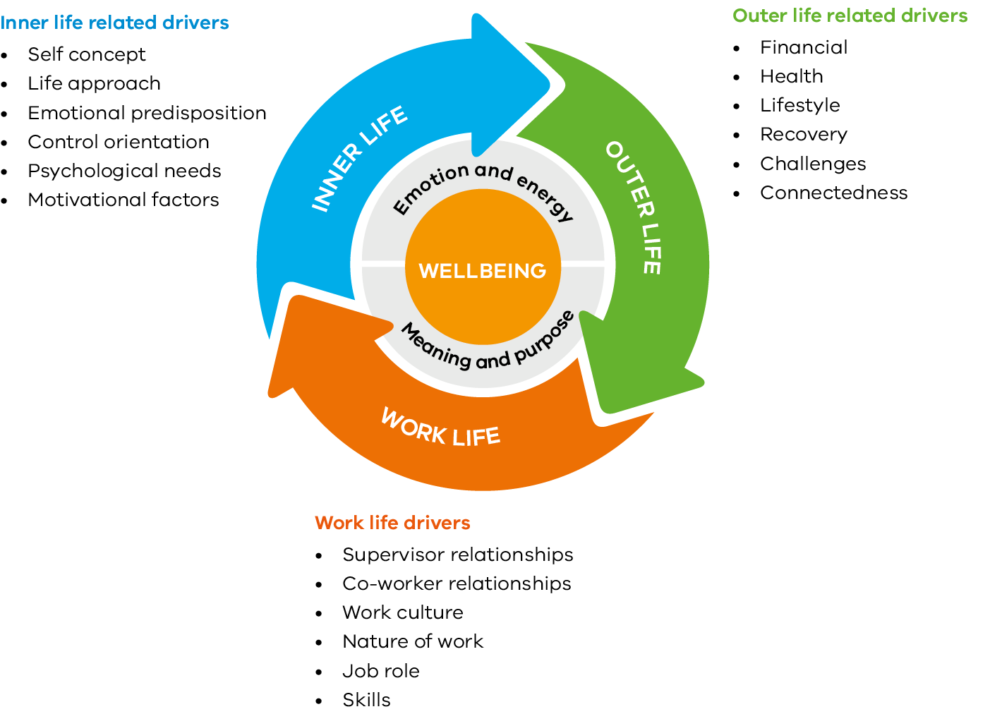
Figure 4: Understanding Wellbeing and Wellbeing Drivers

Adopting leading practices to promoting health and wellbeing
The Principal Health and Wellbeing Strategy utilises the key principles espoused in the WoVG Mental Health and Wellbeing Charter. The Charter brings together contemporary research and practices across three different domains to provide a robust framework for the promotion of health and wellbeing at work. The table below shows how the key initiatives introduced through this Strategy align with leading practices across each of the three domains.

KEY INITIATIVES 2018-2019
Promote
Builds on positive psychology, organisation development, management and organisational psychology practices

Protect
Builds on occupational health psychology, public health and occupational health and safety and risk management practices and responses

Address
Builds on medicine, psychiatry and psychological health and wellbeing responses

School Policy Templates Portal
Promote
- Frees up principals to focus on aspects of the role that bring meaning and purpose
Protect
- Minimises the source of a significant job stressor
- Reduces job demands

Principal Mentor Program
Promote
- Helps develop social capital
- Develops a growth mindset
Protect
- Reduces isolation as a risk factor
- Buffers against potential stressors on the job

Regional Capability Development
Promote
- Helps develop social capital
- Encourages positive leadership and cultural practices
Protect
- Buffers against potential stressors on the job

Proactive Wellbeing Supervision
Promote
- Adopts a strengths based approach
- Emphasis on enhancing wellbeing (not addressing issues)
- Encourages the development of effective coping mechanisms
Protect
- Prevents unmanaged stress from building up
- Reduces the development of vicarious trauma
- Identifies early health and wellbeing risk signs

Principal Health Checks
Promote
- Encourages and promotes healthy lifestyle practices
- Increases awareness of health issues
Protect
- Minimises hidden health risks
- Prevents the escalation of risks into serious illness or injury
- Enables professional health interventions

Complex Matter Management
Protect
- Minimises the source of a significant job stressor
- Reduces job demands
- Connects principals to existing Departmental resources
Address
- Connects principals to professional health interventions

Early Intervention Program
Protect
- Identifies early health and wellbeing risk signs
- Prevents the escalation of risks into serious illness or injury
Address
- Enables longer term professional health interventions

OUR GUIDING PRINCIPLES

The Principal Health and Wellbeing Strategy draws on some key guiding principles to help ensure its relevance to school principals, as well as aligning it with leading practice and ensuring practicality around suggested actions.

Principal-centric services
The Strategy is principal-centric – driven by needs of the principal as the end user. A principal-centric approach requires rethinking how health and wellbeing services are delivered to principals by considering their lived experience. This approach will help ensure that the strategies put in place adopt a focus on delivering a positive experience that promotes awareness of the available services, access to relevant services, satisfaction with the services, and loyalty i.e. repeated utilisation of the service and/ or referral to others.

The principal’s user experience parameters described below will help inform the evaluation of the initiatives introduced through the Strategy.

Balance between individual and systemic supports
The strategy adopts a multi-level approach to managing principal health and wellbeing by providing a strong system of supports that can be tailored to meet individual needs. Most leading practice frameworks such as the Canadian National Standard: Psychological health and safety in the workplace and the Developing Mentally Healthy Workplaces framework (commissioned by the National Mental Health Commission in Australia) recommend a range of initiatives that target wellbeing at an individual, team and organisational level. An effective wellbeing strategy must include a balance of interventions that look at systemic organisational factors such as culture, respect, support, development, workflow, etc. as well as meet the unique context and needs of the individual concerned.
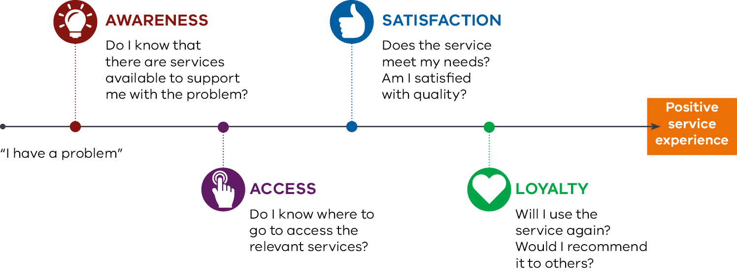
Figure 5: Embedding parameters for delivering a positive user experience

Combining physical and mental health and safety
The strategy focuses on a holistic model of health and wellbeing that combines aspects of physical health, mental health and safety. A safe and healthy workplace promotes and enhances wellbeing. Adoption of such a holistic model helps ensure more sustainable wellbeing outcomes for individuals over time.

Enhancing wellbeing across the wellbeing spectrum
The Principal Health and Wellbeing Strategy looks at enhancing wellbeing across the full wellbeing spectrum. This spectrum includes key stages of mental health and wellbeing: flourishing, coping and struggling.
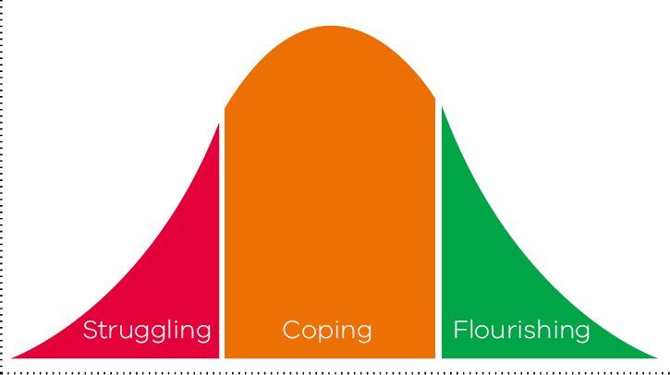
Figure 6: The wellbeing spectrum

Over the course of their lives, individuals may find themselves at different points across this spectrum. Therefore, wellbeing within the principal population may range from positive, healthy functioning at one end, through to severe symptoms that impact on everyday functioning, both in personal and work environments. Different strategies must be incorporated to help enhance wellbeing, no matter where individual principals sit across the wellbeing spectrum.

Embedding strategies across the employee life-cycle
The Strategy provides support across the different stages of principalship. An employee life-cycle approach considers key stages across a role such as recruitment and selection, induction and on-boarding, performance and engagement, professional development, transitioning and separation. The Department recognises that principals at different stages of their principalship will have differing needs and challenges. Accordingly, the Strategy must ensure systemic interventions are in place to help support principals across their professional life-cycle.

One size does not fit all
The Strategy aims to take into account the potential impact of different school demographics on operations, leadership and principal wellbeing. For instance, meeting the day-to-day administrative requirements may prove to be more challenging for principals of small schools and for teaching principals, than their counterparts in larger schools with more established leadership teams. Various other school specific differences such as variations in student population characteristics, community demands, location, etc., can all influence the amount of stress experienced by principals. This Strategy aims to ensure that the approaches adopted can be tailored to meet school specific needs, as far as practicable.

APPENDIX C: CURRENT SUPPORTS AVAILABLE TO PRINCIPALS

The Principal Health and Wellbeing Strategy recognises the importance of ensuring that principals are able to access the right supports at the right times. Accordingly, the Department has curated an extensive list of supports and resources that would be beneficial for principals – personally and as school leaders.

The Department is currently developing the Principals Page + to make it easier for principals to find 'just-in-time' resources and supports. When complete, the Principals Page + will include useful links and support information on a number of relevant issues, including:
- Supporting Principals’ Wellbeing
- Workforce Management
- People Management
- Audit & Risk
- OHS
- Governance Structures
- Strategic Planning
- Performance & Accountability
- School Finances
- Buildings & Infrastructure
- Information Technology
- Professional Learning for Leaders
- Managing Student Behaviours
- Managing the School Community
- Emergency Management
- DET Advisory
- Tools & Resources.

World Health Organisation. (2010). Healthy workplaces: A model for action, from https://bit.ly/2ndkTrH
Riley, P. (2018), Australian Principal Occupational Health, Safety and Wellbeing Survey: 2017 Data. Fitzroy, Victoria: Australian Catholic University.
Bernard, M. (n.d.) The Tsunami of Stress. In Stress Management for Teacher and Principals. Oakleigh, Victoria, Australian Scholarships Group.
Riley, P. (2018), Australian Principal Occupational Health, Safety and Wellbeing Survey: 2017 Data. Fitzroy, Victoria: Australian Catholic University.
Seligman, M. E. P., Ernst, R. M., Gillham, J., Reivich, K. & Linkin, M. (2009) Positive education: positive psychology and classroom interventions. Oxford Review of Education, vol. 35, no. 3, pp. 293-311.
WorkSafe Victoria, ISCRR Guidebook: Integrated approaches to worker health, safety and well-being from https://bit.ly/2GfpFC8
Deloitte (2015), Relieving the overwhelmed organization from https://bit.ly/2G4S4Yd
Bevington Group (2017), Department of Education Principal Work and Wellbeing Annual Survey
Dekker, Paul, and Eric M. Uslaner. 2001. ‘Introduction.’ Pp. 1 – 8 in Social Capital and Participation in Everyday Life, edited by Eric M. Uslaner. London: Routledge.
Bakker, A. B., & Demerouti, E. (2018). Multiple levels in job demands-resources theory: Implications for employee well-being and performance. In E. Diener, S. Oishi, & L. Tay (Eds.), Handbook of wellbeing. Salt Lake City, UT: DEF Publishers.
Darwin, A., & Palmer, E. (2009). Mentoring circles in higher education. Higher Education Research & Development, 28(2), 125-136.
Riley, P. (2009). The development and testing of a time-limited mentoring model for experienced school leaders. Mentoring & Tutoring: Partnership in Learning, 17(3), 233-249.
Harvey, S. B., Joyce, S., Tan, L., Johnson, A., Nguyen, H., Modini, M., & Groth, M. (2014). Developing a mentally healthy workplace: A review of the literature. Sydney: University of New South Wales. http://bit.ly/1X5F5ak
Luthans, F., Youssef, C. M., Sweetman, D. S. & Harms, P. D. (2013) Meeting the Leadership Challenge of Employee Well-Being through Relationship PsyCap and Health PsyCap. Journal of Leadership & Organizational Studies, 20(1), 118-133.
Kuoppala, J., Lamminpaa, A., Liira, J. & Vainio, H. (2008) Leadership, job well-being, and health effects--a systematic review and a metaanalysis. Journal of Occupational & Environmental Medicine, 50(8), 904-915
Howard, F. (2008). Managing stress or enhancing wellbeing? Positive psychology’s contributions to clinical supervision. Australian Psychologist, 43(2): 105 – 113
Institute for Work & Health (2015). Primary, Secondary and Tertiary Prevention, At Work: A quarterly publication of the Institute for Work & Health, 80, retrieved from https://bit.ly/2J4tLKU
Sleep Health Foundation (2011), Facts About Sleep, retrieved from https://bit.ly/2H9cB2g
Riley, P. (2018), Australian Principal Occupational Health, Safety and Wellbeing Survey: 2017 Data. Fitzroy, Victoria: Australian Catholic University.
ibid.
Bakker, A. B., & Demerouti, E. (2018). Multiple levels in job demands-resources theory: Implications for employee well-being and performance. In E. Diener, S. Oishi, & L. Tay (Eds.), Handbook of wellbeing. Salt Lake City, UT: DEF Publishers.
Comcare (2013) Working Together: Promoting mental health and wellbeing at work. Canberra: Australian Government, retrieved from https://bit.ly/2J63r2W
Bevington Group (2017), Department of Education Principal Work and Wellbeing Annual Survey.
FBG (2018), WorkWell Wellbeing Assessment Framework© sourced from www.fbggroup.com.au
Diener, E. (2012). New findings and future directions for subjective well-being research. American psychologist, 67(8), 590.
Henderson, L. W., & Knight, T. (2012). Integrating the hedonic and eudaimonic perspectives to more comprehensively understand wellbeing and pathways to wellbeing. International Journal of Wellbeing, 2(3).
FBG (2018), WorkWell Wellbeing Assessment Framework© sourced from www.fbggroup.com.au
LaMontagne (2016), Work & Mental Health:Developing An Integrated Intervention Approach, retrieved from https://bit.ly/2GLOiHz
Canadian Standards Association (2013). Psychological health and safety in the workplace. Mental Health Commission of Canada, from http://bit.ly/1tdcsam
Harvey, S. B., Joyce, S., Tan, L., Johnson, A., Nguyen, H., Modini, M., & Groth, M. (2014). Developing a mentally healthy workplace: A review of the literature. Sydney: University of New South Wales. http://bit.ly/1X5F5ak

