Safe Work Procedure

NOTE: DO NOT use this equipment unless you have been trained in its safe use and operation

Description of Work: |  |  | Using a Tyre Changing Machine
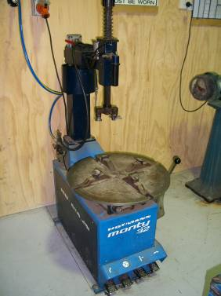 |  |  |  |  |  | Potential Hazards: Exposed moving parts with the potential to cause harm through entanglement, impact and cutting (sharp objects, crush and pinch points), electricity, ergonomics, condition, slip, trips and falls.
Personal Protective Equipment (PPE) Required (Check the box for required PPE):
Gloves |  | Face Masks |  | Eye  Protection | Welding Mask |  | Appropriate  Footwear |  | Hearing Protection | Protective Clothing
Safe Work Procedure Checklist:
1. PRE-Operation:
- Ensure moving parts are lubricated.
- Ensure operator is familiar with equipment controls.
- Check equipment for damage prior to use.
- Do not exceed maximum capacity stated on press.
- Ensure table is clean before using.
- Faulty equipment must not be used. Immediately report suspect machinery.
2. Operation:
- Never put any part of body between hydraulic ram clamps.
  - Never leave the machine unattended when in operation.
  - Before making adjustments, switch off and bring machine to a complete standstill.
3. POST-Operation:
- Switch off machine.
- Leave the machine in a safe, clean and tidy state.
Competent Persons (The following persons are authorised to operate, supervise and test students on the equipment/process).
Name: | Title: |  |  |  |  |  |  | Contact Details:

