Safe Work Procedure

NOTE: DO NOT use this machine unless you have been trained in its safe use and operation.

Description of Work: |  |  | Using a Tractor
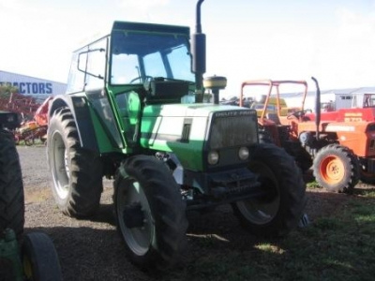 |  |  |  |  |  | Potential Hazards: Hazards associated with entanglement, impact and cutting, shearing, ergonomics, noise, vibration, slips, trips and falls, fire and explosion and fumes.
Personal Protective Equipment (PPE) Required (Check the box for required PPE):
Gloves |  | Face Masks |  | Eye  Protection | Welding Mask |  | Appropriate  Footwear |  | Hearing Protection | Protective Clothing
Safe Work Procedure Checklist:
1. PRE-Operation:
- Operator to inspect work area to ensure that work surface is even and stable to prevent rollover.
- Ensure equipment is free of any signs of wear or damage.
- Wear the appropriate PPE.
- Fuel vehicle away from any possible sources of ignition.
- Ensure that the seatbelt, Roll Over Protective Structure ,Falling Objects Protective Structure (where fitted) and Power Take-Off guard are in sound condition.
2. Operation:
- Before starting the tractor, ensure all levers are in their neutral positions, the parking brake is engaged and the clutch and PTO are disengaged.
- Never start or operate levers from anywhere other than the seat.
- Drive at a speed slow enough to keep control over unexpected hazards.
- Do not operate near ditches, holes or embankments which may collapse under the tractor’s weight.
- Avoid slopes that are too steep for safe operation. Always reverse when going up a steep slope.
- Do not dismount from the tractor unless the engine and the vehicle have completely stopped, the transmission is in park condition and the parking brake is fully engaged.
- Park on even ground, disengage the PTO and lower all attached implements.
3. POST-Operation:
- Ensure all moving parts have come to a complete stop before performing any maintenance or clearing.
- Ensure engine is cool before refuelling in a well-ventilated area.
Competent Persons (The following persons are authorised to operate, supervise and test students on the equipment/process).
Name: | Title: |  |  |  |  |  |  | Contact Details:

