Safe Work Procedure
NOTE: DO NOT use this machine unless you have been trained in its safe use and operation
Description of Work: |  |  | Use of Tenon Saw - Electric
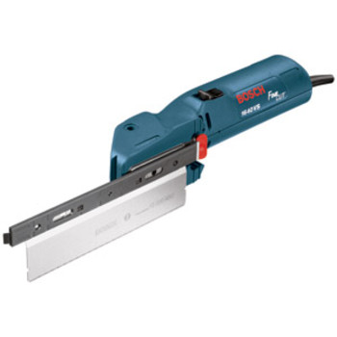 |  |  |  |  |  | Potential Hazards: Electrical hazard with the potential to cause harm through exposure to entanglement, impact and cutting, and slips/trips/falls.
Personal Protective Equipment (PPE) Required (Check the box for required PPE):
Gloves |  | Face Masks |  | Eye  Protection | Welding Mask |  | Appropriate  Footwear |  | Hearing Protection | Protective Clothing
Safe Work Procedure Checklist:
1. PRE-Operation:
- Ensure equipment is serviced on a regular basis, tested and tagged and appropriate isolation procedures (e.g. lock out tags) are in place.
- Ensure that the operator has been trained in safe work practices and appropriate PPE (e.g. eye protection) is available for use.
- Ensure hair, loose clothing and rags etc. and any inappropriate jewellery (e.g. bracelets and long necklaces) is secured or removed.
- Ensure that work piece is secured prior to cutting (e.g. clamped).
- Operator to check for damaged electrical cords or accessories.
2. Operation:
- Ensure operator’s hands and body parts are kept clear of moving blade during operation and maintenance.
- Ensure that the operator is wearing appropriate PPE (e.g. eye protection) whilst operating equipment.
- Ensure appropriate cleaning and housekeeping practices are maintained.
3. POST-Operation:
- Ensure equipment is returned to its original location and appropriately stored and all debris and dust is removed from work area.
Competent Persons (The following persons are authorised to operate, supervise and test students on the equipment/process).
Name: | Title: |  |  |  |  |  |  | Contact Details:

