Safe Work Procedure
Description of Work |  |  |  |  | Use of a step platform ladder
Image |  |  |  |  | Potential hazards (list below)
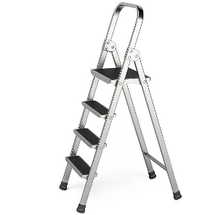 |  |  |  |  | - Fall from >2 metres  - Manual handling
Personal Protective Equipment (PPE) (check the box for required PPE)
Gloves | Face Masks | Eye Protection |  | Welding Mask |  | Appropriate Footwear |  | Hearing Protection | Protective Clothing
☐ | ☐ | ☐ |  | ☐ |  | ☒ |  | ☐ | ☐
Safe Work Procedure
1. Pre-operation:
- Ladder is free from defects or damage before use
- Ladder has a top hand rail
- Ladder has non-slip feet
- Consider whether a second person is needed to assist in securing the ladder and passing materials
- Load rating of ladder is not exceeded
2. Operation:
- Ladder is positioned on a firm, level and non-slip surface
- Ladder is in the fully open position with the spreaders locked
- Check for overhead hazard prior to ascending ladder
- Always have two free hands to ascend and descend the ladder
- Highest rung on the ladder that you can stand on is clearly labelled. If the rung is not labelled, feet should be no higher than the second rung from the top plate
- Undertake work facing the ladder
- Work within an arm’s reach to avoid falling sideways
- Ladder is not left unattended
3. Post-operation:
- Store ladder on hooks at waist height

Competent persons (the following persons are authorised to undertake the task, operate, supervise and test students on the plant or equipment)
Name |  |  | Title / role |  |  |  | Contact details

