Safe Work Procedure
NOTE: DO NOT use this machine unless you have been trained in its safe use and operation
Description of Work: |  |  | Using a Spot Welder
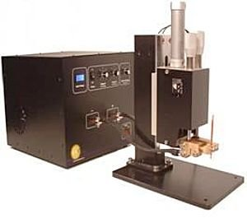 |  |  |  |  |  | Potential Hazards: Fire, compression and electrical hazard with the potential to cause harm through impact and cutting, exposure to heat, fume and gases, electricity and crushing forces.
Personal Protective Equipment (PPE) Required (Check the box for required PPE):
Gloves |  | Face Masks |  | Eye  Protection | Welding Mask |  | Appropriate  Footwear |  | Hearing Protection | Protective Clothing
Safe Work Procedure Checklist:
1. PRE-Operation:
- Task (e.g. Drawings, instructions, specifications etc.) is clearly understood.
- Pieces of metal to be welded are prepared.
- Welder is set to appropriate current and force.
- Electrodes are clean.
- Ensure area is free from combustible material.
- Identify ON/OFF switch and emergency stop button (if applicable).
2. Operation:
- Keep hands clear of electrodes.
- Allow hot metal to cool prior to handling.
3. POST-Operation:
- Switch off spot welder at power point.

Competent Persons (The following persons are authorised to operate, supervise and test students on the equipment/process).
Name: | Title: |  |  |  |  |  |  | Contact Details:

