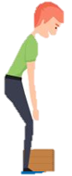
S.M.A.R.T LIFTING
Size up that load
- Assess the load (shape, size and weight)
- Determine where the load needs to be moved and placed
- Determine whether you can carry the load or whether a mechanical aid should be used
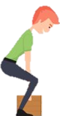

Move the load as close to the body as possible
- Carry the load as close to the body as possible
- Secure your grip

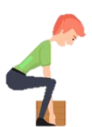
Always bend your knees
- Keep feet apart in a comfortable position (usually in line with hips)
- Minimise lower back bending
- Bend knees (squat or semi-squat position)

Raise the load with your legs
- Lift the load with your legs, not your back, in a smooth motion (avoid twisting or jerky movements)
- Maintain normal curvature of the spine

Turn your feet in the direction you want to move
- Change direction by pointing your feet and not twisting your back
- To set the load down, squat down, keep your head up and allow your legs to carry the weight

