Safe Work Procedure
NOTE: DO NOT use this machine unless you have been trained in its safe use and operation
Description of Work: |  |  | Using a Scrolling Saw
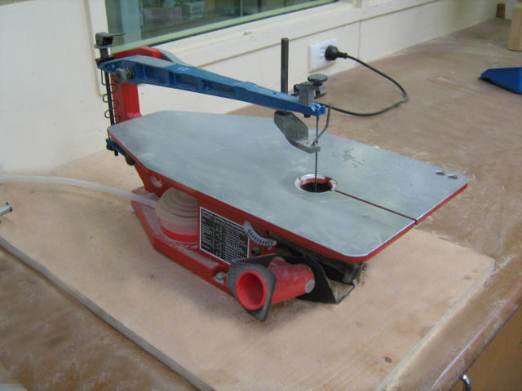 |  |  |  |  |  | Potential Hazards: Exposed moving parts and electrical hazard with the potential to cause harm through entanglement, impact and cutting, exposure to dust, projectiles and sharp objects.
Personal Protective Equipment (PPE) Required (Check the box for required PPE):
Gloves |  | Face Masks |  | Eye  Protection | Welding Mask |  | Appropriate  Footwear |  | Hearing Protection | Protective Clothing
Safe Work Procedure Checklist:
1. PRE-Operation:
- Task (e.g. Drawings, instructions, specifications etc.) is clearly understood.
- Ensure blade is securely in place.
- Identify ON/OFF switch and emergency stop button (if applicable).
2. Operation:
- Ensure blade is moving correctly.
- Keep hands clear of work piece and away from blade.
- Never leave saw running unattended.
3. POST-Operation:
- Switch off saw before removing waste material from the table.
- Ensure good housekeeping practices are in place to minimise dust build-up.
Competent Persons (The following persons are authorised to operate, supervise and test students on the equipment/process).
Name: | Title: |  |  |  |  |  |  | Contact Details:

