Safe Work Procedure
NOTE: DO NOT use this machine unless you have been trained in its safe use and operation.
Description of Work: |  |  | Using a Plunge Router
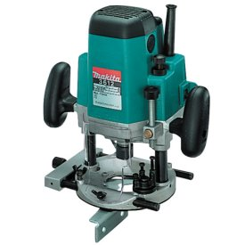 |  |  |  |  |  | Potential Hazards: Exposed moving parts and electrical hazard with the potential to cause harm through entanglement, impact and cutting, exposure to noise, dust, projectiles and sharp objects.
Personal Protective Equipment (PPE) Required (Check the box for required PPE):
Gloves |  | Face Masks |  | Eye  Protection | Welding Mask |  | Appropriate  Footwear |  | Hearing Protection | Protective Clothing
Safe Work Procedure Checklist:
1. PRE-Operation/Task:
- Task (e.g. Drawings, instructions, specifications etc.) is clearly understood.
- Ensure appropriate guarding is in place.
- Choose the desired router bit and ensure it is securely installed.
- Set the router to the desired height.
- Ensure work piece is securely clamped.
- Identify location of ON/OFF switch and emergency stop button (if applicable).
2. Operation/Task:
- Check, that bit runs ‘true’ and does not wobble.
- Keep hands clear of work piece and away from routing blade.
- Turn off machine at power point if changing the bit.
- Exercise care when removing bit as it may be hot.
3. POST-Operation/Task:
- Switch off router before removing waste material.
- Ensure good housekeeping practices are in place to minimise dust build-up.
- Return router bits and router to storage area.
Competent Person(s): (The following persons are authorised to operate, supervise and test students on the equipment/process).
Name: | Title: |  |  |  |  |  |  | Contact Details:

