Safe Work Procedure
NOTE: DO NOT use this machine unless you have been trained in its safe use and operation
Description of Work: |  |  | Using a Rip Saw
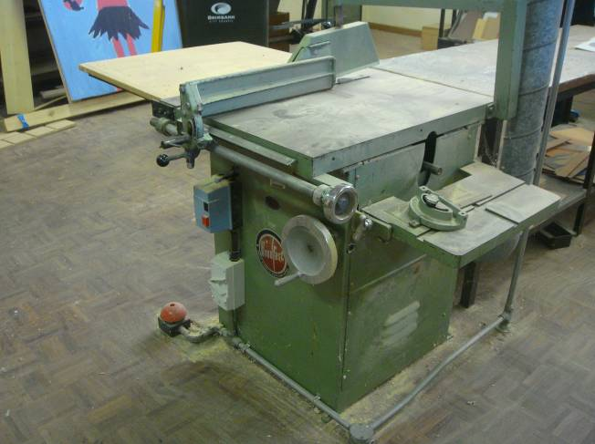 |  |  |  |  |  | Potential Hazards: Exposed moving parts with the potential to cause harm through impact and cutting, entanglement, projectiles and sharp objects, exposure to noise, dust and slip trip and falls.
Personal Protective Equipment (PPE) Required (Check the box for required PPE):
Gloves |  | Face Masks |  | Eye  Protection | Welding Mask |  | Appropriate  Footwear |  | Hearing Protection | Protective Clothing
Safe Work Procedure Checklist:
1. PRE-Operation:
- Task (e.g. Drawings, instructions, specifications etc.) is clearly understood.
- Ensure eye, hearing and clothing protection and appropriate footwear is worn prior to operation.
- Ensure guarding is in place.
- Ensure appropriate blade is used for the task.
- Ensure timber is in good condition and free from foreign material (such as nails).
- Turn on local exhaust system (if available).
- Identify ON/OFF switch and emergency stop button (if applicable).
2. Operation:
- Check that saw blade runs ‘true’ and does not wobble.
- Before making adjustments (e.g. guarding) switch off and bring the machine to a complete standstill.
- Keep hands clear of work piece and away from rotating blade.
- Ensure guarding is in place before the saw is re-started.
- Never leave the machine running unattended.
3. POST-Operation:
- Switch off saw before removing waste material (chips and shavings) from the saw table.
- Ensure good housekeeping practices are in place to minimise dust build-up.
Competent Persons (The following persons are authorised to operate, supervise and test students on the equipment/process).
Name: | Title: |  |  |  |  |  |  | Contact Details:

