Safe Work Procedure

NOTE: DO NOT use this machine unless you have been trained in its safe use and operation.

Description of Work: |  |  | Using a Ride On Lawn Mower
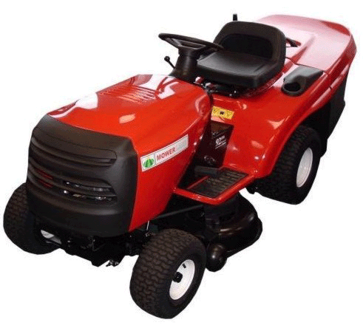 |  |  |  |  |  | Potential Hazards: Exposed moving parts with the potential to cause harm through entanglement, impact and cutting, radiation, fuel hazards, exposure to noise and vibration, manual handling injuries, slips, trips and falls, and inhalation of exhaust fumes and dust.
Personal Protective Equipment (PPE) Required (Check the box for required PPE):
Gloves |  | Face Masks |  | Eye  Protection | Welding Mask |  | Appropriate  Footwear |  | Hearing Protection | Protective Clothing
Safe Work Procedure Checklist:
1. PRE-Operation:
- Clear area to be mown of debris such as rocks, stones, sticks or other objects that may become projectiles.
- Inspect blades, blade bolts and cutter assembly for signs of wear or damage.
- Always shut off the engine and allow it to cool before refuelling.
- Refuel in a well-ventilated area away from any ignition sources.
- Wear appropriate PPE
2. Operation:
  - Check ground conditions will provide adequate wheel grip.
  - Never place hands anywhere near the blades when it is running (i.e. when attaching guards etc.).
  - Never mow on side slopes greater than five degrees, uphills greater than ten degrees, or mow downhill on slopes greater than fifteen degrees.
  - Watch for traffic near or crossing roadways.
  - Always come to a complete stop when changing gears.
  - Stop blades rotating prior to crossing non-grass surfaces.
  - Look behind the mower to check the area is clear before reversing.
  - Ensure mower is idling prior to removing the catcher.
  - Never leave mower running while unattended.
3. POST-Operation:
- Keep mower clean and free of debris.
- Ensure equipment is returned to storage area after use.
Competent Persons (The following persons are authorised to operate, supervise and test students on the equipment/process).
Name: | Title: |  |  |  |  |  |  | Contact Details:

