Safe Work Procedure
NOTE: DO NOT use this machine unless you have been trained in its safe use and operation
Description of Work: |  |  | Using a Reciprocating Saw
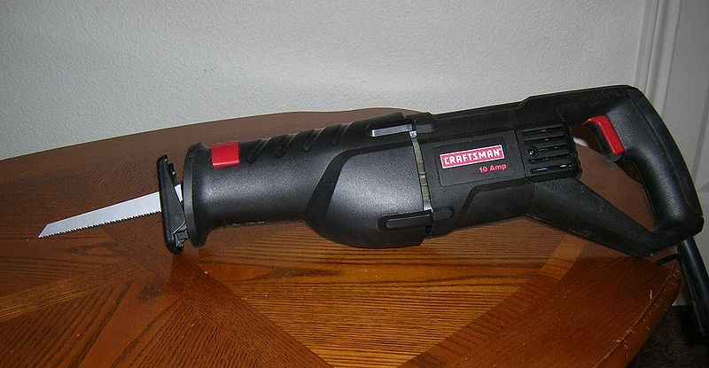 |  |  |  |  |  | Potential Hazards: Exposed moving parts and electrical hazard with the potential to cause harm through entanglement, impact and cutting, exposure to projectiles and sharp objects.
Personal Protective Equipment (PPE) Required (Check the box for required PPE):
Gloves |  | Face Masks |  | Eye  Protection | Welding Mask |  | Appropriate  Footwear |  | Hearing Protection | Protective Clothing
Safe Work Procedure Checklist:
1. PRE-Operation:
- Task (e.g. Drawings, instructions, specifications etc.) is clearly understood.
- Ensure guarding is in place (if applicable).
- Ensure the appropriate blade is being used for the task.
- Identify ON/OFF switch and emergency stop button (if applicable).
2. Operation:
- Check that blade runs ‘true’ and does not wobble.
- Check that the cord is always well away from the blade.
- Keep hands clear of work piece and away from blade.
- Stop operation immediately if blade or cord is damaged.
3. POST-Operation:
- Switch off saw before removing waste material from the table.
- Ensure good housekeeping practices are in place to minimise dust build-up.
Competent Persons (The following persons are authorised to operate, supervise and test students on the equipment/process).
Name: | Title: |  |  |  |  |  |  | Contact Details:

