Safe Work Procedure
NOTE: DO NOT use this machine unless you have been trained in its safe use and operation
Description of Work: |  |  | Using a Radial Arm Saw
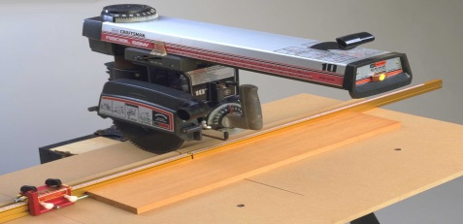 |  |  |  |  |  | Potential Hazards: Exposed moving parts and electrical hazard with the potential to cause harm through entanglement, impact and cutting, exposure to heat, noise, dust, projectiles and sharp objects.
Personal Protective Equipment (PPE) Required (Check the box for required PPE):
Gloves |  | Face Masks |  | Eye  Protection | Welding Mask |  | Appropriate  Footwear |  | Hearing Protection | Protective Clothing
Safe Work Procedure Checklist:
1. PRE-Operation:
- Task (e.g. Drawings, instructions, specifications etc.) is clearly understood.
- Ensure guarding is in place.
- Ensure the appropriate blade is being used for the task.
- Ensure dust extraction is turned on prior to operation (if applicable).
- Identify ON/OFF switch and emergency stop button (if applicable).
2. Operation:
- Check that saw runs ‘true’ and does not wobble.
- The work piece must be held against a fence.
- Allow the saw blade to obtain maximum speed before making a cut.
- Operate the saw with the left hand where possible, avoid reaching over the saw line and do not cross arms when cutting.
- When using the right hand to pull the saw across, keep the left hand well clear of the line of cut.
- Return the cutting head to the rear of the table after each cross cut.
- The maximum cut for the machine must not be exceeded.
- When cutting bowed timber place the bow against the table to avoid the saw binding.
- Before making adjustments switch off and bring the saw to a complete standstill.
3. POST-Operation:
- Switch off the saw and reset all guards to a fully closed position.
- Make sure good housekeeping practices are in place to minimise dust build-up.
Competent Persons (The following persons are authorised to operate, supervise and test students on the equipment/process).
Name: | Title: |  |  |  |  |  |  | Contact Details:

