Safe Work Procedure
NOTE: DO NOT use this machine unless you have been trained in its safe use and operation
Description of Work: |  |  | Using a Power Hacksaw
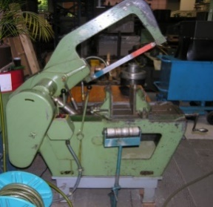 |  |  |  |  |  | Potential Hazards: Exposed moving parts and electrical hazard with the potential to cause harm through entanglement, impact and cutting, exposure to heat, noise, projectiles, sharp objects, friction and sparks.
Personal Protective Equipment (PPE) Required (Check the box for required PPE):
Gloves |  | Face Masks |  | Eye  Protection | Welding Mask |  | Appropriate  Footwear |  | Hearing Protection | Protective Clothing
Safe Work Procedure Checklist:
1. PRE-Operation:
- Task (e.g. Drawings, instructions, specifications etc.) is clearly understood.
- Identify ON/OFF switch and emergency stop button (if applicable).
- Ensure that work is securely clamped in the work vice.
- Check coolant delivery system to allow for sufficient flow of coolant.
- Faulty equipment must not be used.
2. Operation:
- Ensure that work piece is secure.
- Support overhanging work and use appropriate signage if it presents a hazard.
- Keep clear of moving machine parts.
- Direct coolant onto blade before starting cutting.
- Never leave the machine running unattended.
- Before making adjustments or before cleaning waste material accumulations, switch off and bring machine to a complete standstill.
3. POST-Operation:
- Switch off machine and store equipment machine in a safe and clean state.
- Ensure good housekeeping practices are in place to minimise dust build-up.
Competent Persons (The following persons are authorised to operate, supervise and test students on the equipment/process).
Name: | Title: |  |  |  |  |  |  | Contact Details:

