Safe Work Procedure
NOTE: DO NOT use this machine unless you have been trained in its safe use and operation.
Description of Work: |  |  | Using a Plastic Strip Heater
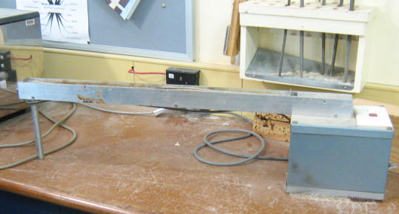 |  |  |  |  |  | Potential Hazards: Moving parts and electrical hazard with the potential to cause harm through exposure to projectiles, sharp objects, gases and fumes.
Personal Protective Equipment (PPE) Required (Check the box for required PPE):
Gloves |  | Face Masks |  | Eye  Protection | Welding Mask |  | Appropriate  Footwear |  | Hearing Protection | Protective Clothing
Safe Work Procedure Checklist:
1. PRE-Operation/Task:
- Task (e.g. Drawings, instructions, specifications etc.) is clearly understood.
- Ensure strip is heated to appropriate temperature (e.g. temperature controlled).
- Ensure that loose clothing is restricted.
- Ensure work area is appropriately ventilated.
- Identify ON/OFF switch and emergency stop button (if applicable).

2. Operation/Task:
- Keep hands clear of work piece and away from strip.

3. POST-Operation/Task:
- Allow heater to cool prior to putting in storage area.

Competent Person(s): (The following persons are authorised to operate, supervise and test students on the equipment/process).
Name: | Title: |  |  |  |  |  |  | Contact Details:

