Safe Work Procedure
NOTE: DO NOT use this machine unless you have been trained in its safe use and operation
Description of Work: |  |  | Using Plumbed Oxy-acetylene Equipment
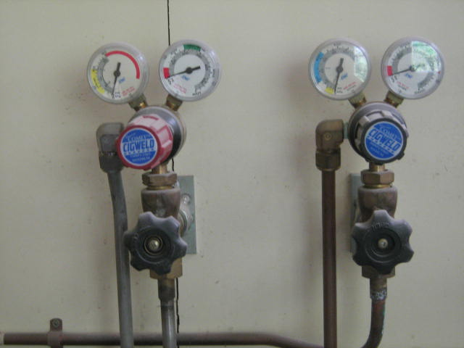 |  |  |  |  |  | Potential Hazards: Fire and ultraviolet light hazard with the potential to cause harm through exposure to heat, projectiles, fumes and gases, radiation, sparks and sharp objects.
Personal Protective Equipment (PPE) Required (Check the box for required PPE):
Gloves |  | Face Masks |  | Eye  Protection | Welding Mask |  | Appropriate  Footwear |  | Hearing Protection | Protective Clothing
Safe Work Procedure Checklist:
1. PRE-Operation:
- Task (e.g. Drawings, instructions, specifications etc.) is clearly understood.
- Ensure the work area is clean and clear of grease, oil and any other flammable materials.
- Ensure the gloves, welding gun and work leads are in good condition.
- Ensure other work areas are protected from flash.
- Ensure appropriate ventilation is in place prior to use.
- Ensure appropriate PPE is worn.
2. Operation:
- Use only a flint lighter to light torch.
- Keep hands clear of work piece and away from flame.
- Ensure equipment is correctly set up for gas flow.
- Never leave the welder running unattended.
3. POST-Operation:
- Switch off machine and fume extraction (if relevant).
- Close gas valves.
- Hang up welding gun and welding cables.
Competent Persons (The following persons are authorised to operate, supervise and test students on the equipment/process).
Name: | Title: |  |  |  |  |  |  | Contact Details:

