Safe Work Procedure
NOTE: DO NOT use this machine unless you have been trained in its safe use and operation
Description of Work: |  |  | Using a Portable Nibbler
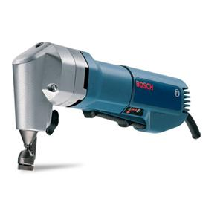 |  |  |  |  |  | Potential Hazards: Exposed moving parts and electrical hazard with the potential to cause harm through impact and cutting, noise, slips, trip and falls, and temperature.
Personal Protective Equipment (PPE) Required (Check the box for required PPE):
Gloves |  | Face Masks |  | Eye  Protection | Welding Mask |  | Appropriate  Footwear |  | Hearing Protection | Protective Clothing
Safe Work Procedure Checklist:
1. PRE-Operation:
- Ensure task (e.g. Drawings, instructions, specifications etc.) is clearly understood.
- Ensure guarding is in place (if applicable).
- Identify ON/OFF switch.
2. Operation:
- Check that blade runs ‘true’ and does not wobble.
- Check that the cord is always well away from the blade.
- Keep hands clear of work piece and away from blade.
3. POST-Operation:
- Switch off nibbler before removing waste material from the table.
- Ensure good housekeeping practices are in place to minimise waste build-up.
Competent Persons (The following persons are authorised to operate, supervise and test students on the equipment/process).
Name: | Title: |  |  |  |  |  |  | Contact Details:

