Safe Work Procedure
NOTE: DO NOT use this machine unless you have been trained in its safe use and operation
Description of Work: |  |  | Using a Nail Gun (pneumatic)
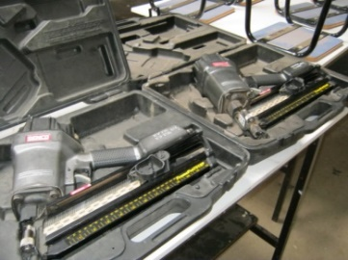 |  |  |  |  |  | Potential Hazards: Discharged nails and pressurised air with the potential to cause harm through direct nail projectiles and indirect ricochets.
Personal Protective Equipment (PPE) Required (Check the box for required PPE):
Gloves |  | Face Masks |  | Eye  Protection | Welding Mask |  | Appropriate  Footwear |  | Hearing Protection | Protective Clothing
Safe Work Procedure Checklist:
1. PRE-Operation:
- Ensure task (e.g. Drawings, instructions, specifications etc.) are clearly understood.
- Nails have been correctly loaded into gun.
- Compressed air hose is in good condition and free from damage.
- Compressed air hose has been correctly attached to gun.
- Work piece is secured in jig and identify trigger switch in one-shot mode.
2. Operation:
- Do not use in close proximity to other workers.
- Use jigs to hold work pieces.
- Keep hands clear of work piece and away from nail gun.
- Hold gun to object to be nailed and hold steady when firing.
- Do not carry or re-position the nail gun with the trigger depressed.
3. POST-Operation:
- Place nail gun down before preparing next work piece.
- Ensure good housekeeping practices are in place to minimise waste build-up.
- Detach compressed air hose and return hose to air compressor.
- Regularly inspect and maintain nail gun and parts.
- Return nail gun to storage area.
Competent Persons (The following persons are authorised to operate, supervise and test students on the equipment/process).
Name: | Title: |  |  |  |  |  |  | Contact Details:

