Safe Work Procedure

NOTE: DO NOT use this machine unless you have been trained in its safe use and operation.

Description of Work: |  |  | Using a Petrol Mulcher
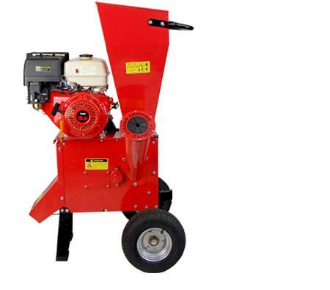 |  |  |  |  |  | Potential Hazards: Hazards associated with entanglement, impact and cutting, noise, fire and explosion and dust.
Personal Protective Equipment (PPE) Required (Check the box for required PPE):
Gloves |  | Face Masks |  | Eye  Protection | Welding Mask |  | Appropriate  Footwear |  | Hearing Protection | Protective Clothing
Safe Work Procedure Checklist:
1. PRE-Operation:
- Ensure equipment is free of any signs of wear or damage.
- Wear the appropriate PPE and avoid loose clothing.
- Ensure that all screws and nuts are properly tightened before use.
2. Operation:
  - Ensure the machine is laid flat on a firm surface.
  - Ensure wood to be mulched is of the correct diameter as outlined in the operation manual.
  - Always use the tool supplied by the manufacturer to feed the mulcher.
  - Always stand steadily and in balance. Do not stretch towards the machine.
  - Ensure operator’s face and body are kept clear of the feeding hopper.
  - If the machine becomes blocked, stop the motor, pull out any objects and check machine for damage.
- Ensure blade has come to a complete stop before performing any maintenance or clearing of blades.
- Ensure engine is stopped and allowed to cool before refuelling.
- Refuel in a well-ventilated area away from an ignition source
3. POST-Operation:
- Ensure equipment has come to a complete stop before storing.
- Ensure equipment is returned to storage area after use.
Competent Persons (The following persons are authorised to operate, supervise and test students on the equipment/process).
Name: | Title: |  |  |  |  |  |  | Contact Details:

