Safe Work Procedure
NOTE: DO NOT use this machine unless you have been trained in its safe use and operation
Description of Work: |  |  | Using a Mortiser
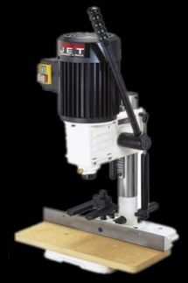 |  |  |  |  |  | Potential Hazards: Exposed moving parts and electrical hazard with the potential to cause harm through entanglement, exposure to heat, dust, projectiles and sharp objects.
Personal Protective Equipment (PPE) Required (Check the box for required PPE):
Gloves |  | Face Masks |  | Eye  Protection | Welding Mask |  | Appropriate  Footwear |  | Hearing Protection | Protective Clothing
Safe Work Procedure Checklist:
1. PRE-Operation:
- Ensure task (e.g. Drawings, instructions, specifications etc) are clearly understood.
- Chisel and drill bit is tight in chuck and chuck key has been removed.
- Work piece is securely clamped.
- Correct speed has been set.
- Where necessary, depth stop for hole has been set or wood to be mortised is rested on scrap.
- Appropriate guarding is in place on the machine.
- Identify ON/OFF switch and emergency stop button (if applicable).
2. Operation:
- Check, that drill bit runs ‘true’ and does not wobble.
- Keep hands clear of work piece and away from tool.
- Back out frequently on deep cuts to clean and cool chisel and drill bit.
- Exercise caution when removing hot drill bit.
3. POST-Operation:
- Switch off drill before removing waste materials from the table.
- Make sure good housekeeping practises are in place to minimise dust build-up.
- Return clean chisel and drill bit to drill rack and clamps to their storage area.
Competent Persons (The following persons are authorised to operate, supervise and test students on the equipment/process).
Name: | Title: |  |  |  |  |  |  | Contact Details:

