Safe Work Procedure
NOTE: DO NOT use this machine unless you have been trained in its safe use and operation.
Description of Work: |  |  | Using a Metal Inert Gas (MIG) Welder
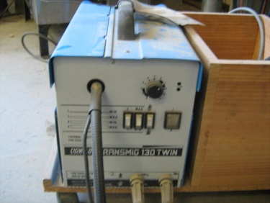 |  |  |  |  |  | Potential Hazards: Fire and electrical hazard with the potential to cause harm through impact and cutting, exposure to heat, projectiles, sparks, sharp objects, electric shock, fumes, radiation and flame.
Personal Protective Equipment (PPE) Required (Check the box for required PPE):
Gloves |  | Face Masks |  | Eye  Protection | Welding Mask |  | Appropriate  Footwear |  | Hearing Protection | Protective Clothing
Safe Work Procedure Checklist:
1. PRE-Operation/Task:
- Task (e.g. Drawings, instructions, specifications etc.) is clearly understood.
- Ensure the work area is clean and clear of grease, oil and any other flammable materials.
- Keep the welding equipment, work area and gloves dry to avoid electric shocks.
- Ensure the gloves, welding gun and work leads are in good condition.
- Check that other work areas are protected from flash.
- Ensure appropriate ventilation is in place prior to use.
- Ensure appropriate PPE is worn.
- Identify ON/OFF switch and emergency stop button (if applicable).
2. Operation/Task:
- Keep hands clear of work piece and away from electrode.
- Ensure machine is correctly set up for current, voltage, wire feed and gas flow.
- Ensure work return cables make firm contact to provide a good electrical connection.
- Never leave the welder running unattended.
3. POST-Operation/Task:
- Switch off machine and fume extraction (if relevant).
- Close gas cylinder valve.
- Hang up welding gun and welding cables.
Competent Person(s): (The following persons are authorised to operate, supervise and test students on the equipment/process).
Name: | Title: |  |  |  |  |  |  | Contact Details:

