Safe Work Procedure
NOTE: DO NOT use this machine unless you have been trained in its safe use and operation.
Description of Work: |  |  | Using a Metal Rolling Machine
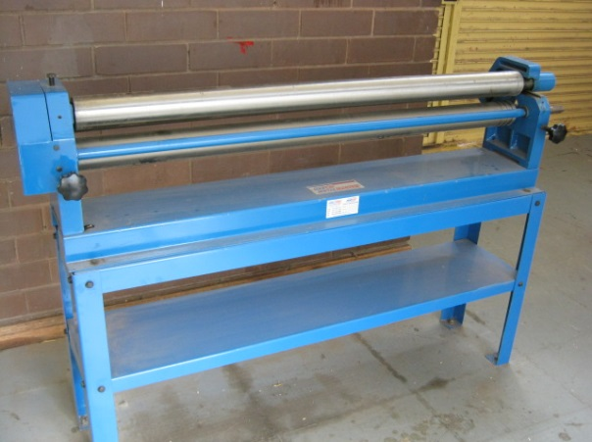 |  |  |  |  |  | Potential Hazards: Exposed moving parts with the potential to cause harm through exposure to sharp objects, crush and pinch points.
Personal Protective Equipment (PPE) Required (Check the box for required PPE):
Gloves |  | Face Masks |  | Eye  Protection | Welding Mask |  | Appropriate  Footwear |  | Hearing Protection | Protective Clothing
Safe Work Procedure Checklist:
1. PRE-Operation/Task:
- Ensure task (e.g. Drawings, instructions, specifications etc.) is clearly understood.
- Working parts (i.e. hinges) should be well lubricated and working surfaces kept free of rust and dirt.
- Ensure no slip/trip hazards are present in workspaces and walkways.
- Faulty equipment must not be used. Immediately report suspect machinery.
2. Operation/Task:
- Do not attempt to roll material beyond the capacity of the machine with respect to thickness, shape, or type.
- Never attempt to bend rod, wire, strap, or spring steel sheets in this machine.
- Adjust for thickness of work piece – rotate adjusters at either end of rolling machine.
- Insert work piece in line with the rolling pins.
- Using hand rolling handle, continue to roll work piece.
- Keep clear of moving handles and rolling pins.
3. POST-Operation/Task:
- Leave the work area in a safe, clean and tidy state.
Competent Person(s): (The following persons are authorised to operate, supervise and test students on the equipment/process).
Name: | Title: |  |  |  |  |  |  | Contact Details:

