Safe Work Procedure
NOTE: DO NOT use this machine unless you have been trained in its safe use and operation.
Description of Work: |  |  | Using a Milling Machine
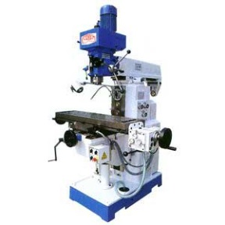 |  |  |  |  |  | Potential Hazards: Electrical hazard with sharp cutters and moving components which has the potential to cause harm through entanglement, impact and cutting, noise, metal splinters and burrs, and flying debris.
Personal Protective Equipment (PPE) Required (Check the box for required PPE):
Gloves |  | Face Masks |  | Eye  Protection | Welding Mask |  | Appropriate  Footwear |  | Hearing Protection | Protective Clothing
Safe Work Procedure Checklist:
1. PRE-Operation/Task:
- Ensure task (e.g. Drawings, instructions, specifications etc.) is clearly understood.
- Ensure that there are no slip or trip hazards in the workspace.
- Check machine guards are in position.
- Ensure the correct drill bit is used, is secure and in a suitable condition.
- Remove the chuck key from the chuck after securing the drill bit.
- Identify ON/OFF switch and emergency stop button.
2. Operation/Task:
- Keep clear of moving machine parts.
- Never leave the machine running unattended.
- Ensure work piece is secure (in vice) and keep overhangs as small as possible.
- Set the correct speed to suit the cutter diameter, the depth of cut and the material.
- Ensure machine is switched off and at a complete standstill before making adjustments and measurements.
3. POST-Operation/Task:
- Ensure that the machine is switched off.
- Remove milling cutters and store them safely.
- Leave the machine and work area in a safe, clean and tidy state.
Competent Person(s): (The following persons are authorised to operate, supervise and test students on the equipment/process).
Name: | Title: |  |  |  |  |  |  | Contact Details:

