Safe Work Procedure
NOTE: DO NOT use this machine unless you have been trained in its safe use and operation
Description of Work: |  |  | Using a Metal Cutting Horizontal Bandsaw
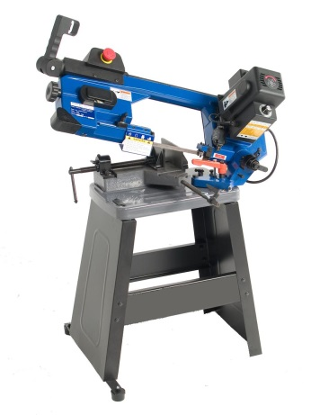 |  |  |  |  |  | Potential Hazards: Exposed moving parts and electrical hazard with the potential to cause harm through entanglement, impact and cutting, exposure to noise, dust, projectiles slips, trips and falls and sharp objects.
Personal Protective Equipment (PPE) Required (Check the box for required PPE):
Gloves |  | Face Masks |  | Eye  Protection | Welding Mask |  | Appropriate  Footwear |  | Hearing Protection | Protective Clothing
Safe Work Procedure Checklist:
1. PRE-Operation:
- Ensure guarding is in place.
- Ensure eye, hearing, clothing protection, facemask and appropriate footwear is worn prior to operation.
- Identify ON/OFF switch and emergency stop button (if applicable).
2. Operation:
- Check that the saw runs ‘true’ and does not wobble.
- Ensure work piece is securely clamped prior to use.
- Keep hands clear of work piece and away from the blade.
- Never leave the machine running unattended.
3. POST-Operation:
- Switch off saw before removing waste material from the table.
Competent Persons (The following persons are authorised to operate, supervise and test students on the equipment/process).
Name: | Title: |  |  |  |  |  |  | Contact Details:

