Safe Work Procedure

NOTE: DO NOT use this equipment unless you have been trained in its safe use and operation

Description of Work: |  |  | Operation of a Liquid Petroleum Gas (LP Gas) fuelled BBQ
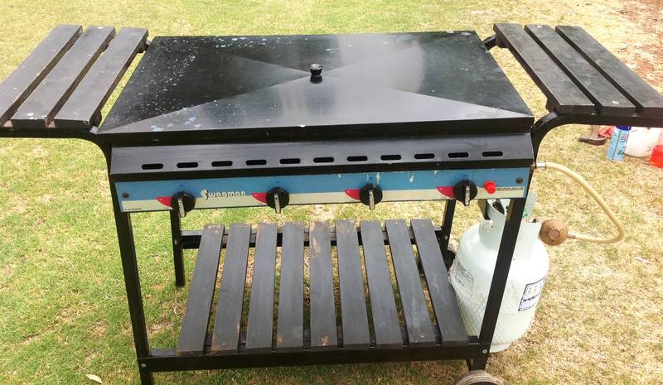 |  |  |  |  |  | Potential Hazards:  - Fire and explosion  - Temperature  - Slips/trips/falls
Personal Protective Equipment (PPE) Required (Check the box for required PPE):
Gloves |  | Face Masks |  | Eye  Protection | Welding Mask |  | Appropriate  Footwear |  | Hearing Protection | Protective Clothing
Safe Work Procedure Checklist:
1. PRE-Operation:
LP Gas cylinders:
- Only fill LP Gas cylinders at authorised filling stations employing trained personnel
- Avoid overfilling LP Gas cylinders
- Ensure the LP Gas cylinder is undamaged, free of corrosion/ damaged fittings and avoid using cylinders with a test date older than ten years
- Follow the connection instructions supplied with the LP Gas cylinder and avoid fitting a LP Gas cylinder to a natural gas appliance
BBQ fuelled by a LP Gas cylinder:
- Ensure a regulator is used between the LP Gas cylinder and the appliance unless the BBQ is designed for high pressure gas
- Check that fittings are clean and tight -- use soapy water to check for leaks
- Only use the BBQ outdoors in well ventilated and well lit areas and avoid use in high winds
- Ensure a fire blanket or suitable fire extinguisher is available
2. Operation:
- Operate BBQ as per manufacturer’s instructions
- Ensure that the lit BBQ is in the care of a responsible adult at all times
- Never put any flammable liquid on a BBQ
- Ensure adequate space is available for holding unprepared and prepared food and use appropriate BBQ implements
3. POST-Operation:
- Shut off the cylinder valve prior to disconnecting the LP Gas bottle from the BBQ
- Remove all excess fat from the hot plate and drip tray once cooled.
- Ensure valves are turned off firmly when not in use
- Store LP Gas cylinders upright and secured on a firm level base away from any ignition source
Competent Persons (The following persons are authorised to operate, supervise and test students on the equipment/process).
Name: | Title: |  |  |  |  |  |  | Contact Details:

