Isolation and Tag Out Procedure

Isolation and Tag Out Procedure

Purpose:
The purpose of this procedure is to ensure:
- all unsafe plant, machinery and equipment (‘equipment’) is identified and removed from service
- all plant and equipment undergoing maintenance, inspection, cleaning or repair is isolated from relevant energy sources (for example, electrical, hydraulic, chemical or mechanical energy sources) and tagged.

Scope:
This procedure applies to all Department of Education and Training (the Department) workplaces, including; schools, central and regional offices.

Procedure

Identification of unsafe equipment
The Workplace Manager and/or Management OHS Nominee is responsible for ensuring equipment identified as being unsafe or requiring maintenance work, is switched off and disconnected from any energy source (e.g. plug removed from power supply and/or connector hose removed from gas cylinders).
If an employee operating or inspecting equipment identifies any equipment that is unsafe or in need of maintenance or repair, they are to take corrective steps, as above and notify the Workplace Manager and/or Management OHS Nominee.
Examples of unsafe equipment may include:
- electrical lead insulation that is pulled away from the plug, exposing the wires
- electrical plant and equipment that does not start / stop when switched on and connected to a power source or operates in an unusual manner
- signs of damage and/or excessive wear and tear; for example, exposed wires, missing or damaged guards, signs of scorching or degraded fluid or gas lines
- leaking fluids (e.g. break, hydraulic)
- damaged pins / plugs on electrical leads
- rusted or damaged gas fittings.

Withdrawal of equipment from service
The Workplace Manager and/or Management OHS Nominee is responsible for ensuring equipment identified as being unsafe is withdrawn from service in accordance with Sections 3.2.1 to 3.2.5 of this Procedure.

Isolation of static and portable non-electrical equipment
Unsafe non-electrical equipment must be isolated from energy sources, for example by using some of the following methods:
- installing mechanical stops or retaining pins capable of being padlocked
- physically blocking the system against movement
- bleeding residual gases, liquids and vapours from systems
- relieving pressure for hydraulic or pneumatic systems
- pressure, hydraulic or pneumatic systems must be relieved of pressure if appropriate, or parts be blocked that could move due to loss of pressure.

Isolation of static and portable electrical equipment
Unsafe electrical equipment must be isolated from energy sources, for example by using some of the following methods:
- removal of fuses
- isolation of the drive motor at the source
- isolation of the control panel
- complete removal of power cable/plug from plant and equipment
- locking out the power supply board.

Isolation is not practicable
There may be equipment that can only be cleaned, maintained, repaired or adjusted while energised or while there are moving components. For equipment that can only be cleaned or adjusted while energised, a risk assessment should be completed using the Risk Assessment Template or equivalent. A Safe Work Procedure (SWP) should also be developed, with relevant employee(s) trained in the safe operation, with the SWP displayed adjacent to the static item of equipment.

Tag out
For equipment that has been isolated, a tag indicating that the item is “Out of Service” should then be placed onto all on/off switches and power leads (refer Appendix 1).
The “Out of Service” tag must be left on faulty items until the fault has been rectified or the tag is replaced with a ‘Danger – Do Not Operate’ tag and/or lock by a contractor or other person authorised to rectify the fault. The tag is to indicate the reason for the equipment being isolated, who the tag was completed by and the date it was completed.
The workplace should have ‘Out of Service’ and ‘Danger Do Not Operate’ tags available in an accessible location, when required.
Note: see Appendix 1 for example tags.

Lock out
Out of service equipment must be locked out to prevent unauthorised use. Lock out may also be undertaken by persons authorised to service, maintain or repair plant or equipment.
Lockout can be achieved by lock out at energy isolation points, preferably by use of keyed devices such as padlocks or isolation clasps. Where these are not available, or it is not possible to isolate with a key lock, the equipment must be relocated to a secure locked location until it can be removed or repaired.

Repair or maintenance of plant and equipment

Competent person
The Workplace Manager and/or Management OHS Nominee must ensure that only a competent person (for example, electrician, plumber, gas-fitter or service technician) is permitted to repair the equipment and remove the ‘Caution - Out of Service’ or ‘Danger – Do Not Operate’ tags and/or locks. For certain types of equipment, the competent person may need to hold a licence or registration to be able to undertake repair or maintenance. If the competent person is not a Department employee, then that person should be managed as per the requirements outlined in the Contractor OHS Management Procedure.
The competent person must ensure isolation devices are installed and the equipment is tagged as ‘Do not operate’ until the repair or service has been completed.

Reinstatement
Equipment must only be returned to service when the defect or condition which necessitated its removal for service has been repaired or corrected. Tags and isolation devices are to be removed and the equipment must only be re-connected and activated according to specific requirements for the equipment.

Maintaining records
A record must be kept of dates, times and names of employees/contractors isolating and tagging of equipment in the Isolation and Tag Out Register or equivalent.

Defined terms
Terms defined within this Procedure can be located on the Department’s Defined Health, Safety Terms website. Defined roles will appear in bold.

References
Occupational Health and Safety Act 2004
Occupational Health and Safety Regulations 2017

Related documentation
Contractor OHS Management Procedure
Isolation and Tag Out Register
Risk Assessment Template
Safe Work Procedure

Further assistance
Further information, advice or assistance on any matters related to isolation and tag out is available by contacting the OHS Advisory Service on ph. 1300 074 715 or email safety@edumail.vic.gov.au.

Appendix 1
Front of tag | Back of tag
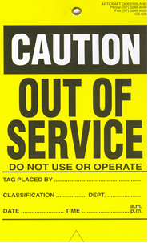 | 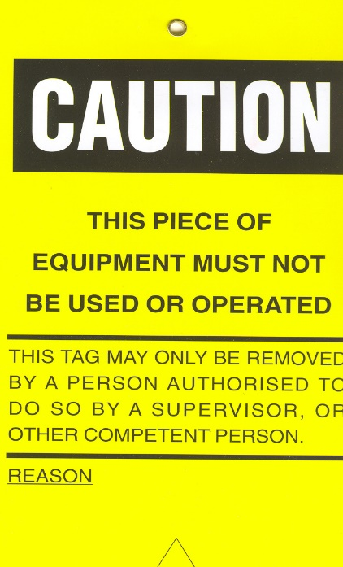
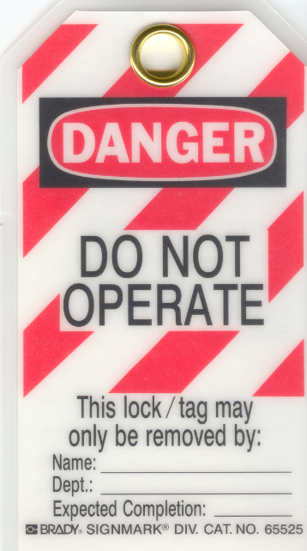 | 