Safe Work Procedure
NOTE: DO NOT use this machine unless you have been trained in its safe use and operation.
Description of Work: |  |  | Using a Hydraulic Press
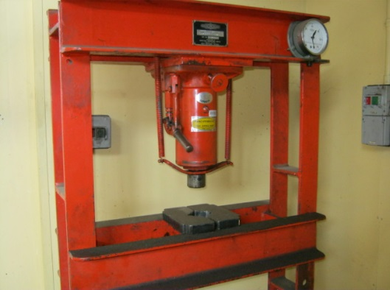 |  |  |  |  |  | Potential Hazards: Potential to cause harm as a result of crushing from moving parts, hazardous manual handling, materials being ejected from the plant and chemical hazard (release of hydraulic fluid).
Personal Protective Equipment (PPE) Required (Check the box for required PPE):
Gloves |  | Face Masks |  | Eye  Protection | Welding Mask |  | Appropriate  Footwear |  | Hearing Protection | Protective Clothing
Safe Work Procedure Checklist:
1. PRE-Operation/Task:
- Task (e.g. Drawings, instructions, specifications etc.) is clearly understood.
- Ensure press is in good working order without visible damage to structure or hydraulic fluid leaks.
- Ensure work piece is placed squarely on the plate.
- Clamp work piece (if appropriate).
2. Operation/Task:
- Keep hands and body clear of press mechanism when lowering.
- Lower ram until it contacts the work piece.
- Adjust pressure of ram to desired setting.
- Identify ON/OFF switch and emergency stop button (if applicable).
3. POST-Operation/Task:
- Ensure the area is clear of other people.
- Release pressure on hydraulic press.
- Slowly raise ram and remove work piece from plate.
- Return work pieces and other items to storage area as appropriate.
Competent Person(s): (The following persons are authorised to operate, supervise and test students on the equipment/process).
Name: | Title: |  |  |  |  |  |  | Contact Details:

