Safe Work Procedure

NOTE: DO NOT use this machine unless you have been trained in its safe use and operation.

Description of Work: |  |  | Using a High Pressure Water Cleaner
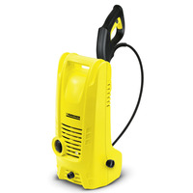 |  |  |  |  |  | Potential Hazards:  Exposure to hazards associated with impact (from back spray), pressurised content, electricity, ergonomics, slips trips and falls and back spray containing water, dirt or debris.
Personal Protective Equipment (PPE) Required (Check the box for required PPE):
Gloves |  | Face Masks |  | Eye  Protection | Welding Mask |  | Appropriate  Footwear |  | Hearing Protection | Protective Clothing
Safe Work Procedure Checklist:
1. PRE-Operation:
- Check all parts and cords for any damage before use.
- Unwind high pressure hose fully from the hose drum.
- Use only attachments supplied and approved by the manufacturer.
- Wear appropriate PPE.
2. Operation:
- The high pressure cleaner must not be directed at other people, animals or live electrical equipment.
- Ensure firm footing and hold the spray handgun and spray lance firmly in both hands whilst in operation.
3. POST-Operation:
- Turn off appliance and press the lever to release any remaining pressure in the system.
- Disconnect the appliance from water supply
- Store the handgun and spray lance in the accessory point and store appropriately.
Competent Persons (The following persons are authorised to operate, supervise and test students on the equipment/process).
Name: | Title: |  |  |  |  |  |  | Contact Details:

