Safe Work Procedure
NOTE: DO NOT use this machine unless you have been trained in its safe use and operation.
Description of Work: |  |  | Using a Heat Gun
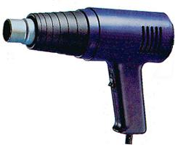 |  |  |  |  |  | Potential Hazards: Hazards with the potential to cause harm through exposure to heat, electricity, fumes, condition, slips, trips and falls.
Personal Protective Equipment (PPE) Required (Check the box for required PPE):
Gloves |  | Face Masks |  | Eye  Protection | Welding Mask |  | Appropriate  Footwear |  | Hearing Protection | Protective Clothing
Safe Work Procedure Checklist:
1. PRE-Operation/Task:
- Task (e.g. Drawings, instructions, specifications etc.) is clearly understood.
- Ensure appropriate parts are attached to gun for the task to be completed.
- Ensure that loose clothing is restricted.
- Ensure work area is appropriately ventilated.
- Identify ON/OFF switch.
2. Operation/Task:
- Keep hands clear of work piece and away from element.
3. POST-Operation/Task:
- Allow heat gun to cool prior to putting in storage area.
Competent Person(s): (The following persons are authorised to operate, supervise and test students on the equipment/process).
Name: | Title: |  |  |  |  |  |  | Contact Details:

