Safe Work Procedure
NOTE: DO NOT use this machine unless you have been trained in its safe use and operation
Description of Work: |  |  | Using a Guillotine
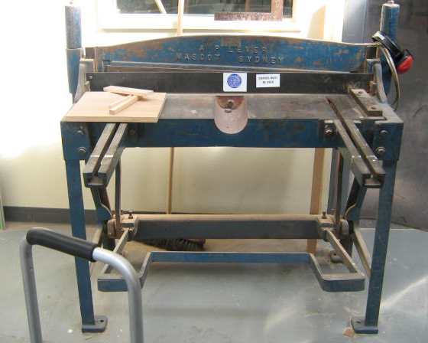 |  |  |  |  |  | Potential Hazards: Exposed moving parts with the potential to cause harm through exposure to sharp objects and crush and pinch points.
Personal Protective Equipment (PPE) Required (Check the box for required PPE):
Gloves |  | Face Masks |  | Eye  Protection | Welding Mask |  | Appropriate  Footwear |  | Hearing Protection | Protective Clothing
Safe Work Procedure Checklist:
1. PRE-Operation:
- Task (e.g. Drawings, instructions, specifications etc.) is clearly understood.
- Ensure all guards are in place.
- Remove all tools and scrap materials from the bed, top and slides of the machine.
- Parts should be well lubricated, free of dirt and free of dust.
- Identify ON/OFF switch and emergency stop button (if applicable).
2. Operation:
- Do not attempt to cut material beyond the capacity of the machine.
- Never attempt to cut rod, strap or wire with this machine.
- Use correct lifting procedures when handling large sheets of material.
- Take extreme care during the initial feeding of the work piece into the machine.
- The work piece should always be held as far back from the edge being fed into the guillotine.
- Ensure fingers and limbs are clear before activating the guillotine.
- Hold material firmly to prevent inaccurate cutting due to creep.
- Ensure operator is aware of his/her feet position to avoid accidental contact with the foot operated lever.
3. POST-Operation:
- Remove all off-cuts to appropriate areas.
Competent Persons (The following persons are authorised to operate, supervise and test students on the equipment/process).
Name: | Title: |  |  |  |  |  |  | Contact Details:

