Safe Work Procedure
NOTE: DO NOT use this machine unless you have been trained in its safe use and operation.
Description of Work: |  |  | Using a Grinder (bench of pedestal)
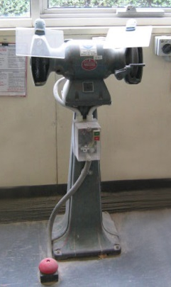 |  |  |  |  |  | Potential Hazards: Exposed moving parts and electrical hazard with the potential to cause harm through entanglement, impact and cutting, exposure to heat, noise, projectiles, sharp objects, friction and sparks.
Personal Protective Equipment (PPE) Required (Check the box for required PPE):
Gloves |  | Face Masks |  | Eye  Protection | Welding Mask |  | Appropriate  Footwear |  | Hearing Protection | Protective Clothing
Safe Work Procedure Checklist:
1. PRE-Operation/Task:
- Task (e.g. Drawings, instructions, specifications etc.) is clearly understood.
- Ensure the appropriate wheel is installed, in good condition and correctly in place.
- Ensure appropriate guarding is in place and in good working order.
- Identify ON/OFF switch and emergency stop button (if applicable).
2. Operation/Task:
- Check that the wheel runs ‘true’ and does not wobble.
- Keep hands clear of work piece and away from disk.
- Turn off machine at power point before changing the disk.
- Ensure guarding is in place before re-starting machine.
- Ensure grinder is isolated from power sources before being cleaned, adjusted, maintained or repaired.
3. POST-Operation/Task:
- Switch off grinder before removing waste material from the bench.
- Ensure disk is still in good condition after use.
Competent Person(s): (The following persons are authorised to operate, supervise and test students on the equipment/process).
Name: | Title: |  |  |  |  |  |  | Contact Details:

