Safe Work Procedure
NOTE: DO NOT use this machine unless you have been trained in its safe use and operation.
Description of Work: |  |  | Using Gas Torch Equipment
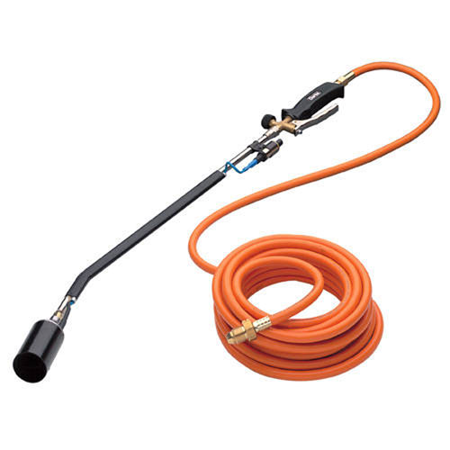 |  |  |  |  |  | Potential Hazards: Hazards with the potential to cause harm through impact and cutting, exposure to fire and explosion, heat, projectiles (spitting metal), sparks, slips, trips, falls, fumes and gases.
Personal Protective Equipment (PPE) Required (Check the box for required PPE):
Gloves |  | Face Masks |  | Eye  Protection | Welding Mask |  | Appropriate  Footwear |  | Hearing Protection | Protective Clothing
Safe Work Procedure Checklist:
1. PRE-Operation/Task:
- Ensure task (e.g. Drawings, instructions, specifications etc.) is clearly understood.
- Ensure the work area is clean and clear of grease, oil and any other flammable materials.
- Ensure the gloves, heat gun, work area and leads are in good condition.
- Restrict access into work areas.
- Ensure appropriate ventilation is in place prior to use.
2. Operation/Task:
- Keep hands clear of work piece and away from flame.
- Never leave the gas torch running unattended.
3. POST-Operation/Task:
- Switch off gas bottle and fume extraction (if relevant).
- Close gas cylinder valve.
- Store equipment appropriately.
Competent Person(s): (The following persons are authorised to operate, supervise and test students on the equipment/process).
Name: | Title: |  |  |  |  |  |  | Contact Details:

