Safe Work Procedure
NOTE: DO NOT use this machine unless you have been trained in its safe use and operation.
Description of Work: |  |  | Using an Electric Kiln
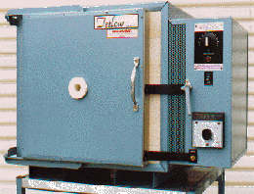 |  |  |  |  |  | Potential Hazards: Electrical, crush and burns hazard with the potential to cause harm through impact and cutting, exposure to heat, pinch points, fumes, dust and sharp objects.
Personal Protective Equipment (PPE) Required (Check the box for required PPE):
Gloves |  | Face Masks |  | Eye  Protection | Welding Mask |  | Appropriate  Footwear |  | Hearing Protection | Protective Clothing
Safe Work Procedure Checklist:
1. PRE-Operation/Task:
- Task (e.g. Drawings, instructions, specifications etc.) is clearly understood.
- Ensure all fired pieces are removed from the kiln.
- Ensure the temperature is set appropriately.
- Put all pieces to be fired in the kiln.
- Close the kiln door securely, being careful of the pinch points.
- Ensure the kiln has appropriate ventilation.
2. Operation/Task:
- Turn on the kiln and keep hands clear of it whilst in operation.
3. POST-Operation/Task:
- When the firing process is finished, wait until kiln has cooled prior to opening the door.
- Wear gloves to prevent burns and cuts from damaged ceramics.
Competent Person(s): (The following persons are authorised to operate, supervise and test students on the equipment/process).
Name: | Title: |  |  |  |  |  |  | Contact Details:

