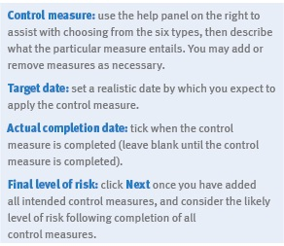
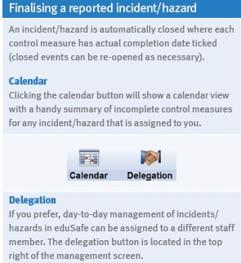

Authorised by:
The Department of Education and Training
2 Treasury Place
East Melbourne, Victoria, 3002

Revised January 2018
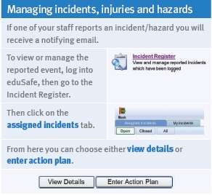
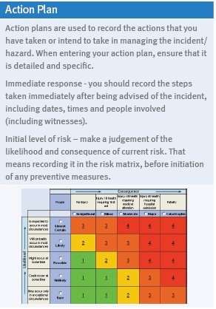

eduSafe
Quick Reference Guide

What is eduSafe
eduSafe is an online system for reporting and managing employee incidents/ injuries, hazards and near misses across the whole of the Department of Education and Training.

eduSafe offers
- A single system for reporting and managing employee related incidents, injuries, hazards and near misses.
- Self-reporting
- Easy access from any computer
- Email notification and automatic reminders
- Live up to the minute incident information
- Comprehensive management tools and reports

eduSafe does not
- Change any existing procedures or policies
- Change the need to notify serious incidents to the Security Services Unit (SSU)
- Change reporting of notifiable incidents to the Victorian WorkCover Authority
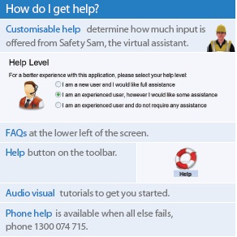
- Cater for reporting student incidents/injuries

How do I get started?
You will need your current DET login details and password and access to the internet. To access eduSafe type the following link into the browser’s address line:
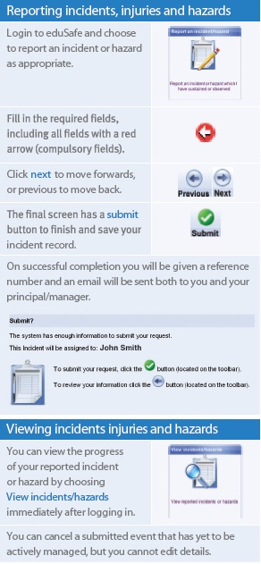
www.eduweb.vic.gov.au/edusafe

Roles and responsibilities
The Department of Education and Training’s Hazard and Incident Reporting and Investigation Procedure describes the hazard and incident, reporting, management and investigation process. Claims for workers’ compensation arising from a work related injury need to be made separately.
Employees
Employees should use eduSafe to report incidents/injuries or hazardous situations, for themselves. You can also report incidents on behalf of other people, such as visitors or colleagues.
Where necessary a WorkCover Claim Form will still need to be submitted.
Principals and Managers
Management are to use eduSafe to manage incidents reported by their staff and to report incidents on behalf of non-employees. eduSafe provides reporting tools and charts.
Principals and managers are also required to consult with employees and the HSR when making decisions to control health and safety risks. Consultation with employees and HSRs is an important and effective part of managing risks.

Although principals and managers can delegate their role in eduSafe to appropriate nominees, ultimate responsibility for health and safety and management of reported events resides with the principal or manager.

