Safe Work Procedure
NOTE: DO NOT use this machine unless you have been trained in its safe use and operation
Description of Work: |  |  | Using a Drop Saw (Mitre, Rip or Crosscut)
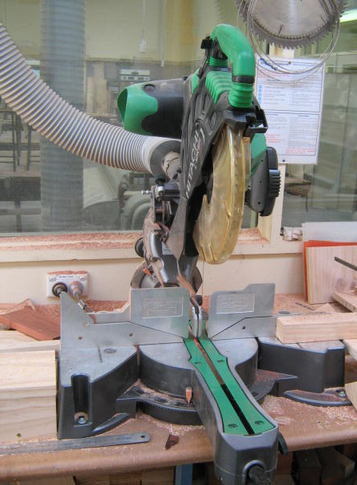 |  |  |  |  |  | Potential Hazards: Exposed moving parts and electrical hazard with the potential to cause harm through entanglement, impact and cutting, exposure to noise, dust, projectiles and sharp objects.
Personal Protective Equipment (PPE) Required (Check the box for required PPE):
Gloves |  | Face Masks |  | Eye  Protection | Welding Mask |  | Appropriate  Footwear |  | Hearing Protection | Protective Clothing
Safe Work Procedure Checklist:
1. PRE-Operation:
- Task (e.g. Drawings, instructions, specifications etc.) is clearly understood.
- Ensure guarding is in place.
- Ensure the appropriate blade is being used for the task.
- Ensure the local exhaust/ventilation system is switched on and in good working order.
- Identify ON/OFF switch and emergency stop button (if applicable).
2. Operation:
- Check that saw runs ‘true’ and does not wobble.
- Keep hands clear of work piece and away from rotating blade.
- Back out frequently on deep cuts to clean and allow the blade to cool.
- Ensure guarding is in place before saw is re-started.
3. POST-Operation:
- Switch off saw before removing waste material from the table.
- Ensure good housekeeping practices are in place to minimise dust build-up.
Competent Persons (The following persons are authorised to operate, supervise and test students on the equipment/process).
Name: | Title: |  |  |  |  |  |  | Contact Details:

