[Workplace name]

Contractor Occupational Health and Safety (OHS) Induction
Handbook

[Insert school photo or logo if desired]

Prepared by: | [Name]
Date Prepared: | [Click here to enter a date]
Review Date: | [Click here to enter a date]

Click here to enter a date.

““

Dear [Choose an item.] ,
The Department of Education and Training (the Department) has implemented an OHS Management System (OHSMS) in that requires all contractors engaged to provide maintenance, repair work, or services in [workplace] be approved prior to the commencement of any works.
Please read the attached Contractor OHS Induction Handbook and familiarise yourself with its contents. Upon arrival to the site, please report to the general office to sign in and be issued with a visitor’s pass that is to be worn at all times whilst on Department premises. You will also be required to undergo a site specific OHS induction.
The following information is to be provided:
  - copy of current public liability insurance certificate (Note: $10 million minimum cover required)
  - copy of current workers compensation insurance certificate (if company).
  - copy of trade licenses and bring original for sighting
  - current Working with Children Check (where applicable)
  - copy of Safe Work Method Statement /Job Safety Analysis for the high risk wrok to be undertaken or as mandated by the Department.
This information is to be returned to us by Click here to enter a date.
Note: If you are assessed as non-compliant you will be advised to submit further evidence.
If you any questions please do not hesitate to contact on or
Yours Sincerely,

Table of Contents

Table of Contents 2
Introduction 3
Department Health, Safety and Wellbeing (HSW) Policy 4
Required conduct/behaviour 5
Access arrangements 6
Access 6
Traffic Management 6
OHS Induction 7
Safe Work Method Statements (SWMS) 8
Confined Space Entry Permit 9
Site specific hazards 10
Asbestos 10
Hazardous Substances and Dangerous Goods 10
Potential to fall two metres or more 10
Hot Work 11
Cables 11
Animals / Wildlife 11
Emergency management 12
Workplace Codes 12
Emergency Procedures 12
Leaving Site in an Emergency 12
Evacuation Point 12
Emergency contacts 13
First aid and amenities 14
First Aid 14
Amenities 14
Hazard and Incident reporting 15
Appendix A: Emergency Evacuation Map 16

Introduction
To comply with the requirements of the Victorian Occupational Health and Safety (OHS) Act 2004 and the Victorian OHS Regulations 2017 the Department of Education and Training (the Department) has implemented an OHS Management System (OHSMS) in all Victorian Government schools.
The OHSMS requires all engaged contractors and sub-contractors to:
- report to the general office upon arrival at site
- complete an OHS induction using the Contractor OHS Induction Checklist
- sign in/out and ensure their visitors pass is worn at all times whilst on Department premises
- provide the following information:
  - licence numbers and/or qualification details
  - Public Liability Insurance Certificate of Currency (minimum $10 million sum insured)
  - Workers Compensation Insurance Certificate of Currency (if not a sole trader)
  - Safe Work Method Statement (SWMS) or Job Safety Analysis (where applicable, see page 7).
- complete a Confined Space Entry Permit in consultation with the principal and/or their delegate for confined space entry.

Department Health, Safety and Wellbeing (HSW) Policy
The Department has the Health, Safety and Wellbeing Policy, which has been endorsed by the Department Secretary and can be seen below:
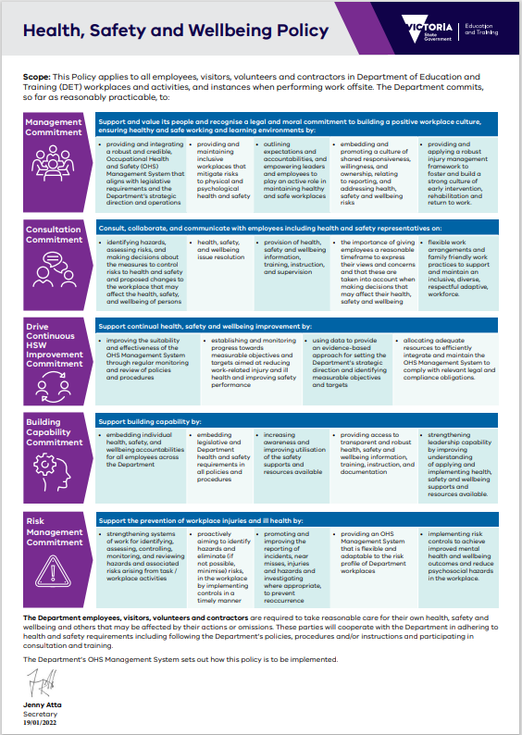

Required conduct/behaviour
All contractors are expected to abide by the workplaces code of conduct while on site. This includes:
- No smoking on school grounds or within four metres of an entrance to all Department workplaces.
- No alcohol or drugs are to be consumed on any Department premises. Any contractor under the influence will be dismissed.
- No offensive language is permitted on any Department premises.
- Noise must be kept to a minimum. If this is not practicable, then non-urgent work should be scheduled outside of school hours, where possible.
- Possessions, materials, and equipment should be secured and not be left unattended.
- Abide by the workplaces traffic management procedures.
- Entrance to other areas of Department workplaces aside from the work area is prohibited, unless otherwise agreed to.
- Remove all litter and debris from the workplace.
- Report any problems, hazards, or incidents to the principal or their delegate.
- Dress appropriately and wear the correct personal protective equipment suitable.
- No pets are permitted on Department premises.

Access arrangements

Access
All contractors must report to the general office and sign in upon arrival at the workplace. This requirement is indicated on signage located at all entrances to the school, see below:
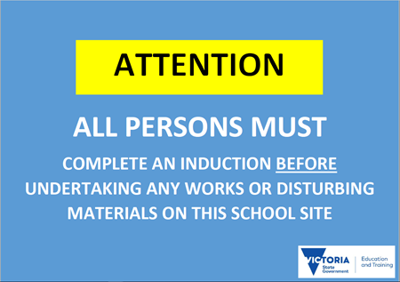

Contractors are to restrict their movements and activities within the school to those areas and times approved/agreed to.

Traffic Management
Contractor vehicles are to enter and exit the school grounds via the following locations:
- [Insert entry locations]
- [Insert exit locations]
Designated pedestrian crossings are:
- [Insert locations or delete section if not applicable]
Vehicles entering school grounds must adhere to all traffic signage. Where there is no signage, vehicles are to move at walking pace at all times. If a vehicle has limited visibility or mobility, a spotter should be used when the vehicle is in motion.
Contractors are not to operate vehicles on, or around, school grounds during designated drop off/pick up times or during break times:
- Drop off: [insert time]
- Recess: [insert time]
- Lunch: [insert time]
- Pick up: [insert time]

OHS Induction
Upon arrival at the site, you will be required to complete an OHS Induction covering the site specific risks.
Contractor inductions are valid for 12 months, except where the provision of a SWMS is mandated for high risk work. In this instance, the contractor must be re-inducted (see Chapters 3 and 4 of the Contractor OHS Management Procedure).

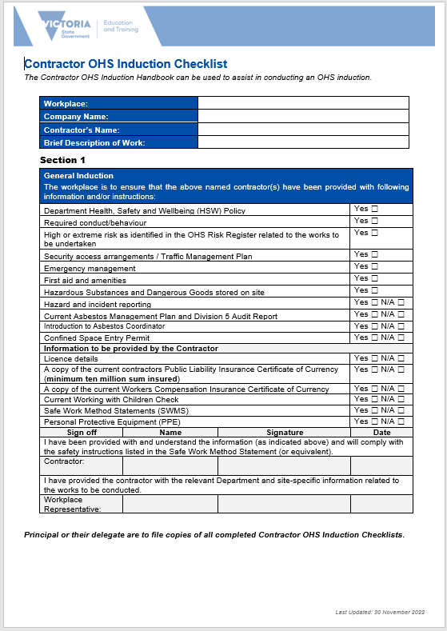

Safe Work Method Statements (SWMS)
A contractor is expected to supply a Safe Work Method Statement (SWMS) or equivalent template, prior to the commencement of works, based on the level of risk or as mandated by the Department for the following high risk work:
- confined space entry
- demolition works
- hazardous manual handling
- hot works (e.g., welding)
- powered mobile plant (e.g., forklift)
- removal or disturbance of asbestos
- temporary supports for structural alterations
- tilt-up or precast concrete.
- trenches or shafts deeper than one and half metres
- use of explosives
- use of Hazardous Substances and Dangerous Goods
- working at height (two metres or more)
- works in tunnels
- Work that is in, on or nearby:
  - artificial temperature extremes (e.g., work in an operating cool room or freezer)
  - chemical, fuel or refrigerant lines
  - contaminated or flammable atmospheres
  - electrical installations or services
  - pressurised gas distribution mains or piping
  - roads
  - telecommunications towers
  - water/liquids that pose a drowning risk
If the proposed work requires a SWMS, the works cannot proceed until the principal and/or their delegate has reviewed and signed the SWMS, to verify it has been sighted. A new SWMS will be required if scope of works change.

Confined Space Entry Permit

[Delete section if the workplace does not have a confined space]
For works to be completed in a confined space, a contractor is to obtain and complete a Confined Space Entry Permit in consultation with the principal or their delegate as per the following procedure:
- report to the general office to sign in upon arrival
- ensure that your SWMS is complete
- obtain and complete a permit to work in consultation with the principal or their delegate
- prominently display the permit to work
- return the permit to work to the office, to be signed off, at the completion of task or end of the day
- if the task is not completed, repeat the process on successive days until the task is complete
- if the scope of works changes the permit to work must be re-issued.

Site specific hazards
[Insert details of any other site specific hazards below]

Asbestos
All schools are expected to have a Schools Asbestos Management Plan in the event of the discovery of suspected asbestos containing material (ACM) or the accidental disturbance of existing ACM.
If ACM has been identified in the school, the following process must be followed prior to the commencement of works:
- Asbestos Register MUST be checked at the time of sign-in when the proposed work involves drilling, scraping, sanding, sawing or any other destructive process.
- if work is to be carried out in the vicinity of Asbestos Containing Material the Asbestos Coordinator [Insert Asbestos Coordinator’s name and work phone number] must be consulted prior to the commencement of work.
- asbestos containing material may only be removed by a licensed removalist.

Hazardous Substances and Dangerous Goods
If transporting hazardous substances or dangerous goods onto site, the principal or their delegate must be informed. You must complete a Safe Work Method Statement or equivalent to outline the controls methods you will use to ensure that the risks of the hazardous substances and/or dangerous goods are managed.
Such controls may include, but are not limited to:
- the provision of Safety Data Sheets (SDS)
- correct labelling of containers
- correct storing and handling of containers
- correct disposal of any waste
- provision of personal protective equipment (PPE).

Potential to fall two metres or more
Where there is the potential to fall two metres or more including:
- work at a height of two metres or above (measured from the ground to foot position on ladder rung/work platform) or
- undertake excavation work (depth of one and a half metres or more)
A Safe Work Method Statement or equivalent e.g., Job Safety Analysis must be supplied to the school demonstrating how you will manage the risks.

Hot Work
If a hot work task is to be undertaken (e.g., welding, burning, soldering, grinding) a Safe Work Method Statement or equivalent, must be supplied to the school, demonstrating how you will manage the risks.

Cables
[Edit this section to suit workplace or delete section if not applicable]
There are overhead power lines [insert location]. Work in this area must be approved by the workplace manager.
Various underground service cables are present throughout the site. Adequate controls must be implemented and discussed with the principal and/or their delegate or other Department site contact prior to performing works that could disrupt Department services.
Prior to conducting works, please contact ‘Dial Before You Dig’ on ph. 1100 (toll Free) between 8am and 5pm. For further information access the Dial Before you Dig Vic/Tas Service Guidelines.
You can also call Energy Safe Victoria on (03) 9203 9700 or 1800 652 563 during normal business hours, or email ESV at info@energysafe.vic.gov.au.

Animals / Wildlife
There is the potential to come into contact with domestic animals and wildlife while on this site. Should this occur, you must:
- do not approach any domestic animals (e.g., dogs) or dangerous wildlife
- report the sighting of any domestic animals or dangerous wildlife to the principal or their delegate.
- do not reach into any holes or gaps in the buildings without first checking to see if it is safe.

Emergency management

Workplace Codes
[Insert appropriate code colours to situations or delete section if not applicable]
In the event that a code is called, please obey the following instructions:
- Code [Insert colour]: Fire, proceed to evacuation point.
- Code [Insert colour]: Possible emergency, remain alert but stay where you are for now.
- Code [Insert colour]: Lockdown, follow instructions.
- Code [Insert colour]: Gas leak, proceed to evacuation point etc.

Emergency Procedures
On hearing the alarm:
  - switch off all equipment
  - proceed to the advised assembly area
  - report to one of the wardens
  - do not leave the assembly area until advised.

Leaving Site in an Emergency
All contractors are required to proceed to the evacuation point and remain there until given clearance to leave by the Incident Controller or principal.

Evacuation Point
The evacuation point is located at [Insert location]; refer to Evacuation Map (Appendix A).

Emergency contacts
School contacts
Principal | [Insert name] | [Insert school number/extension]
Assistant Principal | [Insert name] | [Insert school number/extension]
Asbestos Coordinator | [Insert name] | [Insert school number/extension]
Business Manager | [Insert name] | [Insert school number/extension]
Office Manager | [Insert name] | [Insert school number/extension]
General Office Number | [Insert name] | [Insert school number/extension]

School after hours contacts
Principal: | [Insert mobile or home number]
Business Manager: | [Insert mobile or home number]

Emergency contacts
Police: | 000
Fire: | 000
Ambulance: | 000
Poisons: | 13 11 26

First aid and amenities

First Aid
In the event of an injury:
- if the injury is not serious, report or escort the injured party to the administration office for assistance
- if the injury is serious ring 000, do not wait for first aid officer
- stay with injured party. Send someone else to find the first aid officer or workplace manager
- if no one else is available, ring the school number and inform the office that someone is injured at your location
- if trained, apply first aid to the injured party
- once incident is over, fill in an incident report at the office.
[Optional: Insert map of workplace with first aid room and first aid kits clearly marked]

Amenities
[Optional: Insert details or map of workplace with the following items clearly marked:
- Toilets and amenities
- Lunchroom
- Parking
- Other]

Hazard and Incident reporting
Any hazard or incident which poses a risk to the safety of a student, parent, visitor, contractor or employee must be reported.
- Call 000 immediately to report any incident threatening life or property. This number will connect you to the following emergency services:
  - police for crime, injury that may not be accidental, or assault
  - ambulance for injury and medical assistance
  - fire brigade for fires, gas leaks and incidents involving hazardous and dangerous materials.
- Notify the administration office in person, or, if unable or unsafe to do so, notify someone via the emergency contact list (page 11).
- Principal or their delegate is to report the incident on eduSafe Plus.

Appendix A: Emergency Evacuation Map

[Include a copy of the school’s emergency evacuation map here]

If the contractor is a sole trader, they will not have Workers Compensation Insurance, but may have income protection. Ensure that details are supplied to ---------- School/College.

