Safe Work Procedure
DO NOT use this machine unless you have been trained in its safe use and operation
Description of Work: |  |  | Using a Cold Metal Drop Saw
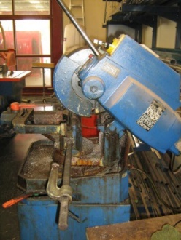 |  |  |  |  |  | Potential Hazards: Exposed moving parts and electrical hazard with the potential to cause harm through entanglement, exposure to noise, dust, projectiles, sparks and sharp objects.
Personal Protective Equipment (PPE) Required (Check the box for required PPE):
Gloves |  | Face Masks |  | Eye  Protection | Welding Mask |  | Appropriate  Footwear |  | Hearing Protection | Protective Clothing
Safe Work Procedure Checklist:
1. PRE-Operation:
- Ensure bench shears are securely fastened to a bench or purpose designed stand.
- Task (e.g. Drawings, instructions, specifications etc.) is clearly understood.
- Ensure guarding is in place.
- Ensure the appropriate blade is being used for the task.
- Ensure blade is in good condition.
- Identify ON/OFF switch and emergency stop button (if applicable).
2. Operation:
- Check that saw runs ‘true’ and does not wobble.
- Keep hands clear of work piece and away from rotating blade.
- Back out on deep cuts to allow the blade to cool.
- Allow the blade to do the work without forcing the saw.
- Ensure guarding in place before saw is re-started.

3. POST-Operation:
- Switch off saw before removing waste material from the table.
Competent Persons (The following persons are authorised to operate, supervise and test students on the equipment/process).
Name: | Title: |  |  |  |  |  |  | Contact Details:

