Safe Work Procedure

NOTE: DO NOT use this machine unless you have been trained in its safe use and operation.

Description of Work: |  |  | Using a Chain Saw (Electric)
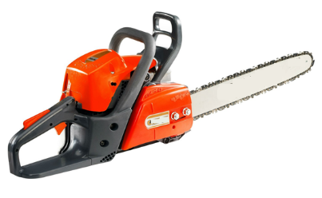 |  |  |  |  |  | Potential Hazards:  Exposed moving parts with the potential to cause harm through entanglement, impact and cutting, electrical hazards, noise, manual handling injuries, vibration, slips, trips and falls, temperature and dust.
Personal Protective Equipment (PPE) Required (Check the box for required PPE):
Gloves |  | Face Masks |  | Eye  Protection | Welding Mask |  | Appropriate  Footwear |  | Hearing Protection | Protective Clothing
Safe Work Procedure Checklist:
1. PRE-Operation:
- Identify ON/OFF switch.
- Undertake visual inspection of electrical leads.
- Uncoil the extension cord.
- Check that chain saw is in good repair.
- Check that chain is lubricated, sharp and the tension is correct.
- Never operate a chain saw without a front hand guard (it protects the operator in a kickback situation).
- Wear adequate and appropriate PPE.
2. Operation:
- Exercise caution in relation to the electrical lead.
- Start chain saw while placed on ground or stable surface.
- Hold the chain saw firmly with both hands and maintain a secure grip. Using a loose grip can cause kickbacks.
  - Always begin your cut at peak revs.
  - Stand to the side of the cutting path of the chain saw.
  - Do not cut above shoulder height.
  - Never hold the chain saw in one hand or by one handle only.
  - Do not walk with chain saw whilst blade is spinning.
  - Do not use in wet conditions.
3. POST-Operation:
- Ensure blade has stopped spinning before removing waste material/work piece.
- Ensure blade has stopped spinning before placing it on the ground.
- Use the chain guard (scabbard) when machine is carried or not in use.
- Ensure equipment is returned to storage area after use.
Competent Persons (The following persons are authorised to operate, supervise and test students on the equipment/process).
Name: | Title: |  |  |  |  |  |  | Contact Details:

