Safe Work Procedure
NOTE: DO NOT use this machine unless you have been trained in its safe use and operation.
Description of Work: |  |  | Using a Belt Sander
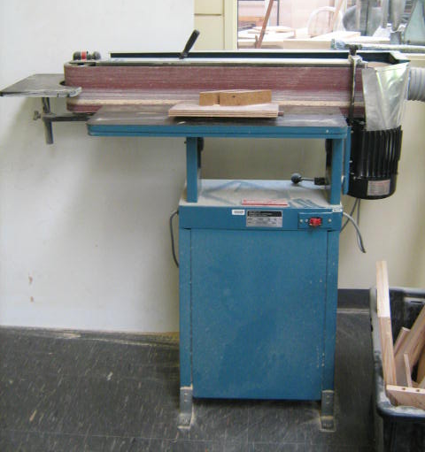 |  |  |  |  |  | Potential Hazards: Exposed moving parts and electrical hazard with the potential to cause harm through entanglement, impact and cutting, exposure to noise, dust, projectiles and sharp objects.
Personal Protective Equipment (PPE) Required (Check the box for required PPE):
Gloves |  | Face Masks |  | Eye  Protection | Welding Mask |  | Appropriate  Footwear |  | Hearing Protection | Protective Clothing
Safe Work Procedure Checklist:
1. PRE-Operation/Task:
- Task (e.g. Drawings, instructions, specifications etc.) is clearly understood.
- Operator must be positioned out of direct line of abrasive belt at all times.
- Turn on local exhaust system (if available).
- Faulty equipment must not be used.
- Identify ON/OFF switch and emergency stop button (if applicable).
2. Operation/Task:
- Allow sander to reach maximum revolutions before operating to avoid overloading.
- Always place material on the table on the downward side to the disc travel.
- Hold material firmly against stops or table before applying pressure on abrasive surface.
- Keep fingers clear of disc or belt while sanding.
- Never leave the machine while it is running.
- Switch off sander and bring it to a complete standstill before making adjustments.
3. POST-Operation/Task:
- Switch off machine and leave work area and sander in a safe and clean state.
- Ensure good housekeeping practices are in place to minimise dust build-up.
Competent Person(s): (The following persons are authorised to operate, supervise and test students on the equipment/process).
Name: | Title: |  |  |  |  |  |  | Contact Details:

