Safe Work Procedure

NOTE: DO NOT use this machine unless you have been trained in its safe use and operation.

Description of Work: |  |  | Using an Automotive Parts Washer
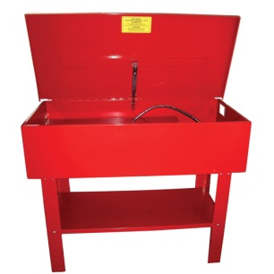 |  |  |  |  |  | Potential Hazards: Fire and electrical hazard with the potential to cause harm through exposure to sharp objects, electric shock, fire and explosion, fumes and condition.
Personal Protective Equipment (PPE) Required (Check the box for required PPE):
Gloves |  | Face Masks |  | Eye  Protection | Welding Mask |  | Appropriate  Footwear |  | Hearing Protection | Protective Clothing
Safe Work Procedure Checklist:
1. PRE-Operation:
- Ensure parts washer tank using combustible or flammable solvents is equipped with an approved automatic lid closure device (i.e. fusible link) that allows the lid to close automatically in the event of a fire, and also allows manual closure if required.
- Ensure electrical wiring and light fixtures attached or near to parts washer using combustible or flammable solvents are sound and in good condition. Flexible power extension cords must not be run near the tank.
- Consult the Safety Data Sheets (SDS) for specific technical data and precautionary measures concerning any materials used with this equipment.
- Ensure adequate ventilation.
- Ensure no slip/trip hazards are present in workspaces and walkways.
- Check there are no naked flames or ignition sources.
- Ensure operator is familiar with, and checks all equipment operations and controls.
- Faulty equipment must not be used. Immediately report suspect machinery.
2. Operation:
- Be aware of other personnel in the immediate vicinity and ensure the area is clear before starting equipment.
- Use correct lifting procedures.
- Clean up spills immediately. Do not leave dirty rags/parts/tools lying around.
- Never leave the equipment running while unattended.
- Keep lid closed when not in use.
- Wash hands with soap and water after every use.
3. POST-Operation:
- Switch off the equipment and ensure lid is closed.
- Leave the work area and the machine in a safe, clean and tidy state.
Competent Persons (The following persons are authorised to operate, supervise and test students on the equipment/process).
Name: | Title: |  |  |  |  |  |  | Contact Details:

