Issue
This health and safety hazard alert is to inform schools of the potential for asbestos to be present in some portable science equipment and in mineral kits used for teaching in schools.
Although these items generally constitute a low risk when the materials are in good condition and are left undisturbed, as a precautionary measure the Department is requesting schools to identify portable items that may have asbestos-containing materials (ACM) and to contact Cushman and Wakefield (the Department’s Asbestos, Reinstatement and Preventative Maintenance Call Centre) on 1300 133 468 for further advice.

PORTABLE EQUIPMENT

Some portable equipment and materials in school science laboratories may have ACM. ACM can be found in internal lining of equipment, especially where heat insulation is required, embedded in gauze or heat mats, or incorporated into cement sheeting used to line ovens. Examples include Milliken’s Oil drop Apparatus, older style hot plates, gauze mats and heat mats and incubator ovens.
Schools should also note that there may be portable equipment that is not specifically designed for use in science laboratories but nevertheless may contain asbestos. For example, some safes and cabinets may contain ACM in the lining and seals to prevent fire damage to contents. In these cases, the equipment should be treated the same as above.
Examples of equipment that may contain ACMs
Milliken’s Oil Drop Apparatus  May contain asbestos in the internal lining | 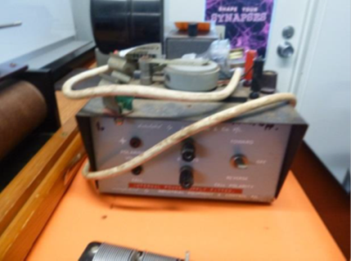 | Hot Plate (older style)  May contain asbestos | 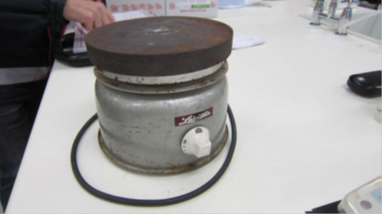
Gauze mats and heat mats  Heat mats and gauze mats made from asbestos containing materials (testing will confirm the presence of asbestos) | 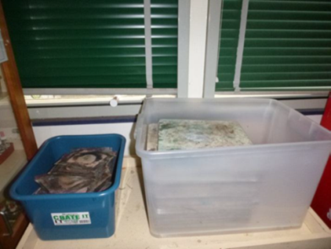 | Incubator oven  Incubator oven with asbestos cement sheet on the door (testing will confirm the presence of asbestos) | 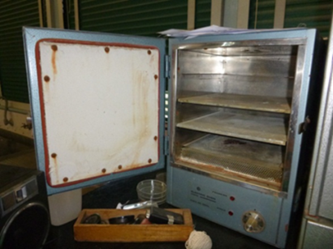
Older style safe  May contain asbestos in the lining and door | 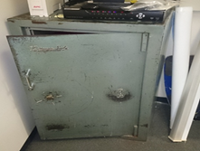 | Older style cabinet  May contain asbestos in the lining and door | 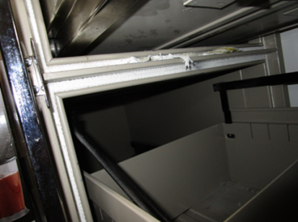

Recommendations/Action required
- Identify portable items suspected of containing asbestos by undertaking a workplace inspection of the science laboratory.
- Isolate portable items suspected of containing asbestos to prevent access. This may include placing the items in a locked room or cupboard; or placing a lock on doors to incubators
- Contact Cushman and Wakefield (the Department’s Asbestos, Reinstatement and Preventative Maintenance Call Centre) on 1300 133 468 to arrange for a competent person to assess the items for the presence of ACM and determine next steps.
- Label and register the equipment. All equipment confirmed to contain asbestos must be labelled accordingly and the details must also be entered in the school’s asbestos register. The attending competent person will advise on labelling requirements.

MINERAL KITS
Mineral kits (including ore and geological kits) may contain asbestos rock samples under a variety of names, for example serpentine, Amosite, tremolite and chrysotile (also referred to as leucotile). Older kits as well as some recently imported kits are believed to potentially contain asbestos rock samples.
The following is a list of possible asbestos-containing minerals that may be present in commercially available mineral kits
Actinolite | Fibrous zeolite including erionite and offretite
Amosite (grunerite) | Richterite
Anthophyllite | Tremolite
Asbestos | Winchite
Chrysotile (leucotile, white asbestos, chrysotile serpentine) | Serpentine or serpentinite – including lizardite and antigorite serpentines
Crocidolite (blue asbestos, riebeckite) | Amphilbole

Examples of equipment that may contain ACMs
Mineral Kits  A.S.E.P. 60941 contains asbestos rock sample | 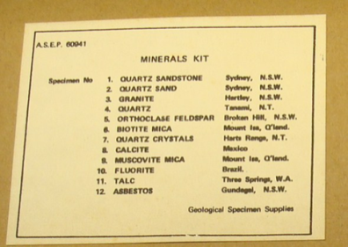 | Mineral Kits  Geological specimen supplies | 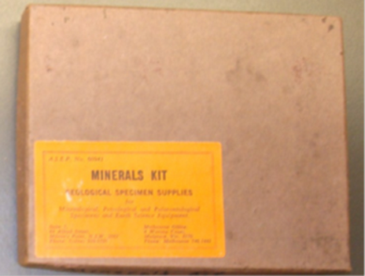
Mineral Kits  Mineral samples | 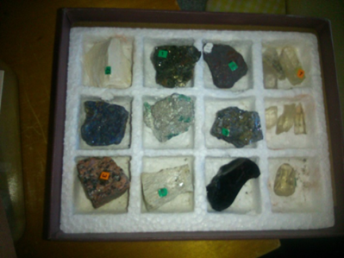

Recommendations/Action required
- Check whether your school has kits containing any sample listed in the table above.

- Where possible, contact the supplier to confirm whether the kit or samples contain asbestos and request a testing certificate or statement. Arrange for a return and replacement of the kit where necessary.

- Kits that cannot be confirmed as being asbestos-free should be withdrawn from use and contained in the original packaging or a sealable plastic bag.
- Contact Cushman and Wakefield (the Department’s Asbestos, Reinstatement and Preventative Maintenance Call Centre) on 1300 133 468 to arrange for a competent person to assess the items and to advise on safe disposal.

Disclaimer
This Alert contains information following DET’s inquiries into an incident at the date of this report. The information contained in this report does not necessarily reflect the final outcome of DET’s action with respect to this incident. DET does not warrant the information in this report is complete or up-to-date and does not accept any liability to any person in relation to the information in this report or as to its use.

