Working AT HOME – OHS GUIDANCE
Guidance
This document is developed to provide guidance for staff members who are working at home. If further support is required, contact: 1300 074 715 or email: safety@edumail.vic.gov.au

For more detailed information and assessment of your workstation please refer to the Department’s Working Alone, in Isolation or from home and Workstation Assessment Risk Assessment

If you are unable to satisfy the above and believe you cannot work remotely safely, please contact your manager to discuss alternatives.

Home-based hygiene
- Ensure you have adequate space to work with clear space for your legs underneath your work area
- Wipe down your workstation regularly
- Work in an area with good air flow (if you can, open a window or door to provide natural ventilation)
- Work in an area of comfortable temperature (not too hot or cold)

Setting up your workspace
When working away from the office, you may not have access to your usual office set up and will likely be utilising a laptop to complete your work. The tips below will allow you to set your workstation up effectively throughout this period.

Working with a laptop
- Place your laptop on an adjustable stand so you can use it as a separate screen.
Tip: elevate your laptop by using a laptop stand or by sitting it on some books.
- Have your screen positioned at eye level, reducing the need to bend or rotate the head.
- Position your screen approximately arm’s length away.
- Attach an external keyboard and mouse.
Tip: if you need to take your keyboard, mouse and skype headset from work please check in with your manager for approval
- Position your keyboard at a height to allow your shoulders and arms to be at a re elbows at a 90 angle
- Position your mouse near to your body keeping your wrist flat whilst in use
- Avoid screen glare by positioning yourself so you do not have a window behind you.
- Ensure correct seating posture.

Seating
Some handy tips for your seat set up and use are provided below:
- Position your chair so the seat pan is just below the knee when you are standing directly in front of it.
- When seated your feet should be firmly on the ground.
Tip: If your feet do not reach the floor, utilise a footrest (you can make one out of boxes or books if needed).
- Aim for a 5cm clearance between the top of the leg and the desk when your chair is pushed in.
- Aim for your back rest to be at a 90 angle.
- If you can, adjust the forward/backwards motion and the up/down motion of the back rest to fit the hollow of your back.

Lighting
When working it is important to consider the lighting of your environment.
- Where possible, use natural lighting from windows.
- Adjust your position, window coverings or lighting throughout the day as natural light shifts.
- Consider desk or task specific lighting where shadows are a problem or general lighting is not suitable.
- Look away from the screen every half hour for a minute to reduce eye fatigue.

Wellbeing
- Stay connected with your colleagues, and other supports via the use of technology.
Tip: use Skype, Webex, FaceTime and other technology to keep in touch.
- Look after your physical health through regular meals and plenty of water.
- Maintain a daily routine as much as possible, including your normal sleep routine and exercise.
- Take a short walk every 30 minutes – not only does it help stretch the legs, it helps regain concentration.

Employee Assistance Program 1300 361 008
Beyond Blue 1300 224 636 www.beyondblue.org.au
Lifeline Australia 13 11 14 www.lifeline.org.au

Stretching
Regardless of whether you are in your normal work environment or working away from the office, regular stretching will assist in reducing neck, shoulder and back pain. Below are some simple stretches you can do, but importantly – do not stretch outside your body’s limits.
Note: The dots in the images below show the muscles you are exercising.

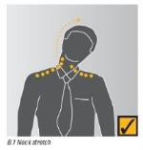 | Neck stretch  Keeping your chin tucked in, gently lower ear to shoulder and hold for 10 seconds on either side. Repeat several times. | 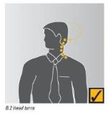 | Head turns  Turn head slowly to look over left shoulder. Turn head the other way. Repeat several times.
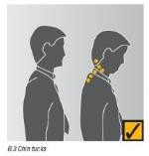 | Chin tucks  Raise the head to straighten the neck. Tuck the chin in and upwards creating a double chin. Repeat several times. | 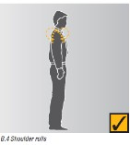 | Shoulder rolls  Circle shoulders forward several times, then backwards. Repeat 3 to 5 times.
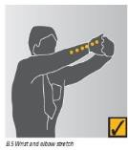 | Wrist and elbow stretch  Interlace fingers, palms outward, and straighten arms in front. Hold for 10 seconds and repeat several times. | 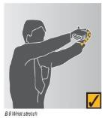 | Wrist Stretch  Straighten your arm in front and bend your wrist forward, gently assist the stretch with your other hand. Hold for 10 seconds. Repeat with the other arm.
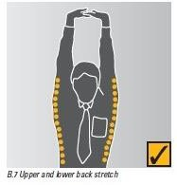 | Upper and lower back stretch Interlace fingers and turn palms upwards above head; straighten arms then slowly lean slightly from side to side. Repeat movement several times | 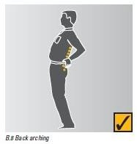 | Back arching  Stand up. Support your lower back with hands and gently arch back and hold for 5 to 10 seconds. Repeat as often as is needed.
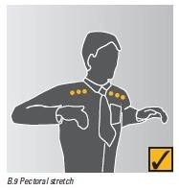 | Pectoral stretch  Raise both arms to shoulder height and bend elbows. Pull both elbows back slowly to bring shoulder blades towards each other. Repeat several times | 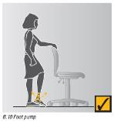 | Foot pump  Stand up, holding a chair for balance if necessary, and alternately raise heals and toes. Repeat 10 times.
 | Adapted from WorkSafe publication Officewise: A guide to health and safety in the office handbook (Edition 5, January 2006)

