Safety at Work for School Staff
Communications Toolkit
2021/2022

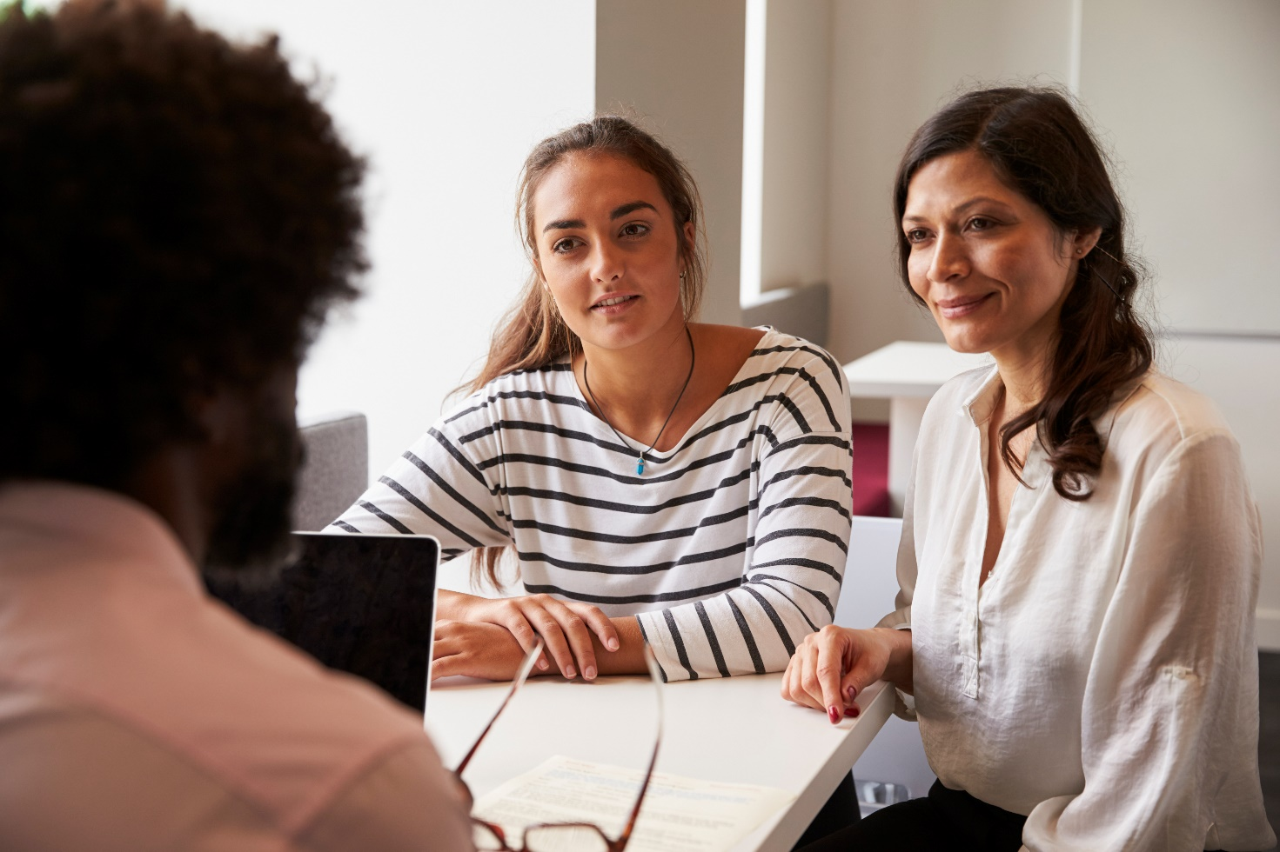

Content

Introduction
Suggested newsletter content
Suggested social media content

Introduction

Everyone in the school community has a right to a safe and healthy learning environment and workplace.
As schools adjust to learning onsite, with health and safety measures that prevent the spread of COVID-19, it’s important that adults in school communities continue to treat each other with respect and kindness.
Instances of violence and aggression towards school staff from parents, carers or other adult members of the school community can have a significant impact on the health, safety and wellbeing of the person who experiences this, as well as those around them. The impact can also be felt by the wider school community.
No one should be threatened or intimidated at work or at school – that’s why the Department has created a suite of resources to set clear expectations of behaviour and make schools safer for staff, students, and their families.
Part of this suite of resources is a new Respectful Behaviours within the School Community Policy which promotes the importance of respectful and collaborative relationships between parents and carers and school staff.
It sets out clear guidelines on the expected standards of behaviour for parents, carers and other adults who interact with the school community to reduce the risk and incidence of work-related violence towards school staff.
We encourage you to use and share these communications materials to raise awareness about the new policy and to promote positive, respectful relationships between adults in our school communities.

Suggested email to members

Please consider using the content below for your members. You can customise the content as required for your style and audiences.

Dear [Audience]
As we adjust back to onsite learning, everyone in the school community has a right to a safe and healthy learning environment and workplace.
And as we continue to prioritise health and safety in schools, including required mask wearing for some students, everyone has a part to play in creating a safe and respectful learning environment. We need your support to make sure our schools continue to be somewhere everyone feels safe and heard.
The Department of Education and Training has released a new policy that describes the positive behaviour expected from parents, carers and other adults in Victorian school communities. The policy sets clear standards of behaviour to create a safe, respectful and inclusive learning environment for students, staff and adults.
There are also other resources to support safe and respectful relationships in our school communities, including information about getting involved with the school, advice on how to raise a concern or complaint, and parenting support resources. You can find the new policy and these other resources here.
Unacceptable and offensive behaviour has no place in Victorian school communities. Parents and carers are always welcome to raise concerns or complaints in a reasonable manner in line with their schools’ complaints processes.
Find out more about how to engage positively with your school here.

Suggested social media content

Here are some sample social media posts that can be used across your own social channels to help encourage awareness of the new policy and respectful behaviours in the community.
Please tag the Department of Education and Training so we can like and share your posts.
DET LinkedIn DET Twitter

Post 1

School communities have demonstrated incredible resilience over the COVID-19 pandemic. As we return to onsite learning, it's important for everyone to be respectful and kind to each other. Learn more about the new Department of Education and Training policy - Respectful Behaviours within the School Community. Respectful Behaviours within the School Community Policy (education.vic.gov.au)

Post 2

Safe and respectful school communities create a better environment for children to thrive. Everyone in the school community has a role to play in maintaining this environment. Parents and carers can learn more about how to engage positively with their school community by visiting Respectful behaviours in schools (education.vic.gov.au)

Right click and save an image to use in your posts
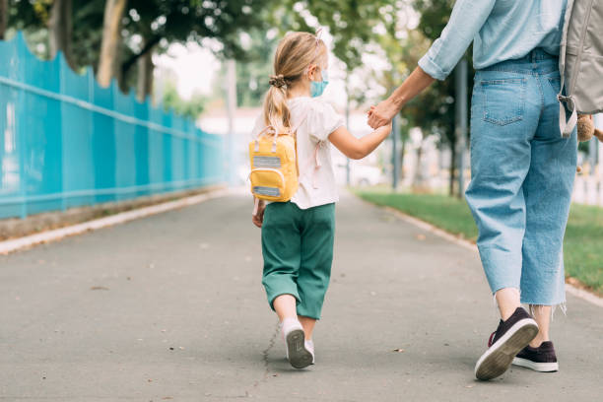

© State of Victoria (Department of Education and Training) 2021. Except where otherwise noted, material in this document is provided under a Creative Commons Attribution 4.0 International Please check the full copyright notice

