Movement of Air Purifiers: Safe Work Procedure
NOTE: Staff are required to complete the Manual Handling eLearning Module (login required) before moving / lifting air purifiers.

Description of Work: |  | Transfer / movement of air purifiers (Samsung AX7500/AX90T model) from point of delivery to the point of use by school staff.
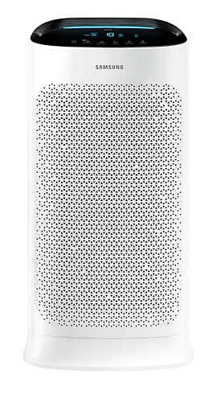 |  |  |  | Potential Hazards  - Hazardous manual handling  - Slips, trips and falls
Personal Protective Equipment (PPE) Required (Check the box for required PPE):
Gloves | Face Masks |  | Eye  Protection |  | Welding Mask | Appropriate  Footwear | Hearing Protection | Protective Clothing
Safe Work Procedure Checklist:
1. PRE-Operation/Task:
- Where possible, ensure the supplier delivers the boxes as close as possible to school buildings and in a safe place for unloading/handling of the boxes.
- Identify two or more staff members to move the boxes to a suitable area for placement and unboxing of air purifiers. Where possible, select staff for this task that do not have any pre-existing injuries or preconditions that may make this work difficult for them. Where possible, staff of a similar height and build should be selected for this task.
- Ensure those staff members have completed the Manual Handling eLearning module (or complete it as a refresher) prior to starting this work. A Manual Handling Awareness Training presentation is also available to support staff to familiarise themselves with safe manual handling techniques.
- Ensure the trained staff are briefed about the route of travel for the air purifier and are supported to discuss how they will move the air purifiers. For example, staff should:
- Consider environmental factors before commencing the move e.g., avoid inclement weather / excessive heat where possible, as this may create additional slip / other hazards.
- Consider when the best time is to move the air purifier, taking into consideration student movements and break times.
- Ensure planned routes of travel are clear from trip hazards or obstructions (such as mats, cords, closed doors or furniture) prior to moving the air purifier, and consider how to navigate / avoid stairs, potentially slippery surfaces, etc. If needed and available, ask an extra person to help to open doors and clear pathways of travel, or ensure these are cleared / opened ahead or time.
- Ensure staff wear appropriate footwear (i.e., closed toed, non-slip shoes) when air purifiers are moved.
2. Operation/Task
- It is preferable for staff to use a hand trolley and/or stair climbing trolley, if available, to assist with moving air purifiers. If a trolley is unavailable, use a two person lift, following the S.M.A.R.T Lifting process.
- Staff should ensure adequate space is available to place the air purifier in its intended location.
- When moving the air purifier, staff should avoid twisting and turning or sustained awkward body positions.

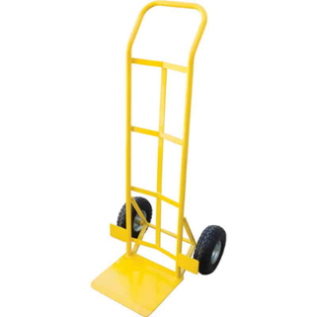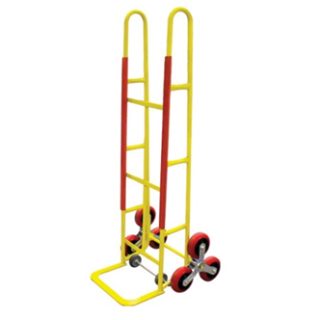

Stair-climbing Trolley
Hand Trolley

3. POST-Operation/Task:
- Staff should remove all packaging, box and associated materials and dispose in appropriate waste or recycling bin.
- The school should retain the air purifier Instruction/Operation Manual and file it in an appropriate place.
- Provide all key staff with instructions for correct use of the Air Purifier in accordance with the Product Instruction/Operation Manual.
- Movement of air purifiers (to a different location within the school)
Schools may wish to move the air purifiers to different locations around the school, based on risk / need / changes in class arrangements. To do this, staff should follow the steps in the ‘Pre-Operation / Task’ section above related to the movement of the air purifiers, including considering environmental factors.
When the best time is to move the air purifier, ensuring planned routes of travel are clear from trip hazards or obstructions, wearing appropriate footwear and using a S.M.A.R.T Lifting process.

