introduction
The Mental Health and Wellbeing (MHW) Charter is all about giving departments, such as the Department of Education and Training (the Department), a framework and clear direction to creating a mentally sound and safe workplace by working towards the elimination of workplace stigma around mental health illnesses and to assist with promoting a healthy work/life balance for our employees and contractors.
The MHW Charter has three key MHW related pillars:
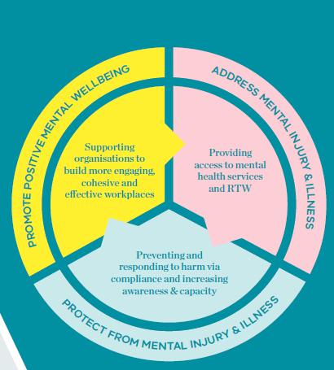
Figure 1 MHW Charter Pillars
The MHW Charter which is to be launched at the Department on 27 March 2017, is closely aligned with Objective 4 – Safe and Inclusive Workplaces of the Department’s “Investing in Our People (IiOP)”, and aims to promote positive MHW through pro-active awareness programs and senior leadership commitment, reduce work-related risk factors and address MHW by providing pathways such as enhancing personal and organisational resilience to support the positive MHW of all staff.
To support these MHW initiatives related activities and wellbeing information sessions will be held over the next twelve months, followed by tailored employee training to better arm staff in coping with workplace MHW pressures and maintaining a positive work/life balance.
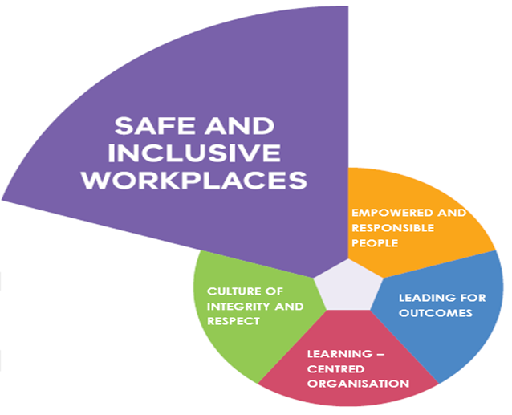
Figure 2- Investing in Our People (Objective 4 – Safe and Inclusive Workplaces)
A MHW Charter action plan has been drawn up and endorsed by senior management to adhere to the Charter’s MHW commitments to create mentally healthy workplaces.
The first step is to have open, dialogue on the topic of MHW with your manager/team leader and team members. They are not expected to be experts in this field. Staff factsheets and manager toolkits are accessible to help promote MHW and give details of additional MHW support resources.
Professional MHW advice is available, 24/7, from the Department’s Employee Assistance Program provider, Lifeworks by Morneau Shepell, on 1300 361 008. An online health and wellbeing platform is also available. See the Employee Health, Safety and Wellbeing Services intranet page for login details.
Promoting mental health in the workplace in a supportive manner is everyone's responsibility and a journey we must all take to ensure sustainable improvement within the Department in the MHW space. It is also important we share our tips and successes to make us and our workplaces more mentally healthy.

Why the Department should be mentally healthy

At any given time
1 in 5
employees are likely to be experiencing a
mental health condition

Untreated mental health conditions
cost Australian employers
$10.9 billion
every year

research shows:
$2.30
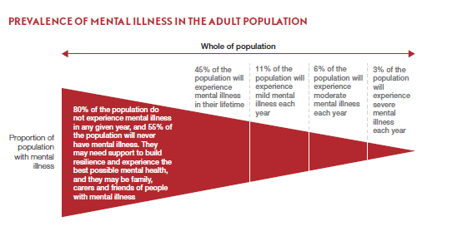
is the average return on investment for every $1 invested in creating a mentally healthy workplace

Figure 3: Prevalence of mental illness in the adult population. Source: Beyond Blue

The Department’s People Matter Survey Results
Data from the Department’s 2016 People Matter Survey gives us an indication of some of the MHW issues that need addressing. Some feedback from the 54 per cent of staff that responded was that:
- 25 per cent stated they experience high to severe work related stress (this was two per cent above similar organisations)
- 32 per cent stated they experience a lack of control over workplace issues causing the stress
- 42 per cent believe the Department has procedures in place to support them in times of stress (nine per cent below similar organisations)
- But only one per cent of respondents accessed EAP for help in dealing with stress
- 77 per cent of respondents also reported that non-work stress did at times impact their ability to do their job, but they also reported they felt more in control of the personal factors causing them stress.

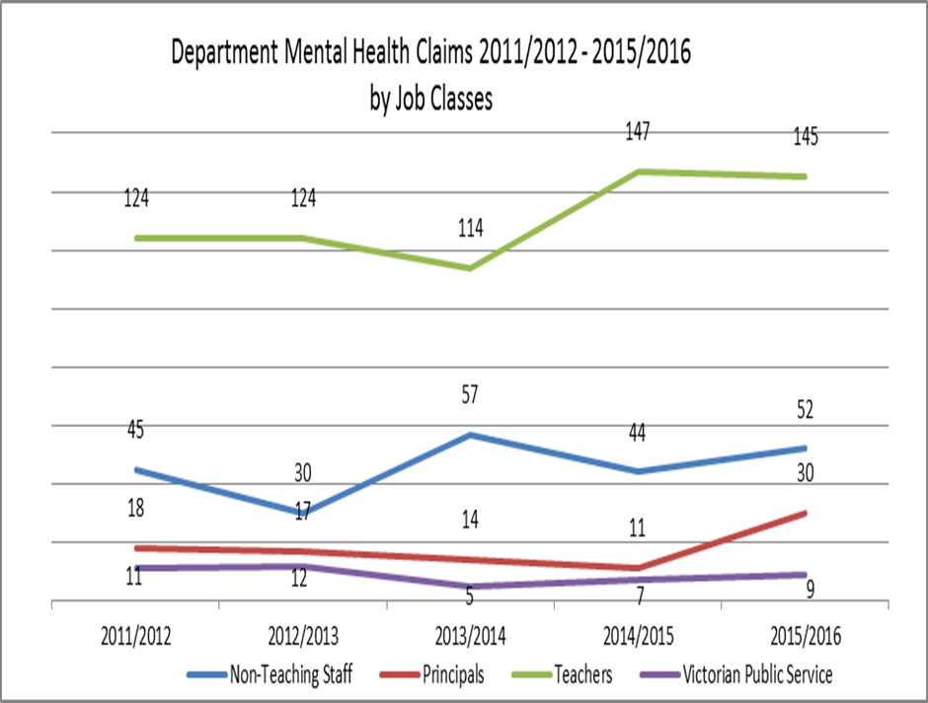
The Department’s Mental Health Claims

Figure 4: the number of compensable (WorkCover) claims received by the Department for psycho-social related disorders such as anxiety, depression etc.

