Isolation and Lockout Safe Work Procedure

Description of Work: |  |  | Isolation and lockout – Maintenance of plant and equipment
Potential Hazards:
- Electrocution
- Cuts / Lacerations / Abrasions
- Amputation

Isolation and Lock Out Processes
This safe work procedure applies to all items of plant and equipment that requires maintenance, service, cleaning or repair, or working to correct unintended stoppages or jams. In such cases plant and equipment must be isolated (disconnected and locked out) from energy sources.
WARNING: The isolation and lockout process can vary between individual plant and equipment depending on their power supply set up. Check the operating manual and specific procedures.
There are potentially three ways to isolate plant:
- Lock plant in off position (e.g. use of built-in keyed devices, padlocks, or isolation clamps)
- Isolate power supply to plant and equipment (e.g. turn off at mains or unplug equipment)
- Isolate power supply to room (e.g. press Emergency Stop button to isolate power to the workshop or room, or switch off power at switchboard)
At least two isolation processes should be followed when conducting maintenance on high risk plant and equipment. Power switches should always be turned to the off position prior to beginning any service or maintenance process and should be locked in that position.
The use of only operational stop buttons, emergency stop devices or interlock devices is not equivalent to the isolation of power sources or the release of stored energy.
If static plant or equipment has a keyed interlock this must be locked in the off position, otherwise lockout devices such as padlocks or clasps must be used. The key must be removed and retained by the person performing the works.
Isolation of Power to the Room |  |  |  | Isolation of Individual Plant and Equipment
- Press Emergency Stop button to isolate power to the technology teaching room or workshop (which can be located at the entry to the room).  - Isolation key to be retained by the person completing service or maintenance works on the selected piece of plant and equipment  - Notification tag to be displayed on Emergency Stop button to make other staff members and/or students aware that power has been isolated (example photo of isolation tag below)  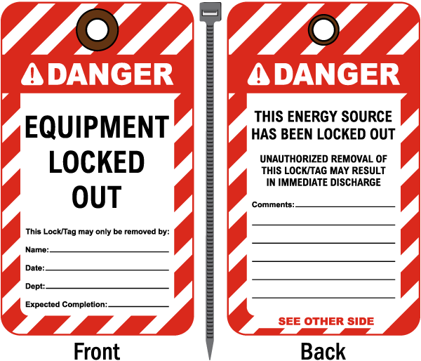  - Notification tag to be displayed on Emergency Stop button to make other staff members and/or students aware that power has been isolated (example photo of isolation tag below) |  |  |  | - Identify the electrical outlet of the item of plant and equipment that needs to be isolated  - For three-phase power, turn main power switch supplying power to that piece of plant to the OFF position (example photo below).  - Lock out power supply with the keyed interlock device or padlock and retain the key  - For mains power, remove the plug from the power supply power outlet.  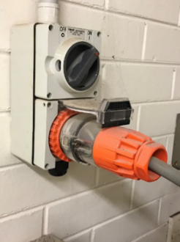  Notification tag to be displayed on plant or equipment (example tag can be seen in Section 3 – Isolation of Power to the Room)
- Complete relevant service or maintenance as required on the selected plant and equipment
- Complete a visual inspection of serviced or repaired plant and equipment
Reinstating plant into use:
- Remove the notification tag from the room’s emergency stop
- Ensure that there are no other personnel near other pieces of plant and equipment
- Use isolation key to return power to the room
- Remove the notification tag from individual plant or equipment power supply
- Plug in power supply and unlock the interlock switch or the padlock
- Switch the power on
- Test the plant and equipment before returning it to service
 | Competent Person(s): (The following persons are authorised to operate, supervise and test students on the equipment/process).
 | Name: | Title: |  |  | Contact Details:

