Safe and Well: Injury and Illness Management Framework
2020

Contents

1 Introduction 2
1.1 Introduction to the injury management framework Error! Bookmark not defined.
1.2 Best practice injury management 3
2 Roles and Responsibilities 4
3 Incident, Near Miss and Hazard Classification 5
3.1 First aid 5
4 Early Intervention 5
4.1 What is ealy intervention? 5
4.2 Benefits of early intervention 6
4.3 Identification of early warning signs of injury/illness 6
4.4 Key components of early intervention 6
5 Supporting an injured staff member 8
5.1 Supporting an injured staff member with physical injuries 8
5.2 Supporting an injured staff member with psychological injuries 8
5.3 Complex injuries 9
6 Rehabiliation And Return To Work Planning 10
6.1 Consultation 10
6.2 Task cards 11
6.3 Suitable duties 11
7 DET Supports 13
7.1 The return to work and compensation team (rwct) 13
7.2 Resources 13

Introduction

What is Injury Management
The Department of Education and Training (DET) is committed to providing assistance to staff members who have work related injuries or illness by providing injury management support and ensuring a safe, sustainable return to work.
Injury management is the process of restoring those who are ill or injured to their fullest physical, psychological and vocational capability. Injury management aims to assist staff members to return to meaningful and productive work at the highest possible level of functioning following illness or injury.
As a Principal/Workplace Manager, the Injury Management Framework should be used as soon as you identify any early onset signs associated with potential workplace injury or illness.

The key objectives of Injury Management are:
- to foster and build a strong culture of early intervention
- to establish a clear process for all injured staff members once an injury has been sustained
- to facilitate the safe and early return to suitable duties for an injured staff member through effective communication with all relevant stakeholders
- to support and encourage an injured staff member to receive the appropriate medical intervention as soon as practicable
- to assist an injured staff member to return to their pre-injury employment
The Injury Management Framework is to be used in conjunction with the DET Workers’ Compensation guides and templates should a workers’ compensation claim be active.

Figure 1: Key elements for Injury Management
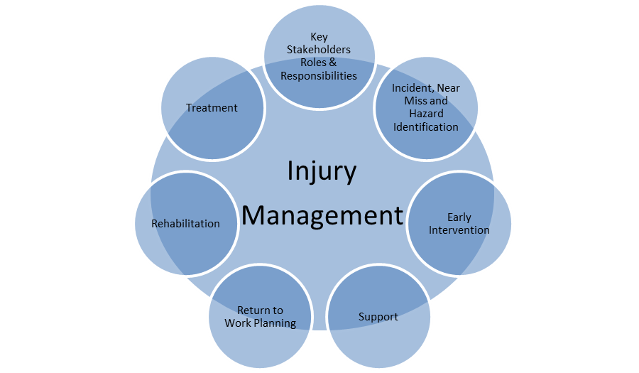
This Injury Management Framework has been developed as guidance to manage work related injury or illness. Please contact the Return to Work and Compensation Team (03 7022 0780) in the Employee Health Safety and Wellbeing Division, if you have any questions about when to utilise this guide.

Best practice injury management

The best practice for work-related injuries and early intervention are as follows and should always be applied where possible:

 |  | Encourage staff to report all incidents as soon as possible for both physical and psychological injuries. Re-iterate to staff members that they will not suffer discrimination for reporting the incident. This is to be done through eduSafe.
 |  | Contact the staff member as soon as practicable (or within 72 hours) to offer assistance and ensure appropriate first aid is provided.
 |  | Encourage the staff member to obtain appropriate medical treatment.
 |  | Continue to follow up with the staff member after any medical outcomes or important events and discuss with them any concerns. Ensure the staff member feels heard and offer any support (including EAP if required) to the staff member.
 |  | Work with the staff member around developing a plan to suit any restrictions and any other supports.
 |  | Provide flexible workplace solutions to support the staff member at work. This can include adjustments to the workplace or reduced hours.

You can find further resources, guides and templates to assist you with this process here

Roles and Responsibilities
The key stakeholders involved in the Injury Management Process are identified as follows:

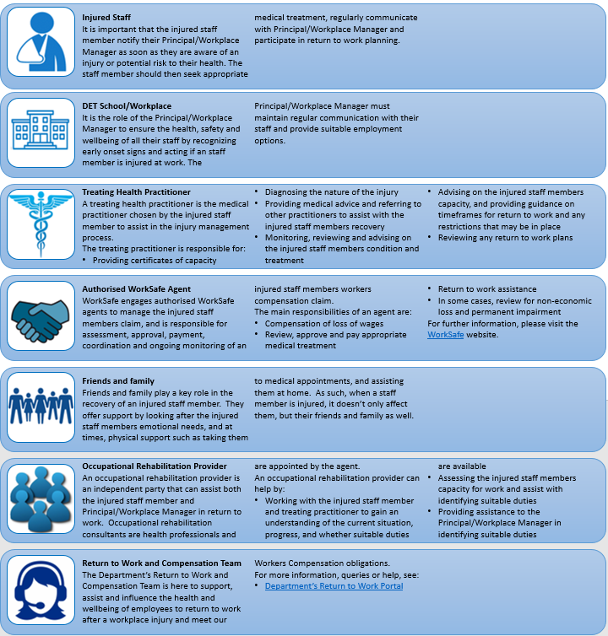
Incident, Near Miss and Hazard Classification

A key component of injury management is timely and reliable incident/accident reporting. If minor injuries, near misses or hazards are reported to the School/Workplace, there is an opportunity to intervene and prevent a more serious injury occurring in the future.
Should an incident occur, the following process is outlined and should be followed:
Figure 2: Incident Reporting flowchart

You can find further information on this process by following this link Reporting and Management of Incidents and Hazards

FIRST AID
Incidents can happen without warning, and it is critical that the School/Workplace is prepared for any first aid emergencies.

Early Intervention

What is early intervention?
Early intervention is planning the injured staff member’s return to work as early as possible, once they have experienced an injury.
Early intervention has a role to play in the initial pre diagnosis phase. This is when the potential work-related injury or illness has been identified.
There are several aspects to the timing and nature of support. It is also clear that every staff member’s recovery process is unique and is built upon a whole range of pre-injury skills, connections, family supports (or lack of them), and is highly dependent on the age when the injury occurred.
Planning a safe and sustainable return to work by temporarily modifying job requirements and providing suitable workplace aids will support injured staff members through their recovery. It is also important to support injured staff members in seeking appropriate treatment.
Importantly for workplaces, early intervention may also be seen as including strategies to reduce the risk of a new or secondary medical condition. This contributes to lowering the potential costs and impacts associated with injury and illness.
Early intervention seeks to reduce the impact of a work-related injury or illness for a school/workplace and individuals by preventing or minimising the impact of a new work-related injury or illness, and/or the deterioration of an existing injury or illness.

Benefits of early intervention
- creates a productive and supportive workplace
- demonstrates management commitment to staff members
- prevents long-term absence from the workplace and the development of chronic illness including secondary psychological conditions
- improves and promotes a positive safety culture in schools and workplaces
- increases management involvement in the injury management process
- overall health and wellbeing benefits to staff associated with productive work
- reduces indirect costs to the school/workplace, such as lost productivity, recruitment and training costs for replacement staff
- returns injured staff member’s back to their activities of daily living
- improves injury outcomes

Identification of early warning signs of injury/illness
Identifying the early warnings signs of staff members who may be at risk of a physical or psychological injury at work is a crucial component of early intervention.
Key warnings signs to consider are as follows:
- out of character behaviour
- not getting things done – increase in errors with work
- complaints of lack of support
- complaints with work load
- withdrawal and/or conflict with work colleagues and/or reduced participation in work activities
- loss of memory and/or unable to concentrate
- increase in sickness and absence away from work
- fatigue
- change in appearance
- weight loss or gain

Key components of early intervention
Strategies may include:
- conducting regular workplace risk assessments/audits
- employee assistance programs
- healthy workplace policies and/or flexible work arrangements
The four key components of early intervention are:
Engage with your staff – engaging and communicating after the identification of early onset signs or an injury will create a positive culture and encourage staff member to participate. It also focuses on building relationships to support the psychological and emotional needs of injured staff members.
Rehabilitation – it is essential to support staff members to engage appropriate and continuous interventions that are focussed on facilitating an early and sustainable return to work. Such interventions may include treatment, aids and appliances. The support of external providers may help in identifying and implementing these interventions.
Engage Community – assist the staff member to remain an active participant in their community. It may be appropriate to engage and encourage the staff member to be a part of the school/workplace community ensuring you continue to involve them in activities if medically appropriate.
Work supports – Review the demands of the role, what controls are in place, and what supports can be offered to support a staff member returning to or continuing to work.
Figure 4: Key components of early intervention
Fair and transparent
Early intervention includes using all 4 pillars whilst being fair and transparent with the staff member, statistics show an increased likelihood of a successful recovery and return to work.

Supporting an Injured Staff Member

5.1 Supporting an injured staff member with physical injuries
A physical injury is a permanent or temporary disfigurement or impairment of any bodily organ or function.
Physical injuries can be caused by but not limited to slips, trips and falls, overexertion, excessive lifting, pushing, pulling, holding, carrying and throwing.
It is important the injured staff member receives the appropriate medical treatment through the co-ordination of their treating medical practitioner(s) to support their return to work.
Benchmark Recovery Times is a guide to be utilised by Principals/Workplace Managers for evidence-based acceptable specific injury and recovery durations.
There may be some variation in recovery timeframes – dependent upon nature and severity of injury, co-morbidities and surgical intervention. This should be used as a guide only.
After suffering a physical injury, a staff member can develop subsequent psychological symptoms such as depression, sadness, anger, poor sleep and lower levels of engagement. These psychological symptoms can be made worse by ongoing pain, medication and isolation from interpersonal relationships. These types of conditions are known as a secondary psychological condition.
Refer to section 5.2 for information of the management of psychological injuries.

5.2 Supporting an injured staff member with psychological injuries
A psychological injury is a cognitive or emotional symptom that impacts on a person’s life, affecting how they think, feel and behave. Also known as a mental health injury, a psychological injury can be caused by environmental, organisational and individual factors.
Psychological illness injuries can be complex as the symptoms and treatments for various psychological illnesses can vary from individual to individual. Two individuals may experience the same ‘diagnosis’ but the way in which the individual responds to treatment may vary significantly as a result of this, the recovery period and the appropriate treatment type may differ significantly.

Causes of work related psychological injures
Being at work is beneficial to our staff members’ mental health, however there are workplace contributing factors which can impact negatively on a person’s mental health. Some of these contributing factors are summarised in Figure 5.

Figure 5: Psychological condition causes

Risk factors for psychological injuries, and the simple things that can be done to prevent/reduce the risk:
Table 1: How to reduce the risk factors of psychological injuries
Risk Factors | Protective Factors
Job Demands | Adequate resources and training to undertake role
Job Control | Adequate involvement and consultation in decision making
Change in role/workplace | Role clarity & well managed change
Stigma and employee awareness | Reasonable adjustments / Early help seeking
Effort Reward Imbalance | Constructive and ongoing feedback / Recognition and reward
Exposure to trauma | Employee Assistance Program / Resilience building
Bullying/ Workplace conflict | Interpersonal relationships with colleagues/ Workplace Civility

Signs and Symptoms of psychological injuries
Signs and symptoms of psychological injuries can vary depending on the disorder, severity, circumstances and other factors. Some common signs and symptoms may include:
Cognitive:
- Nightmares
- Loss of memory and concentration
- Confusion
- Mood swings
Behavioural:
- Avoidance with participating in activities
- Avoidance in social situations
- No interest to participate in social events
- Highly agitated and irrational
- Changes in sleep patterns
Physical:
- Fatigue and exhaustion
- Lack of sleep
- Aches and pains in the body
- Significant weight loss or gain
- Upset stomach
- Breathing difficulties
Psychological:
- Feeling overwhelmed
- Detachment from colleagues, family and friends
- Depression
- Irritability
- Anger
- Panic attacks
- Anxiety
- Self-blame and self-criticism
- Frequent or excessive worrying

Complex Injuries
Secondary Psychological injury – are a result of a physically injured staff member developing a psychological injury. There are multiple factors that can cause this type of injury. Early intervention is crucial to assist in the prevention of these types of injuries occurring.
Heart Attack/Stroke/infectious disease – can occur during employment. This type of injury/illness will potentially require substantial rehabilitation and may impact on the broader school/workplace community.
Pre-existing Injuries – Staff members with Pre-existing injuries, may require more supports when developing a suitable return to work arrangement. This can often complicate the return to work planning process. Appropriate supports should be identified and provided early to prevent or minimize the risk Pre-existing injuries being exacerbated. Pre-existing injuries also need to be taken into consideration when planning for return to work.
Interpersonal conflict – this can arise in multiple circumstances involving multiple parties. It is important to work collaboratively with each of the parties, and involve mediation if deemed necessary.
Multiple Injuries – if a staff member has suffered from multiple injuries. It is important to understand the benchmark recovery times for each injury and how they may be extended on account of rehabilitation restrictions.
For support in these types of claims, please contact the authorised WorkSafe agent, occupational rehabilitation provider or the Return to Work and Compensation Team for further assistance.

Rehabilitation and Return to Work Planning
Return to work planning, is where the Principal/Workplace Manager will start to review the workplace for potential suitable duties that are available for the injured staff member.
A starting point when thinking about duties is to review the certificate of capacity. The certificate will outline what restrictions the injured staff member will have and will outline any restricted hours.
It is important for the injured staff member to be given the opportunity to provide feedback during return to work planning and all views are taken into consideration when developing a Return to Work Arrangement (RTW A). This provides the best chance of achieving a safe and sustainable return to work outcome.
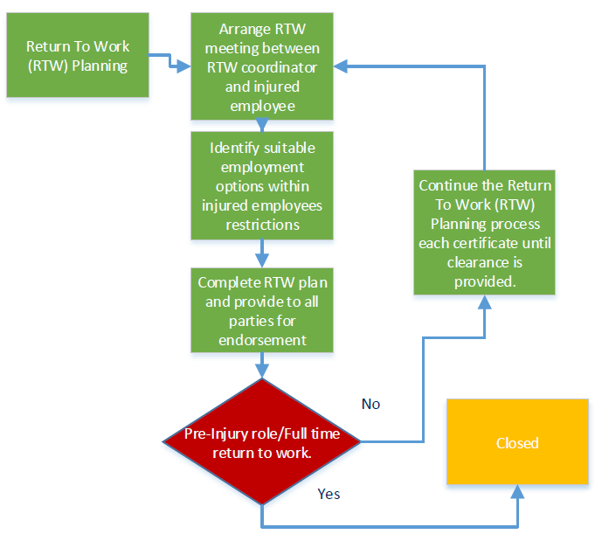
Further information and support contacts can be found here

CONSULTATION
It is important that the Principal/Workplace Manager consider planning a return to work even if an injured staff member is unfit for a work-related injury as per the WIRC Act (2013). Planning a staff member’s return to work and providing suitable options to them and their treating health practitioners should be used as part of the recovery process. Having a medically endorsed return to work goal is an important part of rehabilitative goal setting and helps to engage both the Treating Health Professional (THP) and injured staff member in their recovery and return to work.
It is important that key barriers are identified through all stakeholders as soon as possible in the return to work planning process.
Barriers can include:
- access to workplace
- driving restrictions
- physical limitations
- motivation
- psychosocial barriers
Consultation is to be undertaken with all stakeholders: the injured staff member, treating health practitioner(s), occupational rehabilitation provider, and authorised WorkSafe agent.
- Injured staff member
In Return to Work Planning for work related injuries, consultation must take place with the injured staff member, and must be ongoing throughout the Return to Work process.
Consulting with an injured staff member includes:
- discussing injury recovery timeframes and any issues
- active listening and raising concerns
- seeking information and sharing views
- discussing issues in a timely manner
- scheduling regular meetings
- consulting with the Health and Safety Representative (HSR) where applicable
Tips to Communicate
- ask questions regarding the injured staff member’s injury, diagnosis and timeframes for recovery
- focus on what they can do, not what they cannot do
- ensure the injured staff member remain on the distribution list for general emails, and forward on newsletters or social group emails to their personal email address
- If appropriate, ensure injured staff members are kept up to date with any changes to staff
- ask appropriate colleagues to keep in touch
- with medical endorsement invite them to relevant team meetings or events if appropriate
- Treating health practitioner
When supporting a staff member with a work-related injury, it is important to ensure that the Principal/Workplace Manager continues to be in contact with the injured staff member’s THP (such as Physiotherapist, Psychologist etc). This allows for discussions around recovery and return to work timeframes.
There are several ways to consult with the treating health practitioner in relation to work related injuries. These are:
- attend the medical appointment if practicable and if the injured staff member provides permission
- contact the medical practitioner by phone
- send return to work information by email or fax
- provide return to work information to the injured staff member prior to any appointments
It is not always possible to contact the injured staff members treating health practitioner, but it is important to make attempts and keep records as per the WIRC Act (2013).
- Occupational Rehabilitation Provider (if applicable)
The occupational rehabilitation provider is an independent third party, and is appointed by the authorised WorkSafe agent to assist the Principal/Workplace Manager with the return to work process. They will assist by arranging meetings with the Principal/Workplace Manager and the injured staff member around wellbeing and any return to work options and includes onsite meetings and reviews of the workplace.
It is a requirement for injured staff members to maintain contact and attend meetings with the occupational rehabilitation provider and the Principal/Workplace Manager.
- Authorised WorkSafe Agent
The agent will ensure they consult with all parties in the return to work process. The agent will provide any medical information in relation to the physical injury to the occupational rehabilitation provider, with limited medical information provided to the School/Workplace, due to privacy requirements.

Task cards
Task cards are a valuable tool which ensure internal and external stakeholders are fully informed of the specific job tasks and inherent requirements of each role undertaken with the School/Workplace. They are a condensed version of the DET Position Descriptions and support the Return to Work Planning process.
Each of the task cards includes a job/task break down and guidance on the physical demands required for each tasks, injury risks and how each task can be performed safely.
The task cards can be provided to relevant treating health practitioners to assist in the identification of suitable duties.

Suitable duties
Suitable Duties are defined as short-term work arrangements developed in conjunction with the Principal/Workplace Manager or delegate, the injured staff member in consultation with the advice provided by the treating health practitioners, to assist with the injured staff member’s return to work and rehabilitation.
The following factors should be considered when identifying suitable duties for:
- What needs to occur to overcome barriers – i.e. reduced hours, modified or alternative duties, support in the workplace
- Identification of duties that are in line with the injured staff member’s medical restrictions - review the task cards for assistance with identification of duties.
- The hierarchy of duties assessment table. The first option should be modifying the staff member’s current role (e.g. workplace supports). If suitable duties of a modified role cannot be identified, alternate duties are to be considered (seek advice from the authorised WorkSafe agent or occupational rehabilitation provider).
Table 2: Hierarchy of duties assessment
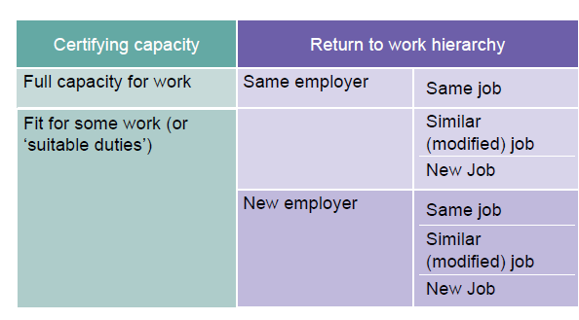
If all of the above options are exhausted contact Return to Work and Compensation Team for further support and guidance.
Legal obligations can be found on the WorkSafe website, Workplace Injury Rehabilitation and Compensation (WIRC) Act, Disability policies and procedures, and the OHS Act.
You can also access further guides and templates regarding the return to work process here.

DET Supports

THE RETURN TO WORK AND COMPENSATION TEAM
The RWCT is committed to providing support, assistance and influence in the health and wellbeing of all DET staff members to return to work after a workplace injury and meet workers’ compensation obligations.
The functions of the team are to provide:
- expert advice, coaching and education on general injury management and return to work
- expert support with complex claim management and meeting legislative requirements
- assistance at conciliations and legal hearings
- performance management of Workers’ Compensation stakeholders. Agent, Investigator and Legal panels, and Occupational Rehabilitation, including development and reporting on KPIs
- support the wellbeing of all DET staff who utilise our service

RESOURCES

- Return to Work Coordinator Portal
- Employee Assistance Program (EAP)
- Principal Health and Wellbeing Strategy
- Conflict Resolution
- Work Place Contact Officer
- OHS Advisory Service
- Mental Health and Wellbeing Charter
- Workplace Bullying
- Complaints, unsatisfactory performance and misconduct
- Equal Opportunity (Discrimination and Harassment)
- Respectful Workplaces
- Disability and reasonable adjustments in the workplace

