Safety at Work for School Staff
Communications Toolkit
2021/2022

Content

Introduction
Suggested email content to members
Suggested social media content
Posters
Additional resources

Introduction

Everyone in the school community has a right to a safe and healthy learning environment and workplace.
As schools adjust to learning onsite, with health and safety measures that prevent the spread of COVID-19, it’s important that adults in school communities continue to treat each other with respect and kindness.
Instances of violence and aggression towards school staff from parents, carers or other adult members of the school community can have a significant impact on the health, safety and wellbeing of the person who experiences this, as well as those around them. The impact can also be felt by the wider school community.
No one should be threatened or intimidated at work or at school – that’s why the Department has created a suite of resources to set clear expectations of behaviour and make schools safer for staff, students, and their families.
Part of this suite of resources is a new Respectful Behaviours within the School Community Policy which promotes the importance of respectful and collaborative relationships between parents and carers and school staff.
It sets out clear guidelines on the expected standards of behaviour for parents, carers and other adults who interact with the school community to reduce the risk and incidence of work-related violence towards school staff.
We encourage you to use and share the communications materials contained in this toolkit to raise awareness about the new policy and to promote positive, respectful relationships between adults in our school communities.

Suggested email content to members

Please consider using the content below for your members. You can customise the content as required for your style and audiences.
As we enjoy being back to onsite learning, everyone in the school community has a right to a safe and healthy learning environment and workplace.
Recently, the Minister for Education launched a new policy and resources aimed at ensuring all schools are safe and positive places to work and learn.
As we continue to prioritise health and safety in schools, including required mask wearing for some students, everyone has a part to play in creating a safe and respectful environment. Whilst the vast majority of Victorian schools have positive and constructive relationships with parents or carers, when parents or carers are violent or aggressive towards school staff, everyone suffers.
I am seeking your support in encouraging school staff to access the new resources and information as part of the Safety at Work for School Staff Initiative, which supports schools to create and maintain safe and respectful school environments.

Respectful Behaviours within the School Community Policy
The new Respectful Behaviours within the School Community Policy available on the Department of Education and Training’s website, promotes the importance of respectful and collaborative relationships between parents and carers and school staff. It sets out clear guidelines on the expected standards of behaviour for parents, carers and other adults who interact with the school community to reduce the risk and incidence of work-related violence towards school staff.
Posters for school staff and for parents/carers have also been developed for display in schools. Resources in multiple languages have been provided to help schools communicate the new policy with their school community.

New advice page on managing challenging parent/carer behaviour
The release of the new policy is aligned with a new chapter titled ‘Parent/carer Behaviours’ that has been added to the Work-Related Violence in Schools Policy and Procedure (previously named Occupational Violence and Aggression in Schools Policy and Procedure).
This chapter outlines strategies and resources to help schools prevent and manage unacceptable behaviours from parents, carers and other adult members of the school community. This includes guidance to help establish and promote respectful and safe parent and carer behaviour, prevent and de-escalate unacceptable behaviours and access support and services to restore wellbeing after an incident.

New Respectful Behaviours in Schools webpage for parents
A new web page has also been created for parents, linking to the new Respectful Behaviours within the School Community Policy and with additional information and resources to support parents to engage positively with school staff, including the appropriate pathways for raising concerns or complaints with schools and other useful resources for parents.
This work is linked to the new laws introduced by the Andrews Government, which strengthens protections for school staff against parent and career aggression by empowering authorised persons, such as principals, to issue School Community Safety Orders in response to harmful, threatening, abusive or disruptive behaviour at work. The new School Community Safety Order scheme will be introduced to all schools in mid-2022.
Violent and aggressive behaviour has no place in Victorian school communities. Staff should not feel that being subjected to violence and aggression is part of the job and are encouraged to report any risks or incidents of violence and aggression to their school leader and through their reporting mechanisms.
We are pleased that the Department is taking a strong stance to communicate to the school community the behaviours which are unacceptable.

Suggested social media content

Here are some sample social media posts that can be used across your own social channels to help encourage awareness of the new policy and respectful behaviours in the community.
Please tag the Department of Education and Training so we can like and share your posts.
DET LinkedIn
DET Twitter

Post 1

School communities have demonstrated incredible resilience over the COVID-19 pandemic. As we return to onsite learning, it's important for everyone to be respectful and kind to each other. Learn more about the new Department of Education and Training policy - Respectful Behaviours within the School Community. Respectful Behaviours within the School Community Policy (education.vic.gov.au)

Post 2

Safe and respectful school communities create a better environment for children to thrive. Learn more about the expectations of behaviour in Victorian school communities. Respectful behaviours in schools (education.vic.gov.au)

Right click and save one of these images to use in your posts
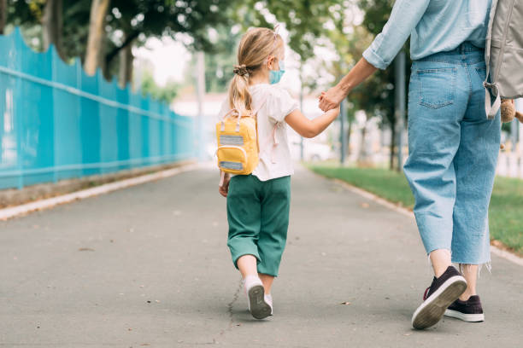

Posters

Download and print the staff facing poster for display in settings reserved for school staff.

Download and print the parent facing poster for display in settings where parents, carers and adults in the school community frequent. The poster is available in 30+ languages here under ‘Safety at Work for School Staff communications material’.

Extra school leadership and staff resources

- A communications support pack for principals to use when communicating with school employees about vaccinations, and to respond to concerns about vaccination requirements is available, including template newsletter content.
- The department’s Where to find COVID-19 Information page includes links to the updated School Operations Guide and resources including face mask guidance and infection prevention and control webinars.
- The department’s Parent and carer COVID-19 resources that schools are encouraged to share resources to support parents and carers.
Extra parenting support services and resources

- Department of Families, Fairness and Housing - services and support for families, including:
- Strengthening Parent Support Program – a free program for parents and carers with a child from birth to 18 years, with a disability or developmental delay.
- Regional Parenting Services - support for parents and carers of children from birth to 18 years located in regional Victoria.
- Family intervention services - advice on how to develop your parenting skills when you’re having difficulties in managing your child’s behaviour.
- Child, family and relationship services – family support services to help parents raise their children.
- Raising Children Network - guidance on supporting school age children, including resources, videos, articles and apps.
- Parentline - a confidential counselling and support services for parents and carers of children from birth to 18 years old.
- Child behaviour - information about how to manage and build positive behaviour with your child.
- Parenting Ideas - resources about raising confident, happy and resilient children.
- MyTime program – support for parents and carers of children with disabilities. Skilled facilitators provide guidance to help access local services and reliable information.
- Triple P Parenting program - ideas and strategies to help parents and carers including ways to set routines, manage behaviours and how to take care of yourself

© State of Victoria (Department of Education and Training) 2021. Except where otherwise noted, material in this document is provided under a Creative Commons Attribution 4.0 International Please check the full copyright notice

