CRT Funding / Financial Assistance
General Information:
Topic: Course information | Response/Resource
- What governs the content of this course? | The Occupational Health and Safety (OHS) Act (2004) requires the Department, so far as is reasonably practicable, to provide and maintain for employees a working environment that is safe and without risks to health.  The OHS Regulations 2017 (Part 3.5 - Plant) require employers to identify and control risks associated with machinery and plant in the workplace.  The principal is responsible for ensuring that the relevant safety precautions for operating machinery in the school are implemented. Metalwork and / or woodwork teachers must have also had the obligatory training and have attained the required levels of competency in machinery and plant.
- Who should attend? | The course is only open to metalwork and / or woodwork teachers who have already met the requirements outlined by the Victorian Institute of Teaching (VIT).  Metalwork and / or woodwork teachers must have completed one year of study in Technology Studies which includes a range of materials and systems.
- Due to the COVID-19 situation are classes still running? | Due to COVID-19, Holmesglen and VU have suspended on-campus delivery of non-apprentice vocational and education training till further notice.

General Information
Topic – Support information | Response/Resource
- How is the Safe Use of Machinery and Equipment Safety Program for Metalwork and Woodwork Classrooms Initiative Agreement funded? | Funding has been secured by the Employee Health, Safety and Wellbeing Division application for Initiative Agreement No ID 2427, which was approved by the Schools Targeted Funding Governance.
- How do I access the funding? | See attached support directions.
- What will the Department fund as part of this Initiative Agreement? | Machinery safety upgrades which includes:  - machinery maintenance costs  - purchase of new safer machinery and equipment  - purchase of devices to enable isolation and lockout of machinery, such as dedicated padlocks, power plug lock outs or lock out clasps  - upgrade of static machinery to install a hard-wired key lockable isolation switch, to enable static plant to be isolated and locked in the off position; or installation of manual reset emergency stop buttons  - engaging a qualified electrician if required, to assist schools to implement safety processes associated with locking out unsafe machinery.  Other safety upgrades to machinery will be considered on request.  The total claim is capped per school at $2730.00. Tax Invoices must be attached as supporting documentation.
- Why are the safety machinery upgrades included in this Initiative Agreement? | The Department’s OHS Management System audit program currently includes plant and equipment safety in secondary schools, one element of which is equipment isolation and tag out procedures.  The safety machinery upgrades will ensure safety measures are implemented so that people performing maintenance, service, cleaning or repair, or working to correct unintended stoppages or jams are not put at risk of accidental start-up or movement of powered equipment that hasn’t been isolated from power sources. Similarly, people may also be at risk if they use defective powered equipment that hasn’t been locked out or removed from service.  Principals must ensure all equipment can be isolated, or disconnected from the power source, and can be locked out by use of built-in keyed devices, padlocks, lock outs for circuit breakers or isolation clamps.
- Can principals claim for Training and purchased safety upgrades in 2019? | Yes, as part of this Initiative Agreement, principals can claim for the period commencing 1 July 2019 for the following:  - Course costs for metalwork and /or woodwork teachers that attended the Safe Use of Machinery in Technology Training  - CRT support for those teachers  - Travel, accommodation and meal costs (for teachers that had to stay overnight for the course)  - Safety upgrade to machinery as per above Safety machinery upgrades section
- When will this program end? | Under this initiative schools will not be able to claim for courses attended after 30 June 2020

NOTE: All invoices need to show the itemised safety products purchased, course information and name of teacher who attended, signed CRT timesheets and proof of payment(s) for the reimbursement to be accepted.

Detailed directions
Topic | Response/Resource | Example:
- Information to be included on the Tax Invoice. | Ensure the Tax Invoice is on the school letterhead
The Tax Invoice must be made payable to:
Department of Education and Training
2 Treasury Place
East Melbourne
Vic, 3002
 | Under the Description of supply/service state:  Safe Use of Machinery & Equipment Safety Program | 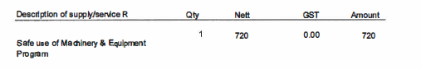
- Information that should not to be included on the Tax Invoice (not covered by the allowed funding expenditure). | The Tax Invoice must not include:  - GST  - Superannuation payments (not covered) | 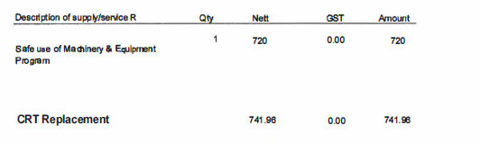
- Support evidence that the school must provide in order to claim for reimbursement. | Paid Tax Invoices for:  - purchased machinery  - technician engaged to perform maintenance on machinery  - electrician engaged to implement safety processes associated with locking out unsafe machinery etc.
- Example of a completed School Claim | - Appendix A  Refer to Appendix A showing the example of XXXX Secondary College claim for course cost, CRT for 12 hours support and safety upgrades to machinery at the college.
- Crosscheck with the school Reimbursement checklist. | Ensure the school follows the Schools Reimbursement Checklist to ensure that the request for reimbursement is approved and paid without delay. | 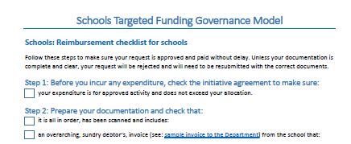
- Where can the school apply for funding? | School to lodge the application in the Schools Targeted Funding Portal. | 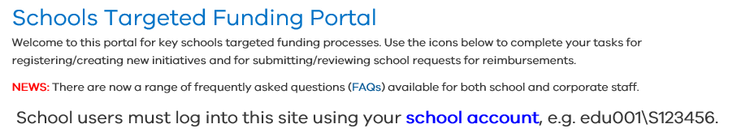
- Where does the school go if it needs additional information on program funding? | Through access of the Principal and Business Manager information flyer from the Schools Targeted Funding Portal

APPENDIX A –
Example of a completed Tax Invoice claiming for:
- CRT reimbursement for two days (12 hours). The CRT rate is $61.83 per hour (CRT timesheet attached.
- Course cost for a Woodwork teacher attending two days at VU Polytechnic (paid course invoice attached)
- Safety upgrade of machinery (all paid receipts attached)
